LAMPIRAN

TABLE 1 Result Elicitation
NO | Goal | Problem | Task
1 | Management of blood stock | - KDD (blood donor family) often misinforms the availability of blood, because there is no information on blood stock that is available periodically.  - Recording blood stock in and out of less updated, so that the available blood stock can not be updated regularly. | -Making management of blood supply into the system  - Making the management of blood stock out by the system  - Information on the amount of blood stock is available
2 | Managing blood donor registration | In the process of registering KDD must come directly to the PMI so it takes a long time if the queue is a lot of blood donor list | - - Register for blood donations online
3 | Management of mobile units | - KDD wants to propose a blood donor site must provide a letter directly to PMI so that it will take a long time for approval  - Lack of information for KDD to get information about the activities of the mobile unit that was held | - Management of the appointment of Mobile Unit premises by the system  - Information on the place of procurement of blood donor mobile  - Submission of a place for procurement of mobile units online

TABLE 2 Early Requirement Goals
Aktor | Goal | Resource | Depedency
UD (Unit Blood) | - Management of blood pumpkin donation data  - Management of the Mobile Blood Donation Unit. | - Approval of mobile unit submission | KDD
Seksi Penyimpan | - Improve Management of available blood stock  - Management data requests blood | - Approval of blood donor data  - Approval data for blood requests | UD dan KDD
KDD (Blood Donor Family) | - Get information on mobile unit activities in realtime  - Getting blood stock information available in realtime  - Registration of blood donors to be effective  - Submission of procurement of mobile units to be effective | - Mobile unit schedule | UD

TABLE 3 Hasil Late Requirement
NO | Actor | Goal | Sub Goal | Fungsionalitas requirement
1 | UD (Unit Blood) | Management of pumpkin blood donor data | - Management of blood donor data | - View blood donor data  - Blood donor approach complete
 |  | Management of the Mobile Blood Donation Unit. | - Information on mobile unit activities  - Management of mobile unit filing data | - View data on mobile unit activities  - mobile unit request data approval
2 | Seksi Penyimpan | Management of blood stock is available | - Management of incoming blood stock data | - Approval of blood data received
 |  | Management of blood demand data | - Management of blood demand data | - Approval of blood demand data
3 | KDD (Blood Donor Family) | Get information on mobile unit activities in real time | - Scheduling mobile unit activities | - View data schedule for mobile unit activities
 |  | Get blood stock information available in realtime | - Display data on incoming blood stock  - Displays blood stock data out | - View available blood calculations
 |  | Registration of blood donors to be effective | - Filling in blood donor data | - Input data on blood donor registration
 |  | Submission of procurement of mobile units to be effective | - Filling in mobile unit filing data  - Check the schedule of mobile unit activities | - Input data filing for mobile units  - Check the schedule of mobile unit activities

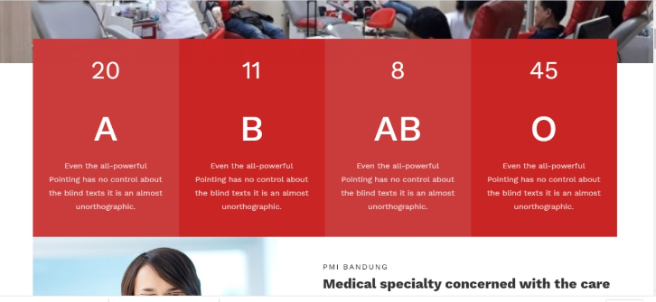
Fig.1 Implementation Display data stock blood
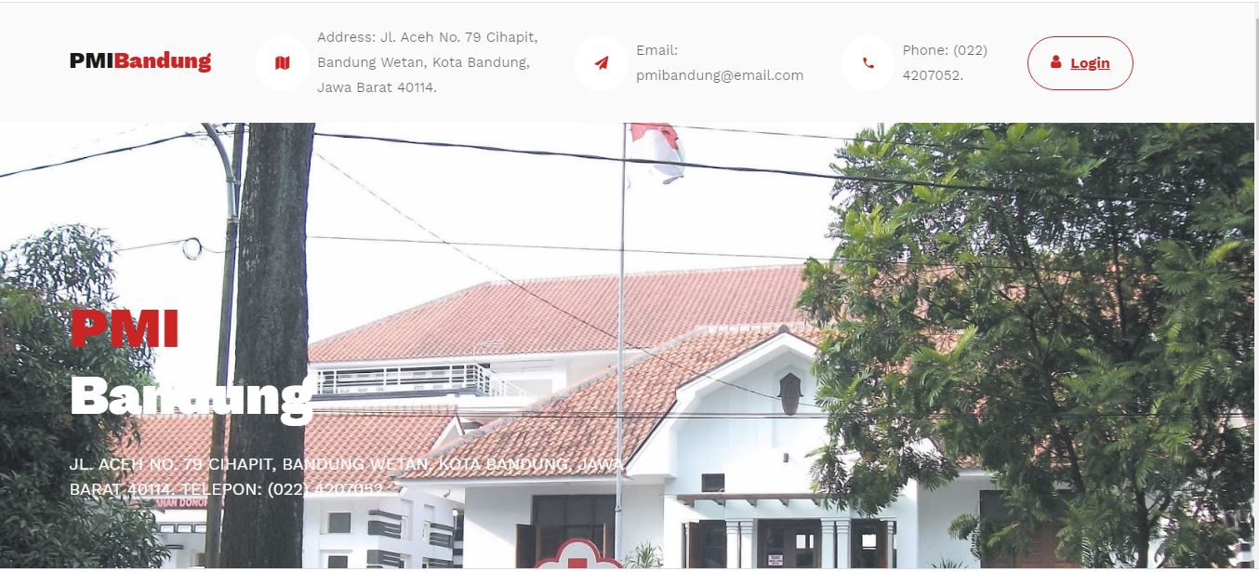
Fig.2 Implementation Display Home
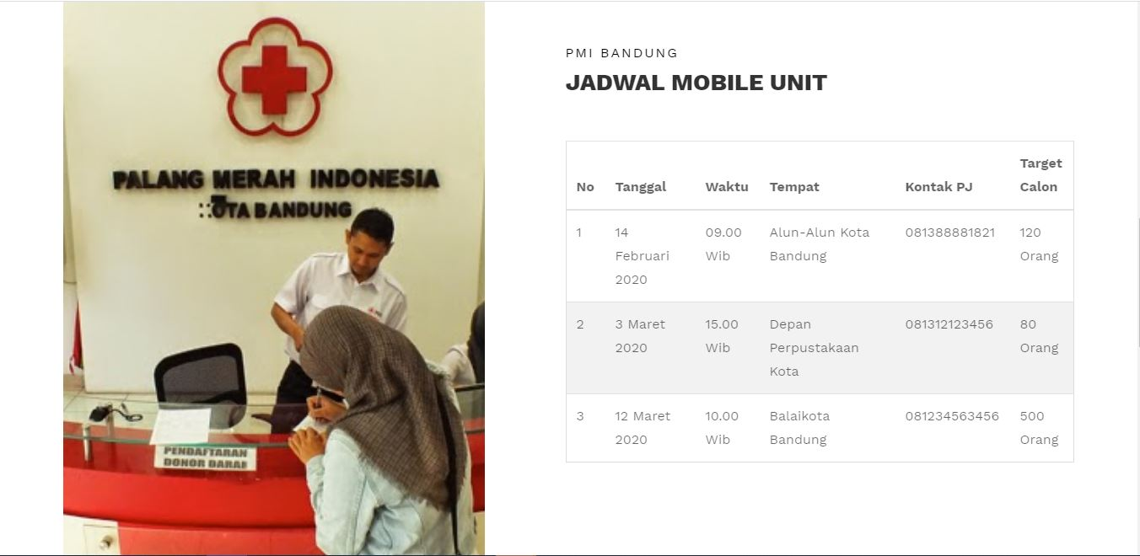
Fig.3 Implementation Display Schedule mobile unit

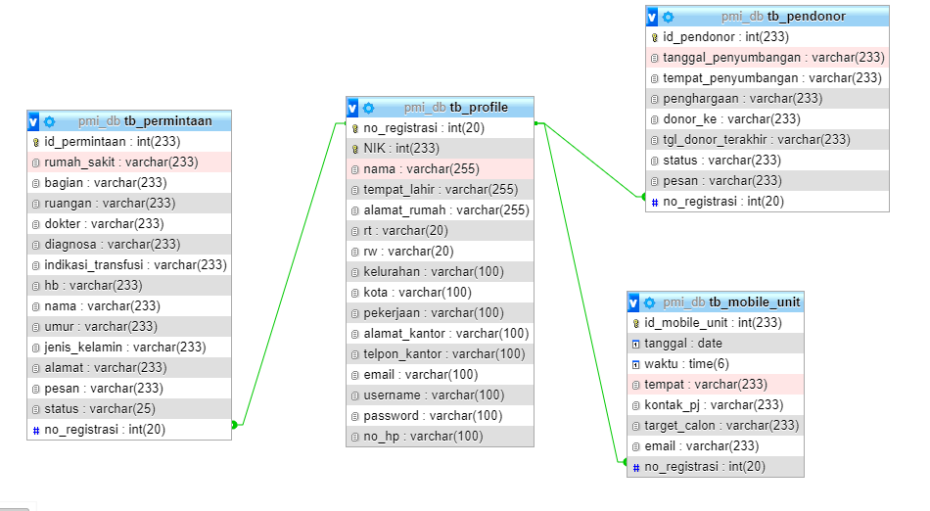
Fig.4 Database
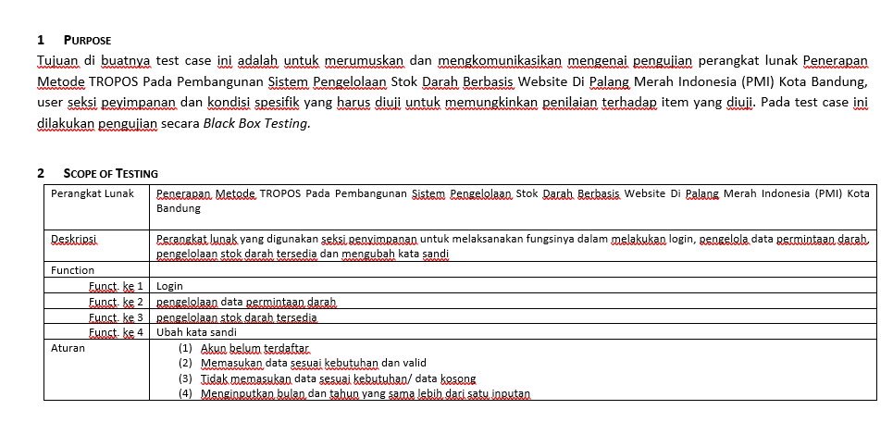
Fig.5 Form User Acceptance Test of Seksi Penyimpanan
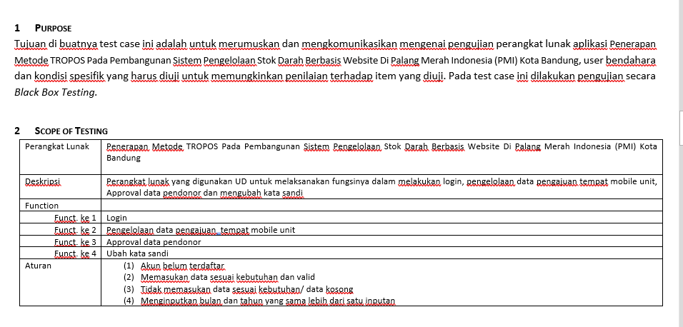
Fig.6 Form User Acceptance Test of Unit Blood
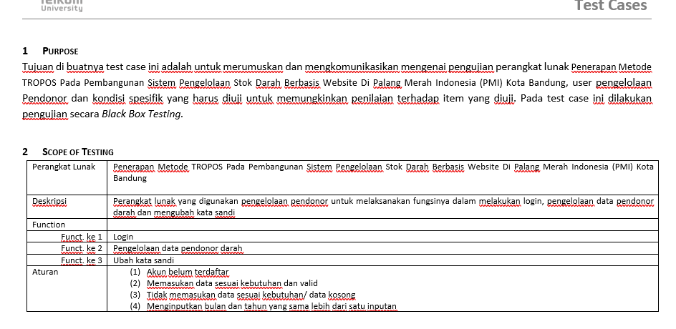
Fig.7 Form User Acceptance Test of Pengelolaan Pendonor

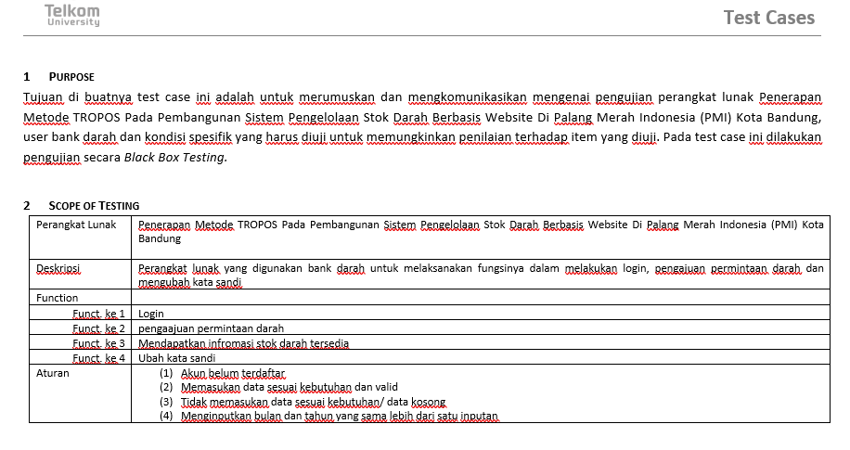
Fig.8 Form User Acceptance Test of Bank Darah

