Design and Build IoT Smart Home For Android Based Electronic Equipment Management System

Dwi Iskandar[1]*, Canggih Ajika Pamungkas [2], Norma Puspitasari [3] , Muh Alif Fathoni [4]

Indonusa Surakarta Polytechnic [1], [2], [3] , [4]

Surakarta, Indonesia

dwik@poltekindonusa.ac.id[1], canggih@poltekindonusa.ac.id [2], normasari@poltekindonusa.ac.id [3], fmuhalif12@gmail.com [4]

***Abstract*—** **Energy consumption in addition to the use of low power consumption devices, it is also necessary to use energy-saving behavior that supports sustainable energy. Unwise use of electricity will of course have an impact on the high use of electricity, this also affects the depletion of electrical energy supplies because the need for electrical energy is greater than the supply of electrical energy, for that it is hoped that every community understands the efforts to use electricity wisely. Problems faced by households in managing the use of electrical energy include: Not using LED lights (Light Emitting Diodes); Using unnecessary electronic equipment; It is not wise to use equipment that requires electrical energy. Research Methodology includes data collection, needs analysis, program development, tool design, testing. Conclusions that can be drawn based on research that has been done include: Smart home that has been made can help turn on and turn off electronic equipment at home, Smart home applications that are made can be connected to the internet network, Smart Home applications can be installed on Smartphones with operating systems Android version 9.0 Pie minimum**

***Keywords—*** ***smart home, android, IoT, electrical energy***

# **Introduction**

Addressing global challenges, such as climate change and other related environments, requires a rethink in the process of electricity production and consumption. The need for greater competitiveness in the provision of critical infrastructure (including electricity) is also a challenge [1]. Energy production in Indonesia, the National Priority for Sustainable Energy includes 2 (two) Priority Programs, namely: New and Renewable Energy (EBT) and Energy Conservation, and Meeting Energy Needs [2]. Energy consumption in addition to the use of low power consumption devices is also required to save electricity consumption behavior that supports sustainable energy.

Unwise use of electricity will of course have an impact on increasing electricity use, this also affects the depletion of electrical energy supplies because the need for electrical energy is greater than the supply of electrical energy, it is hoped that every community will understand the efforts to use electricity wisely. [3]

Save energy while saving money on office or building energy use. The costs of simply forgetting to turn off classroom lights and electrical equipment can add up over time. Controlling temperature and lighting based on time of day or occupancy can really reduce energy costs. Automating heating and lighting systems allows you to outsource routine tasks to intelligent systems and reduces the cost of human error. The system implements key settings with easy control with the touch screen, no longer just for greenery, with the typical family electricity bill having increased by 78% in less time than the internet, web-enabled phone, or even the office. Smart energy efficiency is not only needed in the office. When the price of electrical energy goes up and income goes down, a home automation system will be a more attractive investment because its efficiency increases and costs go down due to innovation [4].

Internet of Things plays a major role in providing solutions for many applications with the support of software, internet, and embedded systems [5]. One of the implementations of IoT for the use of electrical energy is Home Automation. The building blocks of Home Automation are network sensors and the Building Management System (BMS). Using Sensor Web elements, as part of IoT, as opposed to standard sensor elements, communication infrastructure is rapidly changing from local to global, moving BMS to a global level as well. Moreover, the whole home automation system is becoming everywhere. Thus, home automation can be defined as a mechanism that eliminates as much as possible and technically desired human interaction in various domestic processes and replaces it with programmed electronic systems. Ultimately, it is a system that aims to improve the quality of life by automating household activities that can be controlled via the Internet or by telephone.

A home automation system typically connects controlled devices to a central hub. To control the system a user interface needs to be designed for a mobile phone application, or a Web interface, that may also be accessible offline without a compulsory Internet connection [6]

Home automation gives you access to control device in your home from a mobile device anywhere in the world. The term may be used for isolated programmable devices, like thermostats and sprinkler systems, but home automation more accurately describes homes in which nearly everything like lights, appliances, electrical outlets, heating and cooling systems that are hooked up to a remotely controllable network [7]

Internet of Things is referred as spinal cord for home automation system as this technology allows connecting the various components of the system and enables instant communication between them. Internet of Things invokes the connection of things in a network. The things can be lifeless objects as well as living beings which can have a unique identification, provided by a chip comprising logical addressing embedded in them. When things get their virtual identity, it becomes possible to transfer/receive data and operate on them. Other important components are sensors implanted in the things to generate relevant information, employing database and servers to store this information with devices having speciality to form a network which may be webbased. Thus, Internet of Things in a nutshell is to establish a network of things with unique virtual identities like in a computer network but without human intervention alongside humans are able to instruct or check status of the IoT based system depending upon the architecture and requirements of the system [8]

The electricity tariff for the first quarter of 2020 is Rp. 1,114.74/kWh for medium voltage customers, namely B-3 Big Business with power above 200 kVA and P2 Government Office with power above 200 kVA[9].

Household income and electricity prices are the main factors in determining the demand for electrical energy. When income increases, the demand for electricity will also increase so that electricity consumption will increase. However, when the price of electricity is high, the community will reduce their electricity consumption because electricity is a normal good. [10]

Problems faced by households in managing the use of electrical energy include: Not using LED lights (Light Emitting Diodes); Using unnecessary electronic equipment; It is not wise to use equipment that requires electrical energy

# **RESEARCH METHODOLOGY**

**Data collection**

**Needs Analysis**

**Programming**

**Tool Design**

**Trials**

Figure 1. Research Methodology

The stages of research that will be carried out include:

1. Data collection

Looking for reference material on:

1. Daily use of electronic equipment
2. Utilization of IoT technology for smart home
3. Smart home implementation by utilizing Android mobile
4. The C programming language is related to the use of smart home
5. Needs analysis
6. IoT smart home functional requirements analysis
7. Analysis of non-functional requirements for IoT smart home
8. Programming
9. Coding for NodeMCU ESP8266 hardware needs in the Arduino IDE application
10. Coding System with PHP (Hypertext Preprocessor) to connect with NodeMCU ESP8266
11. Android Mobile app design with kodular.io
12. Tool design

Assembling equipment starting from NodeMCU ESP8266, Relay 4 Phase/Channel and other accessories

1. Trial

The trial was carried out by enabling the ESP8266 NodeMCU which had been connected to the internet and then turning off the electronic equipment that had been connected to the internet with the Android .apk

# **RESULT AND DISCUSSION**

1. Needs analysis
2. IoT smart home functional requirements analysis
3. The system can turn off and turn on electronic equipment at home, provided that electronic equipment at home has been connected to the relay module and the relay module has been connected to the ESP8266 NodeMCU. Internet connection in the form of SSID and password must also be registered at NodeMCU ESP8266
4. The Smart Home application can be installed on Smartphones with a minimum Android operating system version 9.0 Pie
5. Analysis of non-functional requirements for IoT smart home
6. Hardware requirements: hardware used in the manufacture of smart homes, including NodeMCU ESP8266, Adapter, USB Cable, Arduino Jumper Cable, Led Lights, Light Fittings, Electrical Cables, PCB holes, Stecker, Relay 4 Phase/Channel.
7. Software: the software used includes Arduino IDE, Sublime Text, browser, XAMPP, Kodular, kodular companion
8. Programming

Programming in this research is grouped into 3 parts:

1. Arduino coding, where this coding will be uploaded to the NodeMCU ESP8266, for the application used in making this coding is Arduino IDE version 1.6.9

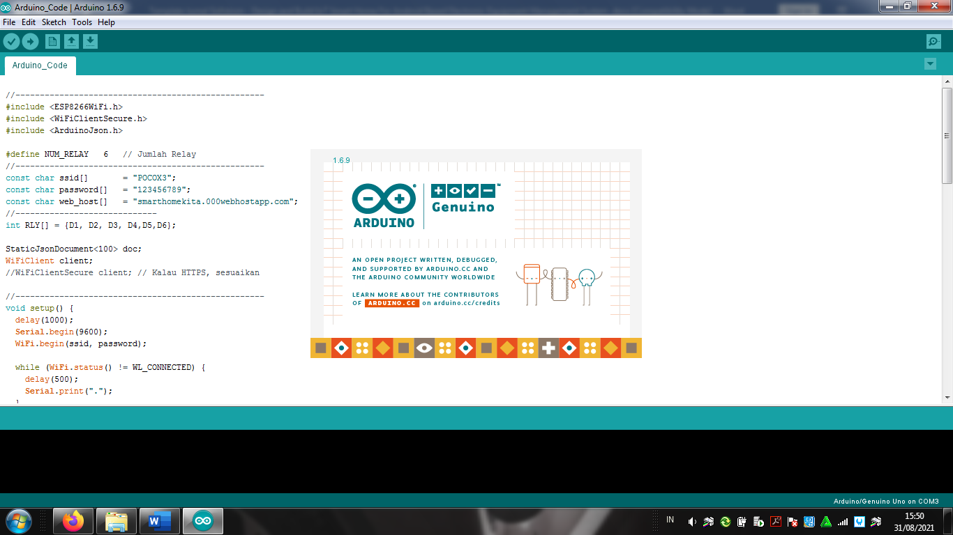

Figure 2. Arduino IDE

The coding quote that will be entered into the NodeMCU ESP8266:

const char ssid[] = "";

const char password[] = "";

const char web_host[] = "";

int RLY[] = {D1, D2, D3, D4, D5, D6};

StaticJsonDocument<100> doc;

WiFiClient client;

void setup() {

delay(1000);

Serial.begin(9600);

WiFi.begin(ssid, password);

The SSID and Password are obtained from an internet connection that will be connected to the NodeMCU ESP8266, while for the web host it is obtained from a link that comes from PHP coding that has been uploaded to the hosting and the domain name is created.

1. Create a database that will be connected with PHP coding, while the application used to create a local database is to use XAMPP. The table structure used in this Smart home is:

CREATE TABLE `relay` (

`relay_id` int(11) NOT NULL,

`nama_relay` varchar(64) NOT NULL,

`logika` int(11) NOT NULL) ENGINE=InnoDB DEFAULT CHARSET=utf8mb4;

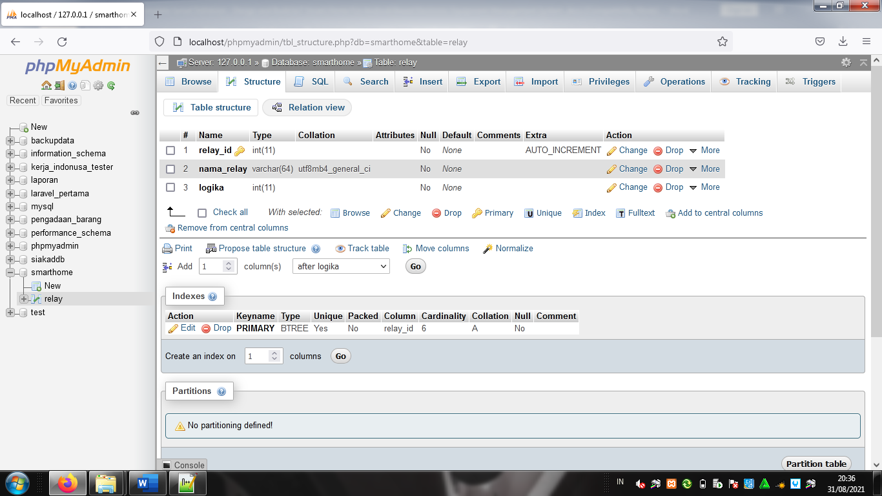

Figure 3. Table Structure

1. Coding System with PHP (Hypertext Preprocessor), this coding is used to connect with NodeMCU ESP8266 using the PHP programming language. After the php coding is complete, the next step is to upload the coding to the hosting that has been provided. And create a domain address that is obtained from the hosting that is owned. The application used to support making PHP coding is Sublime text

For coding quotes from PHP include:

<?php

date_default_timezone_set('Asia/Jakarta');

$dbhost = "";

$dbuser = "";

$dbpass = "";

$dbname = "";

$url = "http://" . $_SERVER["HTTP_HOST"] . dirname($_SERVER["SCRIPT_NAME"]);

$conn = new mysqli($dbhost, $dbuser, $dbpass, $dbname);

if ($conn->connect_error) {

die("Connection failed: " . $conn->connect_error);

}

The coding above is then saved with the name config.php.

Excerpts from other coding are

<?php

include 'config.php';

$relay = $conn->query("SELECT * FROM relay");

if (isset($_GET['tombol'])) {

$relay_id = $_GET['tombol'];

$cek_id = $conn->query("SELECT * FROM relay WHERE relay_id = '$relay_id'");

if ($cek_id->num_rows > 0) {

$rly = $cek_id->fetch_assoc();

if ($rly['logika'] == 1) {

$logika = 0;

} else {

$logika = 1;

}

$conn->query("UPDATE relay SET logika = '$logika' WHERE relay_id = '$relay_id'");

}

header("location: index.php");

}

?>

<?php while ($row = $relay->fetch_assoc()) {

if ($row['logika'] == 0) {

$logika = 'ON';

$warna='y';

}else {

$logika = 'OFF';

$warna='t';

}

$r_id=$row['relay_id'];

?>

<a href="<?= $url; ?>/index.php?tombol=<?= $row['relay_id'] ?>" >

<div

style="

background-repeat:

no-repeat;

background-size: cover;

background-image: url('img/<?=$r_id.$warna?>.png');

height: 160px;"

class="col-md-6 col-xs-6">

<div class="transbox">

<center>

<b>

<font style="color:white;font-size:13px;" >

<?= $row['nama_relay'] ?>

</font>

</b><br>

<i style="color:white"><?=$row['nama_relay']." status ".$logika;?></i>

</center>

</div>

</div></a>

<?php } ?>

The above code is stored with the name index.php

Code for api.php

<?php

include 'config.php';

$relay = $conn->query("SELECT * FROM relay");

while ($row = $relay->fetch_assoc()) {

$data[] = intval($row['logika']);

}

$json = json_encode($data);

echo $json;

header("location:index.php");

?>

1. Creating the main view of the Android Mobile application with kodular.io.

Software requirements on the system development side are using the kodular.io platform with the requirement that the user must have a gmail account for the need to log into the kodular platform. Kodular can be accessed using a web browser at <https://www.kodular.io.[11>]

For Smart Home to be installed on an Android Smartphone, only 2 screens are used, the screens include the main screen / initial screen and the page screen for controlling electronic equipment.

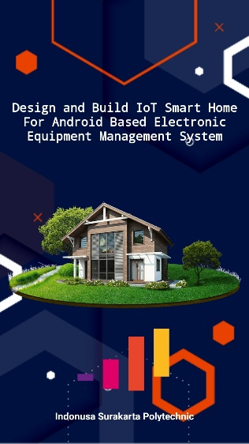

Figure 4. Smart Home Screenshot

Here are the components needed for the initial smart home screen

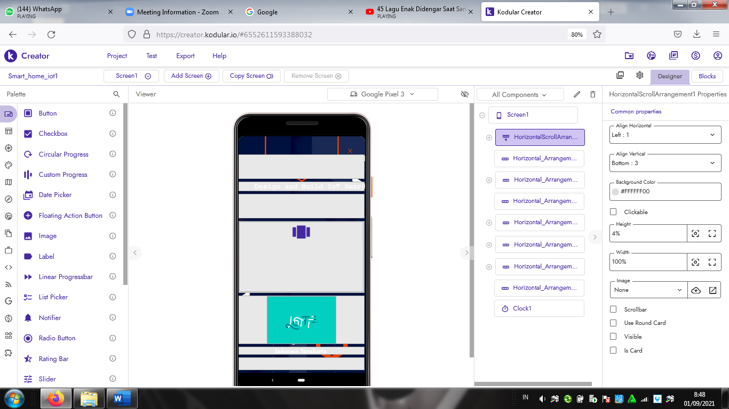

Figure 5. Components Smart Home preview

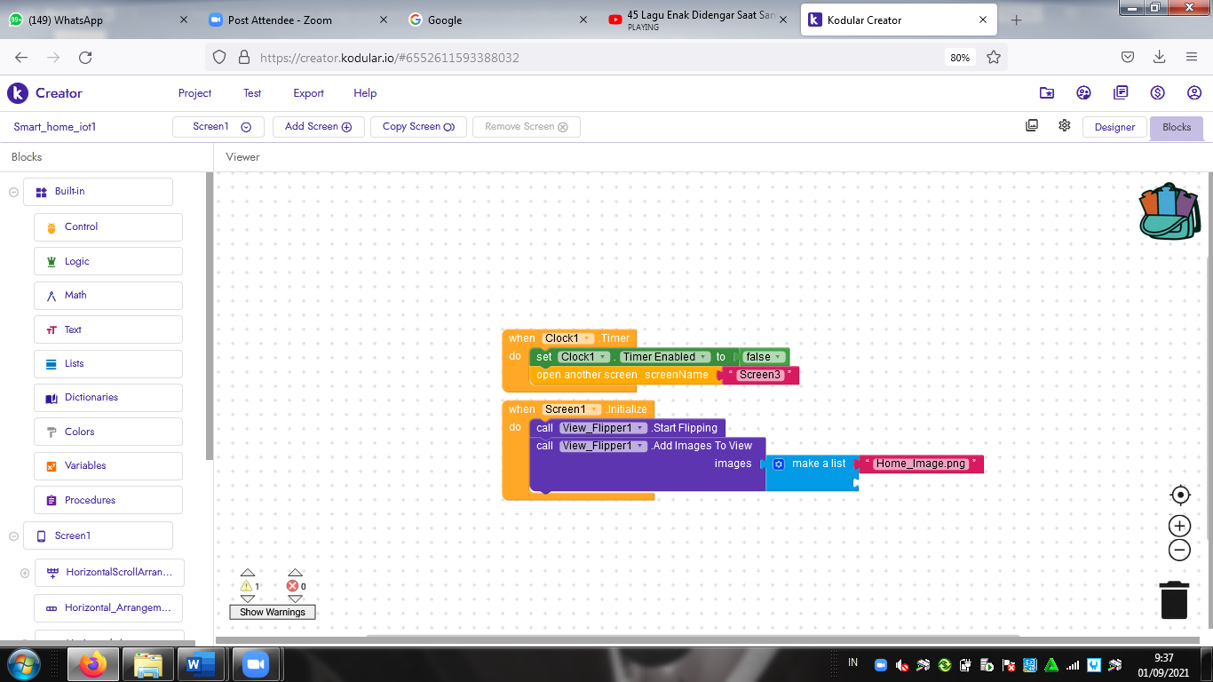

Figure 6. Blocks Smart Home home screen

The next screen used is the display for managing electronic equipment

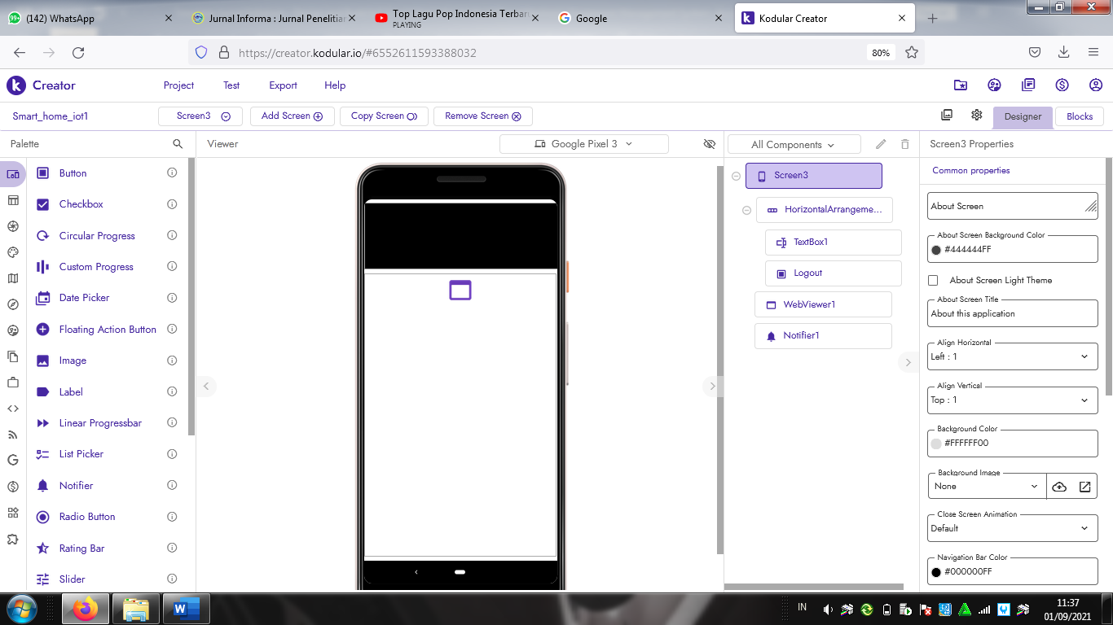

Figure 7. All Components Electronic Equipment

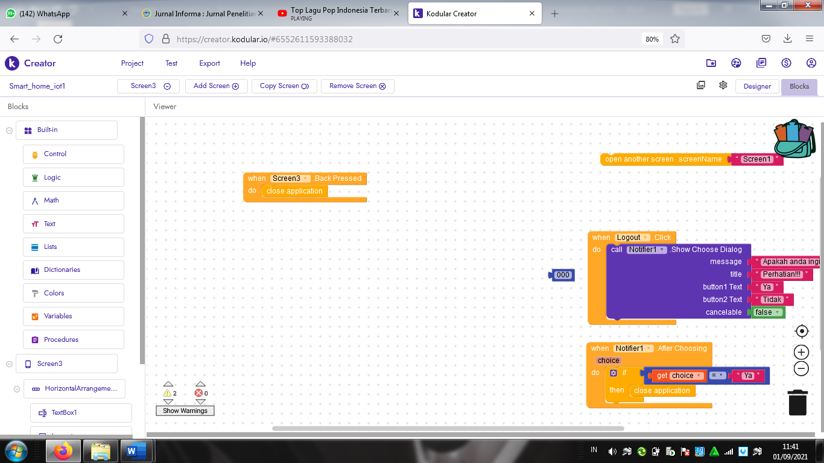

Figure 7. Electronic Equipment Blocks

1. Tool design

Assembling equipment starting from NodeMCU ESP8266, Relay 4 Phase/Channel and other accessories



Figure 8. Tool Circuit Schematic

The explanation of the circuit diagram of the device is that the ESP8266 nodeMCU is connected to the relay using a jumper cable. For the arrangement

Table 1. Wiring Circuit

|  |  |  |
| --- | --- | --- |
| VV |  | VCC |
| D1 |  | IN6 |
| D2 |  | IN5 |
| D3 |  | IN4 |
| D4 |  | IN3 |
| D5 |  | IN2 |
| D5 |  | IN1 |
| G |  | GND |

The lamp circuit is in series, and one of the wires is connected to the relay. One wire from the lamp and the rest of the wires from the relay are connected to the plug which will then be given an electric current.

1. Trial

The test was carried out with

1. Plugging the plug into electricity where previously electronic equipment such as TVs, fans, lights, etc. have been connected to the relay module, the relay module serves to cut off electricity that has been connected to electronic equipment.
2. Check the internet connection, where the existing internet connection must be the same as the one that has been registered on the NodeMCU ESP8266
3. Publish the previously created PHP file to Hosting, then from the hosting create a domain address. This domain address is used to invoke commands in the NodeMCU ESP8266
4. Export smart home applications that have been made in kodular to Android App (.app). If it has been exported, then install it on an Android smartphone with a minimum Android Operating system version 9.0 Pie
5. The smart home can already be used, and you can choose which electronic equipment is on or off.

# **CONCLUSION**

Conclusions that can be drawn based on the research that has been done include::

1. The smart home that has been made can help turn on and turn off electronic equipment at home
2. The smart home application created can be connected to the internet network
3. The Smart Home application can be installed on Smartphones with a minimum Android Operating system version 9.0 Pie
4. The smart home application can only be used if you have an internet connection, both electronic equipment that has been connected to the NodeMCU ESP8266 as well as in the android application

##### **References**

[1] N. Edomah, “Modelling Future Electricity: Rethinking the Organizational Model of Nigeria’s Electricity Sector,” *IEEE Access*, vol. 5, pp. 27074–27080, 2017.

[2] M. Island and N. Heryana, “for Small Island in Indonesia,” *2018 Conf. Power Eng. Renew. Energy*, pp. 1–5, 2018.

[3] Joko, *Implementasi Metode Klasifikasi Naïve Bayes Dalam Memprediksi Besarnya Penggunaan Listrik Rumah Tangga*, vol. 2, no. 3. 2015.

[4] P. Gupta and J. Chhabra, “IoT based Smart Home design using power and security management,” *2016 1st Int. Conf. Innov. Challenges Cyber Secur. ICICCS 2016*, no. Iciccs, pp. 6–10, 2016.

[5] F. J. J. Joseph, “IoT based weather monitoring system for effective analytics,” *Int. J. Eng. Adv. Technol.*, vol. 8, no. 4, pp. 311–315, 2019.

[6] B. Taji, A. D. C. Chan, and S. Shirmohammadi, “Effect of Pressure on Skin-Electrode Impedance in Wearable Biomedical Measurement Devices,” *IEEE Trans. Instrum. Meas.*, vol. 67, no. 8, pp. 1900–1912, 2018.

[7] P. J. Loveland and P. H. Bellamy, “Environmental Monitoring,” *Encycl. Soils Environ.*, vol. 4, pp. 441–448, 2004.

[8] R. S. Kathuria, S. Gautam, A. Singh, S. Khatri, and N. Yadav, “Real Time Sentiment Analysis on Twitter Data Using Deep Learning(Keras),” *Proc. - 2019 Int. Conf. Comput. Commun. Intell. Syst. ICCCIS 2019*, vol. 2019-January, pp. 69–73, 2019.

[9] A. Pribadi, “Tarif Listrik Triwulan I 2020 Tetap,” 2020. [Online]. Available: https://www.esdm.go.id/id/media-center/arsip-berita/tarif-listrik-triwulan-i-2020-tetap.

[10] Y. Ye, S. F. Koch, and J. Zhang, “Determinants of household electricity consumption in South Africa,” *Energy Econ.*, vol. 75, pp. 120–133, 2018.

[11] R. Setiawan, “Rancang Bangun Media Pembelajaran Berbasis Android Tanpa Coding Semudah Menyusun Puzzle,” *J. Sist. Inf. dan Sains Teknol.*, vol. 2, no. 2, pp. 1–7, 2020.

[12] A. K. Gupta and R. Johari, “IOT based Electrical Device Surveillance and Control System,” *Proc. - 2019 4th Int. Conf. Internet Things Smart Innov. Usages, IoT-SIU 2019*, pp. 1–5, 2019.

[13] R. Karunamoorthi *et al.*, “Design and development of IoT based home computerization using Raspberry pi,” *Mater. Today Proc.*, no. April 1968, 2020.

[14] F. Ullah, F. Al-Turjman, and A. Nayyar, “IoT-based green city architecture using secured and sustainable android services,” *Environ. Technol. Innov.*, vol. 20, p. 101091, 2020.

[8][9][10]