***Expert System for Diagnosing Disease Symptoms of Rice Pests Using the Dempster Shafer Algorithm and Fuzzy Tsukamoto Algorithm***

Awan Setiawan [1], Sany Ni’ma Fauzia [2], Kusmaya [3], KM Syarif Haryana [4], Iwan Abadi [5]

Langlangbuana University [1], [2], [3], [4], [5]

Faculty of Engineering, Department of Informatics

Bandung, Indonesia

[Awan2425@gmail.com](mailto:Awan2425@gmail.com) [1], [Sunnynima6@gmail.com](mailto:Sunnynima6@gmail.com) [2], [Kusmaya7165@gmil.com](mailto:Kusmaya7165@gmil.com) [3], [Kmsyarif@gmail.com](mailto:Iwan.abadi69@gmail.com%20[4],%20Kmsyarif@gmail.com) [4], [Iwan.abadi69@gmail.com](mailto:Iwan.abadi69@gmail.com) [5]

***Abstract -* Agriculture is the largest sector in almost every developing country economy. This sector produces food for most of the population in the country. Some Indonesian people work as farmers who have an important role to ensure the availability of basic ingredients, namely rice from rice. However, the limited number of experts, namely Field Agricultural Extension Officers (PPL) resulted in limited counseling that would be obtained by farmers, because to overcome all the problems faced by farmers was constrained by time and the number of farmers who had problems with their crops. In this case, farmers find it difficult to deal with the problems of pests and diseases that attack rice, therefore a tool or an expert application is needed that can help farmers to diagnose pests and diseases of rice in order to provide solutions to overcome them. In this regard, this study aims to develop an application design for an Expert System for Diagnosing Rice Pest Diseases with the Fuzzy Tsukamoto Algorithm which is a method for classifying objects based on the most similar data, as well as adding the Dempster Shafer Algorithm as a comparison of the methods used to obtain data. maximum result validation. By using the Fuzzy Tsukamoto Algorithm, the author uses several symptoms that often occur during the rice harvest season, then compares them with the Dempster Shafter Algorithm to obtain validation of the causes and effects that occur, then the system will provide the best decision to provide advice regarding the symptoms experienced by farmers.**

***Keywords—*** ***Expert System, Expert System Application, Diagnosis of Rice Pest Disease, Fuzzy Tsukamoto Algorithm, Demspter Shafter Algorithm.***

***Abstak* - Pertanian merupakan sektor paling besar hampir di setiap ekonomi negara berkembang. Sektor ini menghasilkan bahan pangan bagi sebagian besar penduduk di negaranya. Sebagian masyarakat Indonesia berprofesi sebagai petani yang memiliki peranan penting untuk terjamin tersedianya bahan pokok yaitu beras yang berasal dari padi. Namun Terbatasnya jumlah pakar yaitu Penyuluh Pertanian Lapangan (PPL) mengakibatkan terbatasnya penyuluhan yang akan diperoleh oleh petani, karena untuk mengatasi semua persoalan yang dihadapi petani terkendala oleh waktu dan banyaknya petani yang mempunyai masalah dengan tanamannya. Dalam hal ini petani kesulitan untuk menghadapi masalah-masalah hama dan penyakit yang menyerang padi, oleh karena itu sangat dibutuhkan alat bantu atau suatu aplikasi pakar yang dapat membantu petani untuk mendiagnosis hama dan penyakit padi guna memberikan solusi penanggulangan. Sehubungan dengan itu, penelitian ini bertujuan untuk melakukan pengembangan desain Aplikasi Sistem Pakar Diagnosa Penyakit Hama Tanaman Padi dengan Algoritma *Fuzzy Tsukamoto* yang merupakan sebuah metode untuk melakukan klasifikasi terhadap objek berdasarkan data yang paling mirip, serta menambahkan Algoritma *Dempster Shafer* sebagai Perbandingan metode yang digunakan untuk mendapatkan validasi hasil yang lebih maksimal. Dengan Menggunakan *Algoritma Fuzzy Tsukamoto* ini, penulis menggunakan beberapa gejala yang sering terjadi pada musim panen padi, kemudian membandingannya dengan Algoritma *Dempster Shafter* untuk mendapatkan validasi tadi sebab-akibat yang terjadi, kemudian sistem akan memberikan keputusan terbaik untuk memberikan saran terkait gejala yang dialami oleh petani.**

***Kata kunci—* Sistem Pakar, Aplikasi Sistem Pakar, Diagnosa Penyakit Hama Tanaman Padi, Algoritma *Fuzzy Tsukamoto*, Algoritma *Demspter Shafter.***

# INTRODUCTION

Basically, the agricultural sector is one of the most important sectors in the economy of a country, because it plays an important role in running the economy in meeting the food needs of a country. Especially in Indonesia, the agricultural sector is an important sector where most of the Indonesian population depends on the results of agriculture.

One of the basic or primary needs of the Indonesian people is rice, therefore the government needs to always maintain a stable level of rice production. In addition to providing food for the community, the agricultural sector is a supplier of raw materials for the industrial sector and a source of foreign exchange earners. Increased production of rice farming is needed to meet the food needs of the Indonesian people.

Based on information from the Department of Food Crops and Horticulture of West Java Province, in an effort to stabilize rice production, the Regional Government always strives to reduce the failure rate of rice crop yields, because it will greatly affect the regional economy. However, in the current era of modernization, there are still many people who do not know and utilize a facility optimally, this is due to the lack of knowledge and information obtained.

The lack of provision on agricultural land management to farmers has resulted in a lack of information about more effective technology for managing agricultural land, but it is also possible that some other farmers have started to enter the realm of modern management. To take advantage of technology during a pandemic like this, the Regional Government under the auspices of the West Java Food Crops and Horticulture Service has a program that can support farmers in the development and management of agricultural land to stabilize rice production, namely the millennial farmer program.

Millennial farmers are a program to foster entrepreneurship in the West Java agricultural sector, change the face of agriculture to be fresh so that the millennial generation is interested in becoming farmers by utilizing digital technology, creating advanced, independent, and modern agriculture, reducing the problem of the availability of agricultural labor in West Java. Millennial farmers are expected to be able to adapt in the field of technology and information so that the role of millennial farmers will be the initiators in the future.

The obstacles faced by millennial farmers now are not just how to increase rice yields, but how to improve the quality of the rice plant, one way is regarding early handling of diseases and pests in rice by applying or utilizing current technological developments. That way, the limited number of rice plant experts is no longer an obstacle for millennial farmers who have problems with their crops. Therefore, in this case, a tool or an expert application system is needed that can help millennial farmers in diagnosing pests and diseases in rice plants in order to provide solutions to overcome the problems that occur.

In previous research, the application of an expert system on symptom identification to determine pests and diseases on rice plants only used one algorithm or one method that was implemented. For example, in the research conducted by Resti Hutami et al in 2017 and Pranoto Agus et al in 2011, the two studies only used one algorithm or method, namely fuzzy Tsukamoto as a method that was implemented for diagnosis. Then there is a study conducted by Christian Yonathan Sillueta, et al in 2018 and Mustakim et al in 2016, both studies were conducted using the Dempster Shafer algorithm or method applied to their system, to diagnose diseases or disorders in the research conducted.

To develop this research, the research uses the Tsukamoto fuzzy algorithm which is a method for classifying objects based on the most similar data and adds the Dempster Shafer algorithm as a comparison of the methods used to obtain maximum validation results.

# RESEARCH METHODS

This study aims to develop and implement the Tsukamoto fuzzy algorithm and the Dempster Shafer to provide accurate results on the results and methods of controlling disease in rice plants.

## A. *Identification* of problems

Many factors affect the incidence of pests on rice plants, one of which is environmental conditions or pests that attack. The limitations of farmers to analyze the symptoms of rice plant diseases make it an obstacle to providing appropriate treatment for the disease. The shortage of agricultural experts is one of the important factors in providing education regarding the symptoms and diseases that are susceptible to pests. With this, the author wants to create an application that can be accessed at any time by farmers and can always be updated regarding symptoms and diseases that attack rice plants in real time.

## B. *Study* of literature

After carrying out the data collection method, the researchers thought about how to create an application that can be accessed in real time by agricultural experts and by farmers. Here experts can always add updated symptoms and diseases and farmers can analyze according to the symptoms that occur in their rice plants, then the system will provide ways of dealing with symptoms that appear on the rice plant. As support for making this expert system, the author will add 2 algorithms, namely fuzzy tsukamoto and demper shafer as accuracy.

## C. *System* planning

### *Business Process Analysis*

Currently, the business process carried out by farmers to get results from analyzing diseases or pests on their rice plants manually is by asking agricultural experts then the expert analyzes the rice plants and farmers get the results from the expert analysis. For more details, the current business process is described in the image below.

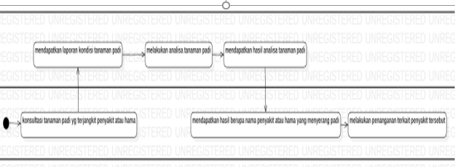

Fig. 1. Analysis of Current Business Process

Based on the current business process where farmers have to manually ask the expert system, and have to wait for the results of the analysis for a long time. For this reason, the proposed business process integrates a decision support system in a specially built application that will accurately produce disease results from inputs made by farmers.

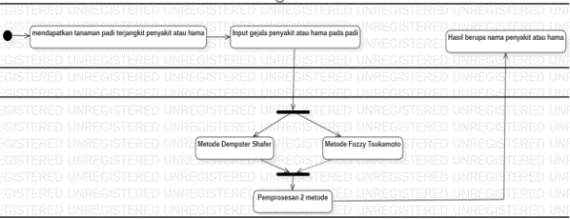

Fig. 2. Analysis of the Proposed Business Process

### *Use case diagrams*

In the use case section, this diagram explains what will be done by the application to be built and who will interact with the application. Use case diagrams to become expert/farmer activities and expert systems. It can be seen in Figure 3.

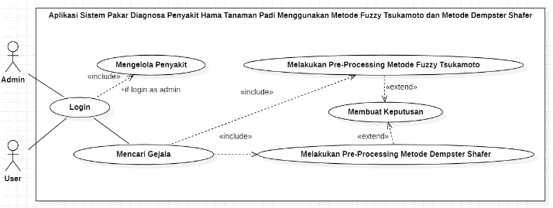

Fig. 3. Usecase Diagram

### *Sequence Diagrams*

Sequence diagram to look for case similarities, where this sequence diagram explains the process flow to find similar cases, then equates the data with the disease data that has been inputted by the previous suer, then pre-processing with the Fuzzy Tsukamoto Method and the Dempster Shafer Method to get later results. make decisions based on previously entered data. Here's Figure.

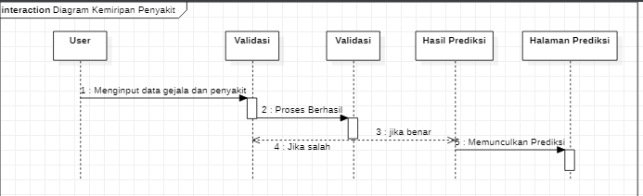

Fig. 4. Sequence Diagram Looking for Case Similarities

Sequence diagrams manage cases, namely the flow where, if the data has been inputted, it will give a decision according to the specified disease. Shown in Figure 5.

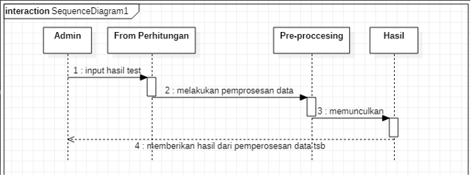

Fig. 5. Sequence Diagram of Managing Disease

### *Activity* *Diagrams*

Activity Diagram illustrates the process of Admin/User inputting data to carry out plant disease cases, then calculating the weight, doing pre-processing using the Fuzzy Tsukamoto Method and the Dempster Shafer Method to get the results and then making decisions based on the data that has been inputted by the previous Admin/User. Here in Figure 6.

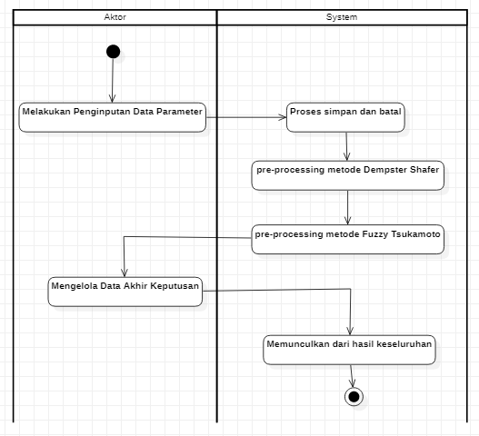

Fig. 6. Activity Diagram Looking for Symptoms Similarities

This Activity Diagram describes the process of Admin managing disease cases that have made a decision, based on the data that has been previously inputted. Here in Figure 7.

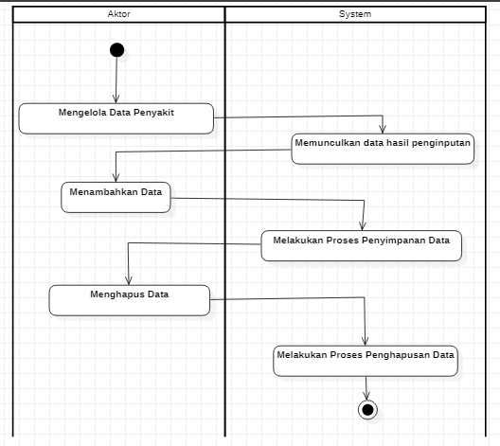

Fig. 7. Activity Diagram for Managing Disease Cases

### *Class Diagram*

Class diagrams describe the structure of the system in terms of defining the classes created to build the system. Each class has its own attributes and methods. Classes that exist in the system must be able to perform functions according to system requirements. The class diagram of this forecasting application can be seen in Figure 8.

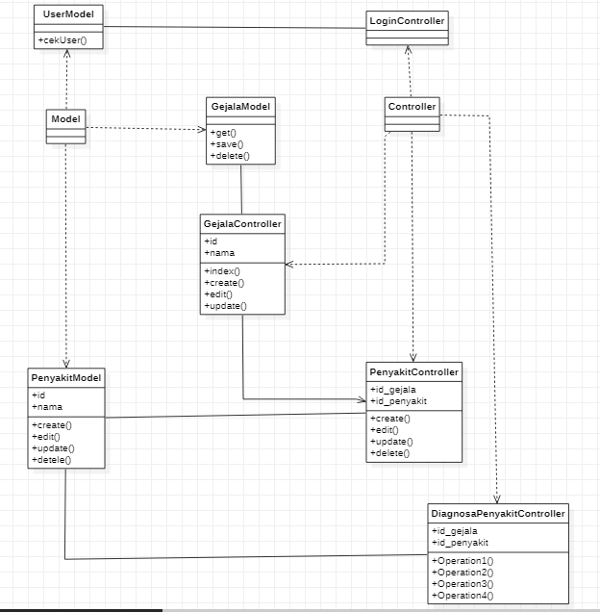

Fig. 8. Class Diagram

## *D. General Design*

1. *Interface Design*

The interface is a description of the application to be developed. The purpose of interface design is to design an effective interface for the software system so that it can be understood by users and the results are according to needs.

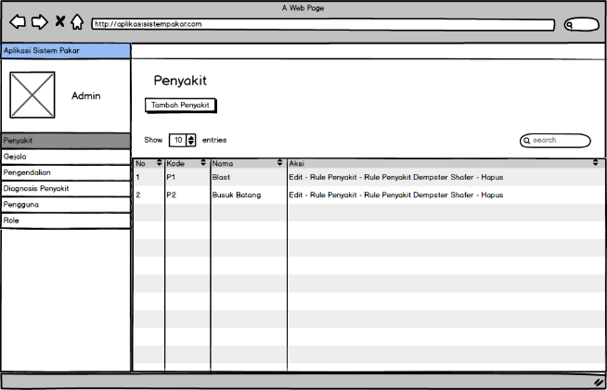

Fig. 9. Data Page Design

On the Data page menu above, there are several menus provided by the system, these menus are the criteria used in searching for a result. These criteria include tests that have been previously inputted. The criteria column will be filled in by the user according to the disease, which later the result of the search or the recommendation will be a diagnosis of disease in rice plants.

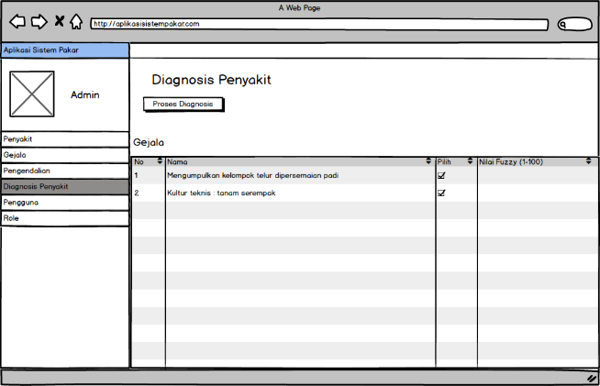

Fig. 10. Input Test Design

The input menu provided by the system for the user, where the function of this menu is to input the results of symptom and disease data.

1. *Database* *Design*

The first thing to do in building an expert system is to create a knowledge base structure. The knowledge base is a collection of facts. Some of the knowledge base structures in this expert system are as follows:

* Symptom knowledge base
* Disease knowledge base

In this case, a user can find out the type of disease and the value of his confidence level by entering the symptoms suffered by rice into the system so that the expert system with the Dempster Shafer Method and the Fuzzy Tsukamoto Method will match the symptoms entered with the type of disease that is present. on the basis of knowledge and also the system will provide a value for the certainty of the type of disease.

The knowledge base contains the types of diseases, the symptoms of rice diseases can be seen in table I.

TABLE I. Knowledge Base Symptoms of rice disease

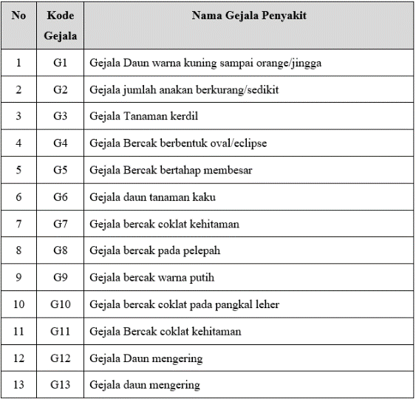

In table II below is a knowledge base containing all types of diseases that attack rice plants.

TABLE II. Rice Disease Knowledge Base

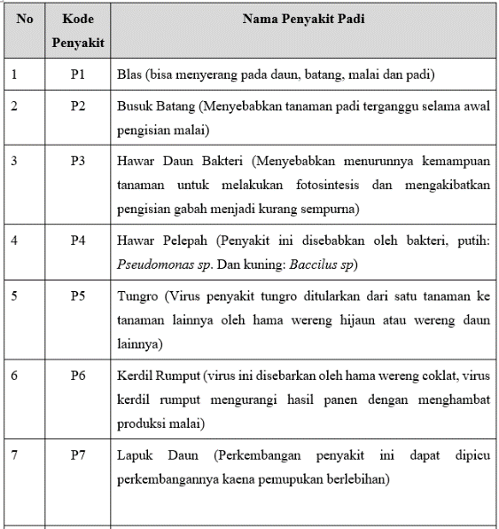

1. *Interface Imple*mentation

The implementation of the interface (User Interface) is an application of a design that has previously been made, below is the interface implementation of the expert system for diagnosing symptoms of rice pests using the Dempster Shafer and Fuzzy Tsukamoto algorithms.

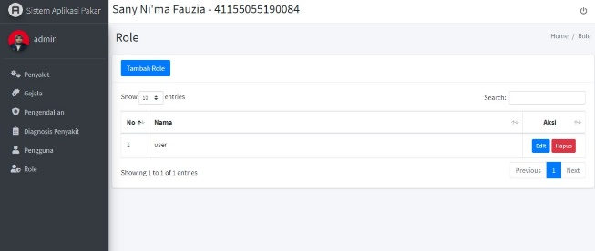

Fig. 11. Main Page

This page is the next page that can manage users to login, where there are several menus such as create, edit and delete.

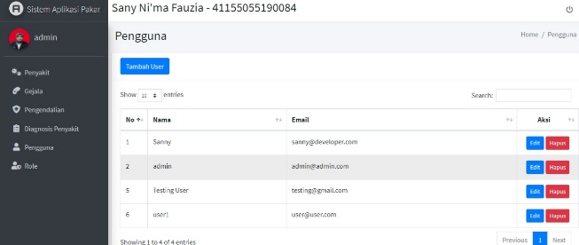

Fig. 12. User Page

Disease page is a page that can only be accessed by Admin/User who can later add, edit and delete disease data to be tested on Rice Plants.

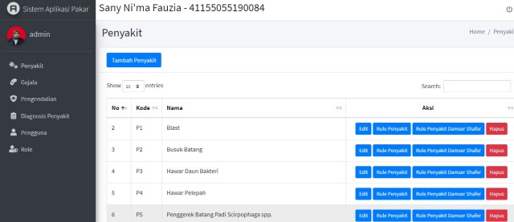

Fig. 13. Disease page

On this page, the user will be immediately presented with some symptVom data that was previously inputted, and can manage it such as adding, editing and deleting it.

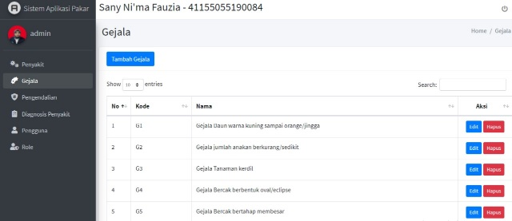

Fig. 14. Symptoms Page

1. *Database* *Implementation*

Implementation of this application database is based on the design that has been done. The implementation is shown from the screenshots contained on the database page, shown in Figures 15 to 18.

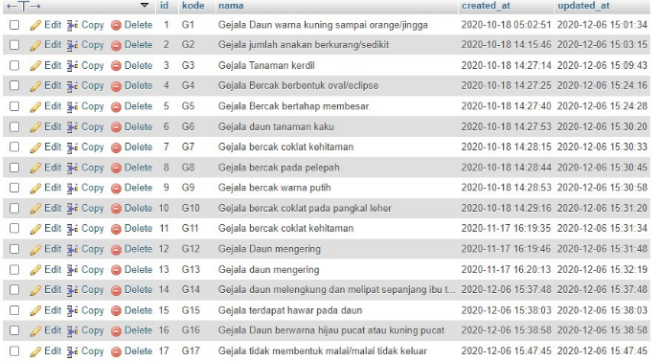

Fig. 15. Implementation of Symptom Table Database

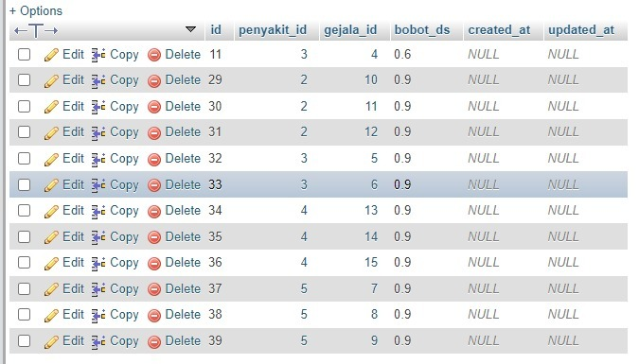

Fig. 16. Implementation of the Disease Table Database

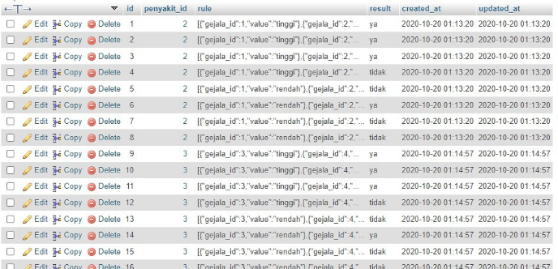

Fig. 17. Implementation of the Rule Disease Symptom Table Database

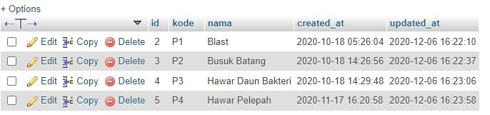

Fig. 18. Implementation of the Disease Data Table Database

# TESTING AND DISCUSSION

## *A. Functional Testing*

Functional testing is carried out to find out the location of errors or discrepancies that exist in the system that has been made. The tests that the researchers did were using black-box testing techniques. Black-box testing focuses on functional testing on the system being built. The results of the tests that have been carried out can be seen in the table III below:

TABLE III. Functional Testing

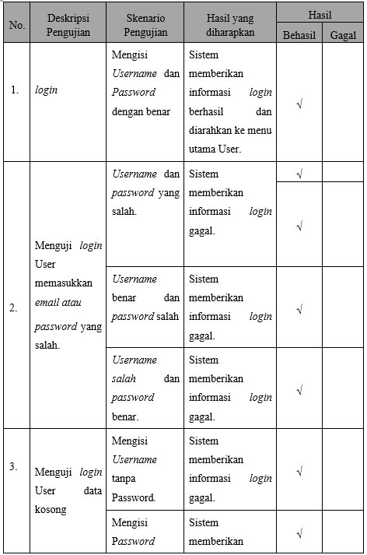

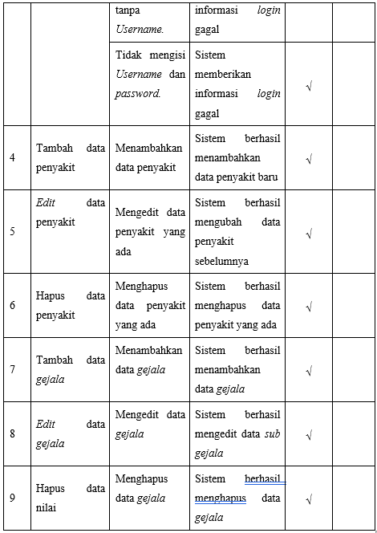

## *B. Algorithm Testing*

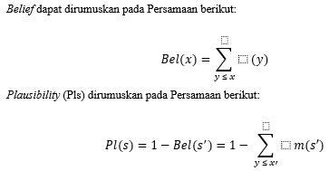

**Where:**

Bel(X) = Belief (X)

Pls(X) = Plausibility(X)

m(X) = mass function of (X)

m(Y) = mass function of (Y)

Plausibility is also worth 0 to 1, if you are sure of X' then it can be said Belief (X') = 1 so that from the formula the value of Pls (X) = 0. Several possible ranges between Belief and Plausibility can be seen in the following table:

TABLE III. Functional Testing

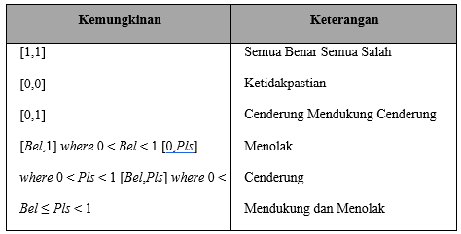

This theory is also known as the frame of discernment (FOD). which is denoted by. This FOD is a universe of talks from a set of hypotheses so that it is often called the environment (Adrian O'Neill, 2000), it can be formulated in the following equation:



**Where:**

Ø = FOD or environment

1,… n = Elements/parts in environment

## *C. Calculation Algorithm*

1. *Case 1 (1 Symptom)*

In this case, an example will be given by entering 1 symptom. For this calculation, suppose the user enters the symptoms of black spots on the leaf midrib.

Symptom 1: Black spots on the leaf midrib

Black spots were observed on the leaf midrib as a symptom of the disease with a value of m {P3} = 0.7, m {P4} = 0.4 for m1 the density value chosen was the highest, then:

m1 {P3} = 0.7

m1 {θ} = 1 – 0.7 = 0.3

From the calculation above, only one symptom is taken. So the results of the diagnosis can be concluded that the rice plant has stem rot disease.

1. *Cases 2 (1 Symptom)*

In this case, an example will be given by entering 2 symptoms. For this calculation, suppose the user enters the symptoms of black spots on the leaf midrib and the leaves change color to yellow/brown/gray.

Symptom 1: Black spots on the leaf midrib

Black spots were observed on the leaf midrib as a symptom of the disease with a value of m {P3} = 0.7, m {P4} = 0.4 for m1 the density value chosen was the highest, then:

m1 {P3} = 0.7

m1 { } = 1 – 0.7 = 0.3

Symptom 2: Leaves turn yellow/brown/grey

Then the addition of symptoms of leaves changing color to yellow/brown/gray, after observing these symptoms as symptoms of the disease with a density value of m{p5} = 0.7, m{p7} = 0.8 for m2 the density value chosen is the highest, so:

m2 {p5,p7} = 0.8

m2 {θ} = 1 – 0.8 = 0.2

Then the calculated new density values ​​for several combinations with the density function m3 can be seen in the following table:

TABLE IV. Combination Rules For m3 case 2

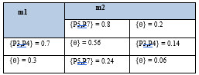

So, it can be calculated by the following equation:

m3 {p5, p7} = 0.24/(1-0.56) = 0.54

m3 {p3, p4} = 0.14/(1-0.56) = 0.31

m3 { } = 0.06/(1-0.56) = 0.14

From the results of these calculations, the highest density value is 0.54 it can be concluded that the disease that attacks rice plants is probably Tungro disease.

# CLOSING

## *A.* *Conclusion*

Research on an expert system for diagnosing rice pest disease symptoms using the Dempster Shafer and Fuzzy Tsukamoto algorithms, the conclusions are as follows:

The application of the Fuzzy Tsukamoto Method and the Dempster Shafer Method in an Expert System for Diagnosing Rice Pest Diseases starts from normalizing sample data and test data, where sample data is the amount of data provided by the application and test data is the amount of data inputted by the user, then it will be calculated by using Euclidean distance to determine the final value of the diagnosis of diseases in Rice Pest Plants.

Based on the results of the implementation and testing conducted by researchers, it can be concluded that:

1. In this study, a test process was carried out on rice data, it was known that the Fuzzy Tsukamoto and Dempster Shafer algorithms could be used for an expert system for the diagnosis of rice plant pests.
2. It is known from the test results that the data has a value above 60%, thus the Dempster Shafer algorithm is very accurate and can be used in the Expert System for Diagnosing Rice Pest Diseases because it gives results in the form of numbers (percent) different from the results by the Fuzzy Tsukamoto algorithm only gives Yes or No results, with a value with a percentage accuracy of 100% divided according to the symptoms entered.

## *B. Suggestion*

Research using the Fuzzy Tsukamoto Method and the Dempster Shafer Method has not yet entered the perfect stage and requires further development including:

1. Added new features and other functions to further enhance the previously created system.
2. Hopefully the next researcher can use more or better algorithms in getting maximum accuracy results.

# REFERENCE

1. D. Darmastuti, “Implementasi Metode *Fuzzy Tsukamoto* Dalam Sistem Pendeteksi Penyakit Jantung,” *J. Sist. dan Teknol. Inf.*, vol. 16, no. 2, pp. 1–6, 2019.
2. D. A. Rivai and B. E. Purnama, “Pembangunan Sistem Informasi Pengolahan Data Nilai Siswa Berbasis *Web* Pada Sekolah Menengah Kejuruan (SMK) Miftahul Huda Ngadirojo,” vol. 3, no. 2, pp. 19–25, 2014.
3. D. Priyanti, “Sistem Informasi Data Penduduk Pada Desa Bogoharjo Kecamatan Ngadirojo Kabupaten Pacitan,” *IJNS - Indones. J. Netw. Secur.*, vol. 2, no. 4, p. 56, 2013.
4. F. Wafiyah, N. Hidayat, and R. S. Perdana, “Implementasi Algoritma *Dempster Shafer* untuk Klasifikasi Penyakit Demam,” *J. Pengemb. Teknol. Inf. dan Ilmu Komputer. Univ. Brawijaya*, vol. 1, no. 10, pp. 1210–1219, 2017.
5. F. Nugraha, B. Surarso, and B. Noranita, “Sistem Pendukung Keputusan Evaluasi Pemilihan Pemenang Pengadaan Aset dengan Metode *Dempster Shafer* ,” *J. Sist. Inf. Bisnis*, vol. 2, no. 2, pp. 67–72, 2019.
6. H. M. S. A. Haviluddin; “Sistem Pendukung Keputusan Untuk Menentukan Siswa Masuk ke Suatu Jurusan,” *J. Inform. Mulawarman*, vol. 6, no. 3, pp. 98–104, 2018.
7. H. T. Sihotang and M. Siboro, “Aplikasi Sistem Pendukung Keputusan Penentuan Siswa Bermasalah Menggunakan Metode *Dempster Shafer* Pada Sekolah SMP Swasta Mulia Pratama Medan,” *J. Informatics Pelita Nusant.*, vol. 1, no. 1, pp. 1–6, 2008.
8. I. A. Nasution, “Sistem pendukung keputusan penentuan pemilihan laptop dengan menerapkan *fuzzy tahani*,” *Pelita Inform. Budi Darma, Vol. VI, Nomor 1, Maret 2014*, vol. VI, no. 0911378, pp. 93–96, 2017.
9. M Komarudin, “Pengujian perangkat Lunak metode *Black box* berbasis *partitions* pada aplikasi sistem informasi di sekolah,” *J. Mikrotik*, vol. o6, no. 1, pp. 02–16, 2016.
10. M. S. Mustaqbal, R. F. Firdaus, and H. Rahmadi, “Pengujian Aplikasi Menggunakan *Black Box Testing Boundary Value Analysis* (Studi kasus: Aplikasi Prediksi Kelulusan SNMPTN),” *Penguji. Apl. Menggunakan Black Box Test. Bound. Value Anal. (Studi Kasus Apl. Prediksi Kelulusan SNMPTN)*, vol. I, no. 3, p. 34, 2018.
11. N. L. G. P. Suwir Mayanti, “Penerapan Metode *Fuzzy Tsukamoto* Untuk Sistem Rekomendasi Pemilihan Mobil,” *Techno.Com*, vol. 16, no. 2, pp. 120–131, 2017.
12. N. Hidayati, “Penggunaan *Rapid Application Development* dalam Rancang Bangun Program Simpan Pinjam pada Koperasi,” *Intensif*, vol. 2, no. 2, p. 87, 2018.
13. N. Hermanto, “Sistem Pendukung Keputusan Menggunakan Metode *Fuzzy Tsukamoto* Untuk Menentukan Jurusan Pada Smk Bakti Purwokerto,” *Semin. Nas. Teknol. Inf. Komun. Terap. 2018 (Semantik 2012)*, vol. 2012, no. Semantik, pp. 52–62, 2018.
14. R. Fauzan, Y. Indrasari, and N. Muthia, “Sistem Pendukung Keputusan Penerimaan Beasiswa Bidik Misi di POLIBAN dengan Metode *Fuzzy Tsukamoto* Berbasis Web,” *J. Online Inform.*, vol. 2, no. 2, p. 79, 2018.
15. [R. *System*, “JURNAL RESTI Implementasi E - Modul pada Program Studi Manajemen Informatika,” vol. 2, no. 2, pp. 492–497, 2018.
16. Y. Radhitya, F. Nur Hakim, and A. Solechan, “Rancang Bangun Sistem Pendukung Keputusan Penentuan Penyakit Dalam Dengan Metode *Dempster Shafer*,” *J. Speed - Sentra Penelit. Eng. dan Edukasi*, vol. 8, no. 3, pp. 7–12, 2017.
17. Y. Utama, “Sistem Pendukung Keputusan Untuk Menentukan Prioritas Penanganan Perbaikan Jalan Menggunakan Metode *Fuzzy Tsukamoto*