Implementation of Data Mining to Predict Student Study Period with Decision Tree Algorithm (C4.5)

Kirana Alyssa Putri[1]*, Dimas Febriawan[2], Firman Noor Hasan[3]

Informatics Engineering, FTII Prof. DR. Hamka Muhammadiyah University [1], [2], [3]

Prof. DR. Hamka Muhammadiyah University

Jakarta, Indonesia

[kiranaalyssa.putri@gmail.com](mailto:kiranaalyssa.putri@gmail.com)[1], [dimas.febriawan@uhamka.ac.id](mailto:dimas.febriawan@uhamka.ac.id)[2], [firman.noorhasan@uhamka.ac.id](mailto:firman.noorhasan@uhamka.ac.id)[3]

***Abstract*—** **Graduating on time is what every student wants to accomplish in college. Students of Prof. Dr. Hamka Muhammadiyah University are one of those who have this dream. However, in many cases, students have difficulty in knowing the most important factors in achieving on-time graduation. A prediction analysis is needed to provide information about the student's graduation study period. Implementation of data mining is applied to this analysis, namely the classification function of the *decision tree (C4.5)* *algorithm* using RapidMiner tools. The methodology for implementing data mining follows the stages of *Knowledge Discovery In Database* (KDD), beginning with data collection, pre-processing, transformation, data mining, and evaluation. The achievements of the research are in the form of visualization and decision tree rules which provide information that the most influential factor in determining the student's study period is GPA. There is other information, namely, students graduated on time (≤4 years) amounted to 170 or 54.5% and students did not graduate on time (>4 years) amounted to 142 or 45.6%. Testing the performance of *decision tree (C4.5)* utilizing *confusion matrix* through RapidMiner tools resulted in accuracy reaching 83.87%, with precision of 87.50% and recall of 91.18%. Provides evidence that the *decision tree algorithm (C4.5)* has optimal performance to provide valuable information about predicting student graduation in order to increase student enrollment with the right study period.**

***Keywords— Decision Tree, C4.5 Algorithm, Prediction, Study Period, RapidMiner***

# Introduction

The University of Muhammadiyah Prof. DR. Hamka is a private university (PU) that has the vision and mission to produce outstanding graduates in both spiritual and academic intelligence. Based on this vision and mission, the university always provides professionalism and quality in every lesson. The goal is for students to develop their excellent competencies in the subjects they study and to graduate in a very timely manner [1]. Graduating on time has important functions for students, such as saving tuition fees and getting ready to enter the workforce more quickly. In addition, the importance of graduating on time is also related to the accreditation evaluation of the university [2], this can motivate universities to evaluate the development of students during the college term through the academic system and the support of lecturers. There is a need for information regarding student graduation based on academic data, which can be utilized to generate new knowledge, this will enable PU to better understand the conditions surrounding students' graduation [3]. As an educational institution, it should be able to manage data to enhance decision making, especially for the benefit of students [4].

According to the background explanation, data mining can be applied to predict the study period of PU students, particularly in the Faculty of Industrial Technology and Informatics (FTII). Data mining is the study of extracting useful knowledge from data, and the resulting insights have a significant impact on decision making [5]. The main goal of data mining is to identify meaningful data correlations and extract valuable new information using statistical techniques [6]. Data mining is an element of *Knowledge Discovery in Databases* (KDD) methods. KDD refers to a series of steps to identify valuable, easily understood information from data that was previously large in scale and high in complexity. In general, the KDD process, which is the basis of data mining, is data collection, pre-processing/cleaning, transformation, data mining and evaluation [7]. Data mining is categorized into description, estimation, prediction, classification, and clustering. One technique that is always used for predicting student graduation is classification [8]. Classification is a data analysis technique applied to group data into categories based on certain attributes. The classification process includes the following stages, the learning phase (training phase) where classification algorithms are applied to the training data to create classification rules which are then used to classify new data. The second stage is classification, with testing data that serves for accuracy calculation [9]. Various analytical methods applied in classification can be an appropriate choice for prediction [10]. There are various classification algorithms in data mining such as *decision tree, naïve bayes, support vector machine, k-nearest neighbor* [11].

The researchers employ one of the classification methods, specifically the *decision tree algorithm (C4.5).* This algorithm proves to be an optimal choice for predicting students' study time due to its advantages, such as being easy to understand and interpret, handling incomplete data, and managing datasets with numerous attributes [12]. The research aims to generate information from data that has been collected, and become the basis for predictions on new data. The dataset utilized comprises the graduation records of FTII PU students. Analysis is needed through testing the performance of the previously formed *decision tree* model. Performance testing through the application of *confusion matrix*, which is generated through comparison of the predicted results of the model with the actual results of the test. Data processing and performance testing of the *decision tree algorithm (C4.5)* are carried out using the help of RapidMiner. This tool provides solutions in data mining analysis. In RapidMiner, various methods such as the *Decision Tree (C4.5) algorithm* are available and can be applied to a set of data including calculations and trials [13].

There is a similar previous research conducted by Endang Etriyanti, Dedy Syamsuar, and Yesi Novaria Kunang (2020) with the title “Implementasi Data Mining Menggunakan Algoritme Naive Bayes Classifier dan C4.5 untuk Memprediksi Kelulusan Mahasiswa”. The findings of the research analysis produced information that the accuracy level of the *C4.5 decision tree algorithm* was 79.08% while the naïve bayes algorithm was only 78.46% [14]. Further research by Lydia Yohana Lumban Gaol, M. Safii, and Dedi Suhendro (2021) with the title "Prediksi Kelulusan Mahasiswa Stikom Tunas Bangsa Prodi Sistem Informasi Dengan Menggunakan Algoritma C4.5”. The research shows that the algorithm used is very good with an accuracy rate of 90.00% with precision 91.38% and recall 98.15% [8]. Another research by Agung Wibowo and Abdul Rohman (2022) entitled “Prediksi Predikat Kelulusan Mahasiswa Menggunakan Naive Bayes dan Decision Tree pada Universitas XYZ”. The focus of this research is to provide information about the description of students who achieve certain graduation predicates and analyze the factors that have an impact on achievement [15].

What makes this research different from previous studies is the utilization of distinct datasets and algorithms. In prior studies by Endang Etriyanti, Dedy Syamsuar, and Yesi Novaria Kunang (2020) and Agung Wibowo and Abdul Rohman (2022), two classification techniques were employed namely, the *naïve bayes algorithm* and *decision tree*. On the other hand, research conducted by Lydia Yohana Lumban Gaol, M. Safii, and Dedi Suhendro (2021) utilized alumni datasets as training data and final year student data as test data. The current research specifically employs a singular classification method, namely the *decision tree algorithm (C4.5)*, utilizing only the FTII PU alumni dataset, consisting of 312 data points as both training and test data, representing 20% of the total dataset.

# Research Methods

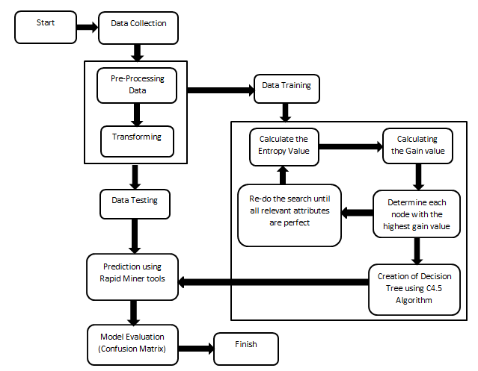

Figure 1. Stage Of The Research Method

* 1. ***Data Collection***

This research uses the data of FTII PU Student Graduation in 2021-2022 as the source of information in the analysis. This is the main data obtained directly from the university database. The data collection process is done through access and official procedures set by the university. This data includes 312 data, which consists of 7 columns, containing students id, total credit courses, GPA, research, length of study and yudisium. This data will be used in the analysis to identify patterns and gain insights into the study periods of students.

TABLE I. FTII PU Student Graduation (2021-2022)

|  |  |
| --- | --- |
| **Nama Atribut** | **Jenis Data** |
| ID | *Integer* |
| Total Credit Courses | *Integer* |
| GPA | *Float* |
| Research | *Text* |
| Length Of Study | *Integer* |
| Yudisium | *Text* |

## **Pre-processing/Cleaning**

This stage is the process of initial preparation and data cleaning. The purpose of this process is to clean the dataset by identifying and addressing potential errors and inconsistencies in the data that may exist. This process involves several steps that are performed in pre-processing [16]:

## Data Validation

This step is used to detect and remove noisy data. Data validation is employed to identify inconsistent and anomalous data. If data is found that could interfere with the subsequent analysis process, it will be deleted. This process is performed manually using Microsoft Excel software.

## Data Cleaning

The second stage involves the data cleaning process using RapidMiner tools to enhance speed and efficiency. Various operators are employed such as the read excel operator for reading data files in xlsx format. The missing value operator to replace missing values with zeros or, alternatively, with the average value of the entire dataset. Additionally, the remove duplicates operator is applied in this process to selectively eliminate attributes considered less influential in the subsequent analysis of student graduation data, specifically the Student ID and Yudisium attributes. The data cleaning process with RapidMiner is outlined as follows:

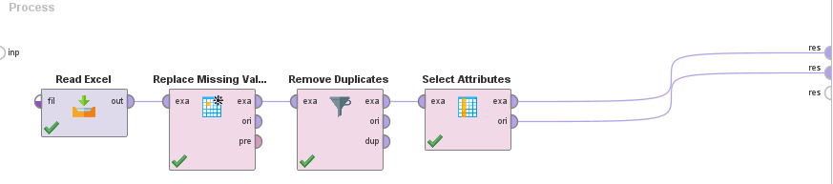

Figure 2. Cleaning and Select Attribute data process with RapidMiner

## **Transforming**

Data transformation is an optional stage in the data mining process, which means that this stage is implemented if necessary. This stage will classify the data to categorize the data based on certain attributes [17]. In this research, transforming is used to change the data class with a certain criteria classification to facilitate understanding of a large dataset of 312 data. The data type in table 1 which is the initial data is converted into binomial and polynomial data types according to data mining rules.

TABLE II. Data Transformation

| **Attribute Name** | **Data Type** | **Class Of Data Used** |
| --- | --- | --- |
| Total Credit Courses | *Binomial* | ≤ 150 Credit Courses, > 150 Credit Coruses |
| GPA | *Polynomial* | Statisfactory, Very Statisfactory, Cumlaude |
| Research | *Binomial* | Thesis, Publication |
| Length Of Study | *Binomial* | ≤ 4 Years, > 4 Years |

## **Data Mining**

The data mining method applied in this study is the *Decision Tree*, a technique with the capability to transform complex datasets into a hierarchical series of decisions, resembling a tree with branches and leaves that signify decisions and class labels. Each node in this structure represents an attribute that has been tested to make a decision [18]. In this research, using *Decision Tree* with the *C4.5 algorithm*. The *C4.5 algorithm* was invented through the development of the *ID3 algorithm* by Ross Quinlan. With a number of significant improvements, including the ability to handle missing values and noise in the dataset, simplify the interpretation of results, and produce more informative rules from the tree model formed [19]. In generating a *decision tree* with the *C4.5 algorithm*, several steps need to be taken. These steps are as follows [20]:

Calculate the *Entropy* of each attribute to determine the root node and other nodes that continue the formation of the *decision tree*, using the formula:

$Entropy\left(S\right)=\sum_{i=1}^{n}{- pi* \log_{2} pi}$ (1)

Description:

S : Dataset

n : Number Of Classes S

pi : Sum Of The Proportion of Si to S

Next, obtain *entropy* for all attributes, with the process of calculating the *gain* value using the formula:

*Gain*(S,A) = $Entropy\left(S\right)-\sum_{i=1}^{n}{\frac{ \left|si\right|}{\left|s\right|}*Entropy\left(Si\right)}$ (2)

Description:

S : Dataset

A : Features

n : Number Of Attribute Partitions

A |Si| : Number Of Data in the i-th partition

|S| : Number Of Data S

## **Result Evaluation**

*Confusion Matrix* is a method implemented in the process of testing classification patterns to gain an understanding of the performance of the prediction model. *Confusion Matrix* is a table containing various evaluation metrics where the predicted results of the model will be compared with the actual class of the input data. Using information from the *confusion matrix*, researchers can measure accuracy, precision, recall F1-score and other evaluation parameters [21] [22].

TABLE III. *Confusion Matrix* Table

| **Actual Classification** | **Prediction Classification** | |
| --- | --- | --- |
| Positive | Negative |
| Positive | *True Positive* (TP) | *True Negative* (TN) |
| Negative | *False Positive* (FP) | *False Negative* (FN) |

*Accuracy* = $\frac{TP+TN}{TP+TN+FP+FN}$ x 100% (3)

*Precision* = $\frac{TP}{TP+FP}$ 100% (4)

*Recall* = $\frac{TP}{TP+FN}$ 100% (5)

Description [23]:

TP = The amount of positive data correctly categorized by the system.

TN = The amount of negative data correctly classified by the system.

FP = The amount of negative data misclassified by the system as positive.

FN = The amount of positive data misclassified by the system as negative.

# Results And Discussion

In this section, the data is ready to enter the data mining stage, with the application of *decision tree (C4.5)* for pattern formation. The calculation of the *decision tree algorithm (C4.5)* uses the *entropy* and *gain* formulas to find the root node and the next node. In this research, the calculation uses Microsoft Excel software.

## **Calculation to Find Entropy**

In this study, the label is the length of study with the criteria ≤4 years and >4 years. The *Entropy* formula is as follows.

$Entropy\left(S\right)=\sum_{i=1}^{n}{- pi*\log_{2 }}$ pi

Means:

*Entropy*(Total) = ( *))

+ (* ))

*Entropy*(Total) = ( $(-\frac{170}{312}$ $\log_{2}$ $(\frac{170}{312}$* )) + ($(-\frac{142}{312}$ $\log_{2}$ $(\frac{142}{312}$* ))

= 0,994182507

TABLE IV. Total Entropy Calculation Of Data (Label)

|  |  |  |  |
| --- | --- | --- | --- |
| **Total Data** | **Length Of Study** | | **Entropy** |
| 312 | ≤ 4 Years | > 4 Years | 0.994182507 |
| 170 | 142 |

From table 4, it is known that students who graduated on time (≤4 years) amounted to 170, meaning 54.5% and students who did not graduate on time (>4 years) amounted to 142 or 45.6%. Then the *entropy* calculation is carried out from the entire number of cases, namely 312 data with the length of study label which results in 0.994182507. *Entropy* of length of study will be the basis for calculating *gain* on other attributes. Furthermore, looking for *entropy* in attributes such as GPA, Research and Total Credit Courses.

## **Entropy Calculation for GPA**

GPA is grouped into 3 categories: Satisfactory for students with GPA from 2.61 to 3.00, Very Satisfactory for students with GPA from 3.01 to 3.50 and Cumlaude for students with GPA from 3.51 to 4.00.

*Entropy*(GPA, Statisfactory) = ( $(-\frac{21}{118}$ $\log_{2}$ $(\frac{21}{118}$* )) + ( $(-\frac{97}{118}$ $\log_{2} (\frac{97}{118}$*\**)) = 0.675607358

*Entropy*(GPA, Very Statisfactory) = ( $(-\frac{111}{153}$ $\log_{2}$ $(\frac{111}{153}$* )) + ( $(-\frac{42}{153}$ $\log_{2}$ $(\frac{42}{153}$* )) = 0.847861745

*Entropy*(GPA, Cumlaude) = ( $(-\frac{38}{41}$ $\log_{2}$ $(\frac{38}{41}$* )) + ( $(-\frac{38}{41}$ $\log_{2}$ $(\frac{3}{41}$* )) = 0.377646321

## **Entropy Calculation for Research**

The research is categorized into two groups, namely Thesis for students who graduate with thesis research and Publication for students who graduate with publication (journal) research.

*Entropy*(Research, Thesis) = ( $(-\frac{165}{307}$ $\log_{2}$ $(\frac{165}{307}$* )) + ( $(-\frac{142}{307}$ $\log_{2}$ $(\frac{142}{307}$* )) = 0.995947431

*Entropy*(Research, Publication) = ( $(-\frac{5}{5}$ $\log_{2}$ $(\frac{5}{5}$* )) + ( $(-\frac{0}{5}$ $\log_{2}$ $(\frac{0}{5}$* )) = 0

## **Entropy Calculation for Total Credit Courses**

Total Credit Courses are grouped into 2 categories, namely ≤150 credit courses for students who complete less than or equal to 150 credits. Meanwhile, the >150 credit courses category is for students who complete more than 150 credits.

*Entropy*(Total Credit Courses, ≤150 Credit Courses) = ( $(-\frac{29}{64}$ $\log_{2}$ $(\frac{29}{64}$* )) + ( $(-\frac{35}{64}$ $\log_{2}$ $(\frac{35}{64}$* )) = 0.993650712

*Entropy*(Total Credit Courses, >150 Credit Courses) = ( $(-\frac{29}{64}$ $\log_{2}$ $(\frac{29}{64}$* )) + ( $(-\frac{35}{64}$ $\log_{2}$ $(\frac{35}{64}$* )) = 0.9863991

## **Calculation to Find Gain**

*Gain* calculation formula.

*Gain*(S,A) = $Entropy\left(S\right)-\sum_{i=1}^{n}{\frac{ \left|si\right|}{\left|s\right|}*Entropy\left(Si\right)}$

## **Gain Calculation for GPA**

*Gain*(Total, GPA) = $Entropy\left(Total\right)-\sum_{i=1}^{n}{\frac{\left|GPA\right|}{\left|Total\right|}*Entropy GPA}$

= 0.994182507 $-((\left(\frac{118}{312}\right)*0.675607358$) $-(\left(\frac{153}{312}\right)*0.847861745$) $-(\left(\frac{41}{312}\right)*0.377646321$))

= 0.273259384

## **Gain Calculation for Research**

*Gain*(Total, Research)

= $Entropy\left(Total\right)-\sum_{i=1}^{n}{\frac{\left|Research\right|}{\left|Total\right|}*Entropy Research}$

= 0.994182507 $- ((\left(\frac{307}{312}\right)*$ 0.995947431) $-(\left(\frac{5}{312}\right)*$ 0))

= 0.014195772

## **Gain Calculation for Credit Courses**

*Gain*(Total, Total Credit Courses)

= $Entropy\left(Total\right)-\sum_{i=1}^{n}{\frac{\left|Total Credit Courses\right|}{\left|Total\right|} * Entropy Total Credit Courses }$

= $0.994182507 -((\left(\frac{64}{312}\right)*$ 0.993650712) $+ (\left(\frac{248}{312}\right)*$ 0.9863991))

= 0.006295897

Determining the root node involves selecting the *gain* with the largest value. In this case, the root node is GPA, which exhibits the highest gain of 0.273259384. The GPA attribute is divided into three partitions namely Satisfactory with entropy 0.675607358, Very Satisfactory with entropy 0.847861745, and Cumlaude with entropy 0.377646321. The stopping criterion is set at zero. In other words, this attribute no longer provides further information. Since none of the three partitions of the GPA attribute have reached zero, the *decision tree* process continues. However, if all *entropy* values on the attribute become zero, the *decision tree* process will stop [24]. Similarly, with the selection of the highest *entropy* value, which is 0.847861745 for the very satisfactory category, this value is used as the basis for calculating the total *entropy* in finding node 1.2. The calculation is performed in the same manner. Below is the initial display of the *decision tree* formation with GPA as the root node.

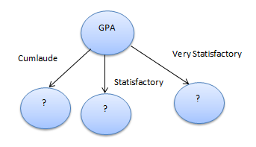

Figure 3. Initial Decision Tree

First calculate the node for GPA (Very Satisfactory) which gets the largest gain result, namely Research and is selected to be the next node 1.2. Then, the partition with the largest *entropy* is Thesis to continue the decision tree node 1.3. The last node is Total Credit Courses, so the calculation for node 1 is complete.

TABLE V. Node 1.2 Calculation Results

| **Node**  **1.2** | **Category** | **Data** | **≤4**  **Years** | **>4**  **Years** | **Entropy** | **Gain** |
| --- | --- | --- | --- | --- | --- | --- |
| GPA | Very Statisfactory | 153 | 111 | 42 | 0.847861745 |  |
| Research |  |  |  |  |  | 0.006099049 |
|  | Thesis | 151 | 109 | 42 | 0.852911871 |  |
|  | Publication | 2 | 2 | 0 | 0 |  |
| Total  Credit  Courses |  |  |  |  |  | 0.000228158 |
|  | ≤150 Credit  Courses | 31 | 22 | 9 | 0.869137581 |  |
|  | >150 Credit  Courses | 122 | 89 | 33 | 0.842169458 |  |

TABLE VI. Node 1.3 Calculation Results

|  |  |  |  |  |  |  |
| --- | --- | --- | --- | --- | --- | --- |
| **Node**  **1.3** | **Category** | **Data** | **≤ 4 Years** | **> 4 Years** | **Entropy** | **Gain** |
| Research | Thesis | 151 | 109 | 42 | 0.852911871 |  |
| Total Credit Courses |  |  |  |  |  | 0.000420544 |
|  | ≤150 Credit Courses | 30 | 21 | 9 | 0.881290899 |  |
|  | >150 Credit Courses | 121 | 88 | 33 | 0.845350937 |  |

Here are the decision trees for nodes 1, 1.2, and 1.3:

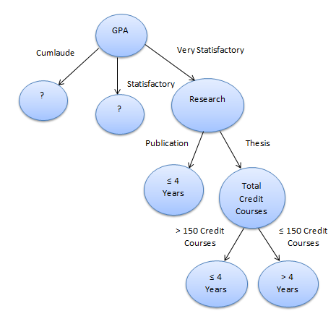

Figure 4. Node 1 Decision Tree

The calculation of *entropy* and *gain* will be done in the same way, satisfactory partition will be used in getting node 2 and cumlaude partition to get node 3. Below is a calculation table and a picture of the completed *decision tree*:

TABLE VII. Node 2 Calculation Results

|  |  |  |  |  |  |  |
| --- | --- | --- | --- | --- | --- | --- |
| **Node**  **2** | **Category** | **Data** | **≤ 4 Years** | **> 4 Years** | **Entropy** | **Gain** |
| GPA | Statisfactory | 118 | 21 | 97 | 0.675607358 |  |
| Research |  |  |  |  |  | 0 |
|  | Thesis | 118 | 21 | 97 | 0.675607358 |  |
|  | Publication | 0 | 0 | 0 | 0 |  |
| Total Credit Courses |  |  |  |  |  | 5,61756E-07 |
|  | ≤150 Credit Courses | 28 | 5 | 23 | 0.67694187 |  |
|  | >150 Credit Courses | 90 | 16 | 74 | 0.67519144 |  |

TABLE VIII. Node 3 Calculation Results

|  |  |  |  |  |  |  |
| --- | --- | --- | --- | --- | --- | --- |
| **Node**  **3** | **Category** | **Data** | **≤ 4 Years** | **> 4 Years** | **Entropy** | **Gain** |
| GPA | Cumlaude | 41 | 38 | 3 | 0.377646321 |  |
| Research |  |  |  |  |  | 0.008342604 |
|  | Thesis | 38 | 35 | 3 | 0.398459274 |  |
|  | Publication | 3 | 3 | 0 | 0 |  |
| Total Credit Courses |  |  |  |  |  | 0.118317676 |
|  | ≤150 Credit Courses | 4 | 2 | 2 | 1 |  |
|  | >150 Credit Courses | 37 | 36 | 1 | 0.179256067 |  |

TABLE IX. Node 3.2 Calculation Results

| **Node 3.2** | **Category** | **Data** | **≤4**  **Years** | **>4**  **Years** | **Entropy** | **Gain** |
| --- | --- | --- | --- | --- | --- | --- |
| Total  Credit Courses | >150 Credit Courses | 37 | 36 | 1 | 0.1792  56067 |  |
| Research |  |  |  |  |  | 0 |
|  | Thesis | 33 | 33 | 0 | 0 |  |
|  | Publication | 4 | 4 | 0 | 0 |  |

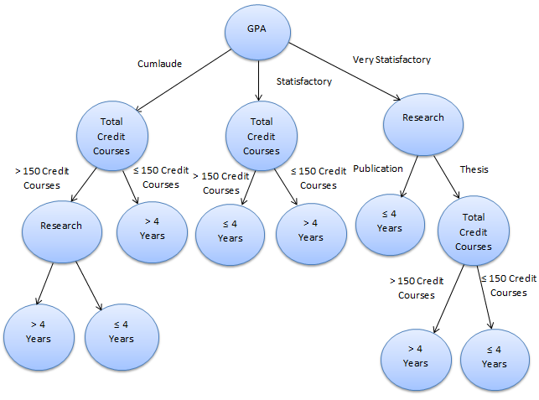

Figure 5. Final Result Of *C4.5 Algorithm Decision Tree*

The results of the *decision tree* model with RapidMiner for student graduation data are as follows:

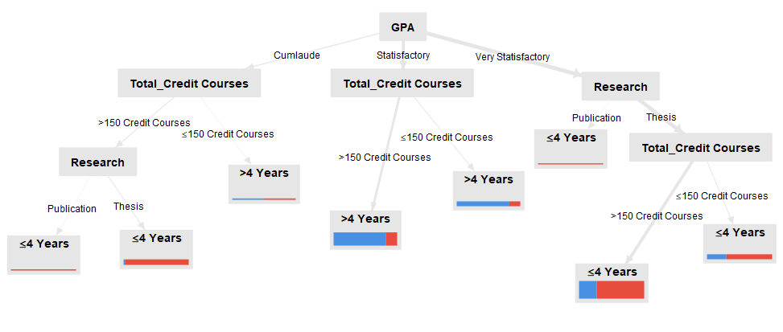

Figure 6. *Decision Tree (C4.5)* Results with RapidMiner

Calculations using Microsoft Excel software with *entropy* and *gain* formulas display the same results as the results of the *decision tree* using RapidMiner tools. This shows that the calculations that have been done are correct according to the rules of the *decision tree algorithm (C4.5)*.

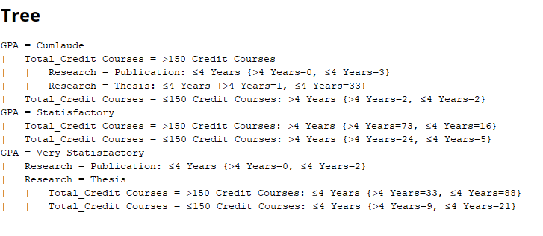

Figure 7. Description Of Data Processing Results Of FTII PU Student Graduation

There is a textual description of the decision tree model formed from the *C4.5* *algorithm*. This description shows that the *decision tree algorithm (C4.5)* is a good analytical technique for drawing conclusions from data that is easy to understand because it is visualized in a *decision tree*. Below is an explanation of the rules generated.

1. Rule 1 GPA = Cumlaude, Total Credit Courses = >150 Credit Courses and Research = Publication, then Length Of Study ≤ 4 Years.
2. Rule 2 GPA = Cumlaude, Total Credit Courses = ≤150 Credit Courses and Research = Thesis, then Length Of Study ≤ 4 Year.
3. Rule 3 GPA = Cumlaude dan Total Credit Courses =

≤150 Credit Courses, then Length Of Study > 4 Years.

1. Rule 4 GPA = Statisfactory and Total Credit Courses = >150 Credit Courses, then Length Of Study > 4 Years.
2. Rule 5 GPA = Statisfactory and Total Credit Courses = ≤150 Credit Courses, then Length Of Study > 4 Years.
3. Rule 6 GPA = Very Statisfactory and Research = Publication, then Length Of Study ≤ 4 Years.
4. Rule 7 GPA = Very Statisfactory, Research = Thesis and Total Credit Courses = >150 Credit Courses, then Length Of Study ≤ 4 Years.
5. Rule 8 GPA = Very Statisfactory, Research = Thesis and Total Credit Courses = ≤150 Credit Courses, then Length Of Study ≤4 Years.

## **Evaluation Of Results**

The performance testing analysis of the *decision tree algorithm (C4.5)*, formed from the graduation data of FTII PU students in 2021-2022, is conducted using a *confusion matrix*. Various RapidMiner operators, such as the split data, are utilized to divide the data into training data (80% of the total original data) and test data (20% of the original data). The apply model operator is then employed to apply models previously trained using the training data to unlabeled data (testing data) [25]. And the last operator is performance for accuracy testing with a *confusion matrix*. The subsequent section outlines the accuracy testing process using RapidMiner tools*.*

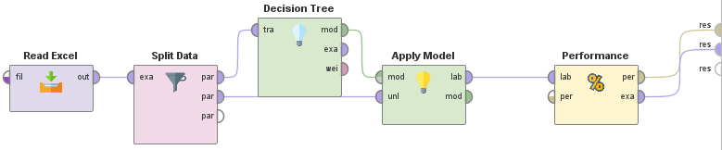

Figure 8. *Confusion Matrix* Accuracy Process

The following are the results of the *confusion matrix* for calculating the accuracy of the *decision tree algorithm (C4.5)*.

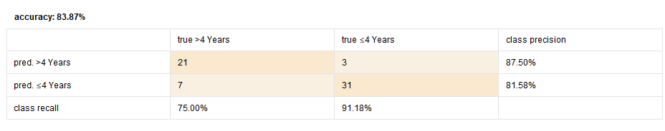

Figure 9. Accuracy Value Of *C4.5 Decision Tree Algorithm*

The results show that the accuracy of the performance of the *decision tree algorithm (C4.5)* for FTII PU student graduation data is 83.87%. This means that the information that has been known for predicting student graduation is good enough and can be used for decision making.

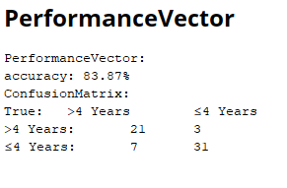

Figure 10. *C4.5 Algorithm* Vector Performance Value

# Conclusion

The *decision tree algorithm (C4.5)* which is applied to predict the duration of time or study period for FTII students at Prof. Dr. Hamka Muhammadiyah University in 2021-2022, produces information or knowledge about the most influential factor in determining student study time, namely GPA with an accuracy rate of 83.87%, precision reaching 87.50% and recall of 91.18%. Further information obtained, namely students who completed graduation on time (≤4 years) amounted to 170 or 54.5% and students who did not completed graduation on time (>4 years) amounted to 142 or 45.6%. In addition, there are 8 rules from the *decision tree* based on student graduation data that has been processed. Thus, the explanation of graduation prediction information will be easier to understand for universities and students. The conclusion of this research is that the prediction pattern formed through the *decision tree algorithm (C4.5)* has good performance in providing knowledge about student graduation. This can support universities in making decisions to increase the number of students with an on time study period and present this information to students through the academic system. Thus, students can know the factors that affect the study period and plan the lecture strategy from the beginning, aiming to achieve graduation according to the expected schedule.

##### References

[1] T. M. S. Manurung, “Pengaruh Motivasi dan Perilaku Belajar Terhadap Prestasi Akademik Mahasiswa,” *JAS-PT J. Anal. Sist. Pendidik. Tinggi*, vol. 1, no. 1, p. 17, 2017, doi: 10.36339/jaspt.v1i1.36.

[2] E. Etriyanti, “Perbandingan Tingkat Akurasi Metode KNN Dan Decision Tree Dalam Memprediksi Lama Studi Mahasiswa,” *J. Ilm. Bin. STMIK Bina Nusant. Jaya Lubuklinggau*, vol. 3, no. 1, pp. 6–14, 2021, doi: 10.52303/jb.v3i1.40.

[3] F. N. Hasan and A. Febriandirza, “Perancangan Data Warehouse Untuk Data Penelitian Di Perguruan Tinggi Menggunakan Pendekatan Nine Steps Methodologhy,” *Pseudocode*, vol. 8, no. 1, pp. 49–57, 2021, doi: 10.33369/pseudocode.8.1.49-57.

[4] F. N. Hasan and I. ketut Sudaryana, “Penerapan Business Intelligence & Online Analytical Processing untuk Data-Data Penelitian dan Luarannya pada Perguruan Tinggi Menggunakan Pentaho,” *Infotech J. Technol. Inf.*, vol. 8, no. 2, pp. 85–92, 2022, doi: 10.37365/jti.v8i2.143.

[5] A. Algarni, “Data Mining in Education,” *Data Min. Educ.*, vol. 7, no. 6, pp. 58–77, 2016, doi: 10.4018/978-1-5225-1877-8.ch005.

[6] A. O. P. Dewi, “Big Data di Perpustakaan dengan Memanfaatkan Data Mining,” *Anuva J. Kaji. Budaya, Perpustakaan, dan Inf.*, vol. 4, no. 2, pp. 223–230, 2020, doi: 10.14710/anuva.4.2.223-230.

[7] M. Azhari, Z. Situmorang, and R. Rosnelly, “Perbandingan Akurasi, Recall, dan Presisi Klasifikasi pada Algoritma C4.5, Random Forest, SVM dan Naive Bayes,” *J. Media Inform. Budidarma*, vol. 5, no. 2, p. 640, 2021, doi: 10.30865/mib.v5i2.2937.

[8] L. Y. Lumban Gaol, M. Safii, and D. Suhendro, “Prediksi Kelulusan Mahasiswa Stikom Tunas Bangsa Prodi Sistem Informasi Dengan Menggunakan Algoritma C4.5,” *Brahmana J. Penerapan Kecerdasan Buatan*, vol. 2, no. 2, pp. 97–106, 2021, doi: 10.30645/brahmana.v2i2.71.

[9] M. R. Fahdia, D. Riana, F. Amsury, I. Saputra, and N. Ruhyana, “Komparasi Algoritma Klasifikasi untuk Orientasi Minat Mahasiswa dalam Penuntasan Studi,” *JIRA J. Inov. dan Ris. Akad.*, vol. 2, no. 7, pp. 970–1007, 2021, doi: 10.47387/jira.v2i7.185.

[10] Y. Mardi, “Data Mining : Klasifikasi Menggunakan Algoritma C4 . 5,” *J. Edik Inform.*, vol. 2, no. 2, pp. 213–219, 2019, doi: https://doi.org/10.22202/ei.2016.v2i2.1465.

[11] S. Widaningsih, “Perbandingan Metode Data Mining Untuk Prediksi Nilai Dan Waktu Kelulusan Mahasiswa Prodi Teknik Informatika Dengan Algoritma C4,5, Naïve Bayes, Knn Dan Svm,” *J. Tekno Insentif*, vol. 13, no. 1, pp. 16–25, 2019, doi: 10.36787/jti.v13i1.78.

[12] Y. S. Luvia, D. Hartama, A. P. Windarto, and Solikhun, “Penerapan Algoritma C4.5 Untuk Klasifikasi Predikat Keberhasilan Mahasiswa Di Amik Tunas Bangsa,” *Jurasik (Jurnal Ris. Sist. Inf. dan Tek. Inform.*, vol. 1, no. 1, p. 75, 2017, doi: 10.30645/jurasik.v1i1.12.

[13] M. Ardiansyah, A. Sunyoto, and E. T. Luthfi, “Analisis Perbandingan Akurasi Algoritma Naïve Bayes Dan C4.5 untuk Klasifikasi Diabetes,” *Edumatic J. Pendidik. Inform.*, vol. 5, no. 2, pp. 147–156, 2021, doi: 10.29408/edumatic.v5i2.3424.

[14] E. Etriyanti, D. Syamsuar, and Y. N. Kunang, “Implementasi Data Mining Menggunakan Algoritme Naive Bayes Classifier dan C4.5 untuk Memprediksi Kelulusan Mahasiswa,” *Telematika*, vol. 13, no. 1, pp. 56–67, 2020, doi: 10.35671/telematika.v13i1.881.

[15] A. Wibowo and A. Rohman, “Prediksi Predikat Kelulusan Mahasiswa Menggunakan Naive Bayes dan Decision Tree pada Universitas XYZ,” *Expert J. Manaj. Sist. Inf. dan Teknol.*, vol. 12, no. 2, p. 104, 2022, doi: 10.36448/expert.v12i2.2810.

[16] A. H. Nasrullah, “Implementasi Algoritma Decision Tree Untuk Klasifikasi Produk Laris,” *J. Pilar Nusa Mandiri*, vol. 7, no. 2, p. 217, 2021, doi: https://doi.org/10.35329/jiik.v7i2.203.

[17] D. Anggraeni and T. Christy, “Analisa Kinerja Algoritma C4.5 Dalam Menentukan Pola Dominasi Mainstream Mahasiswa,” *Jurikom*, vol. 6, no. 4, pp. 333–339, 2019, doi: http://dx.doi.org/10.30865/jurikom.v6i4.1333.

[18] S. U. Putri, E. Irawan, and F. Rizky, “Implementasi Data Mining Untuk Prediksi Penyakit Diabetes Dengan Algoritma C4.5,” *J. Penerapan Sist. Inf. (Komputer Manajemen)*, vol. 2, no. 1, pp. 39–46, 2021, doi: https://doi.org/10.30645/kesatria.v2i1.56.

[19] I. Sutoyo, “Implementasi Algoritma Decision Tree Untuk Klasifikasi Data Peserta Didik,” vol. 14, no. 2, pp. 217–224, 2018, doi: https://doi.org/10.33480/pilar.v14i2.70.

[20] D. A. Ningtyas, M. Wahyudi, and N. Nurajijah, “Klasifikasi Siswa Smk Berpotensi Putus Sekolah Menggunakan Algoritma Decision Tree, Support Vector Machine Dan Naive Bayes,” *J. Khatulistiwa Inform.*, vol. 7, no. 2, pp. 85–90, 2019, doi: 10.31294/jki.v7i2.6839.

[21] D. Ardiansyah and W. Walim, “Algoritma C4.5 Untuk Klasifikasi Calon Peserta Lomba Cerdas Cermat Siswa Smp Dengan Menggunakan Aplikasi Rapid Miner,” *J. Inkofar*, vol. 1, no. 2, pp. 5–12, 2019, doi: 10.46846/jurnalinkofar.v1i2.29.

[22] A. Surahmat and M. Sutrisno, “Analisis Kepuasan Pelanggan Dalam Industri Teknologi Menggunakan Algoritma C4.5,” *Anal. Kepuasan Pelangg. Dalam Ind. Teknol. Menggunakan Algoritm. C4.5*, vol. 13, no. 2, pp. 75–79, 2023, doi: https://doi.org/10.24853/justit.13.2.75-79.

[23] F. Sidik, I. Suhada, A. H. Anwar, and F. N. Hasan, “Analisis Sentimen Terhadap Pembelajaran Daring Dengan Algoritma Naive Bayes Classifier,” *J. Linguist. Komputasional*, vol. 5, no. 1, p. 34, 2022, doi: 10.26418/jlk.v5i1.79.

[24] S. Faisal, “Klasifikasi Data Minning Menggunakan Algoritma C4.5 Terhadap Kepuasan Pelanggan Sewa Kamera Cikarang,” *Techno Xplore J. Ilmu Komput. dan Teknol. Inf.*, vol. 4, no. 1, pp. 1–8, 2019, doi: 10.36805/technoxplore.v4i1.541.

[25] L. A. R. Malik, M. Kamayani, and F. N. Hasan, “Faktor-faktor Yang Mempengaruhi Minat Calon Mahasiswa Baru Mendaftar Pada FTII Uhamka Menggunakan Algoritma K-Nearest Neighbor (K-NN),” vol. 9, no. 1, 2023, doi: https://doi.org/10.37365/jti.v9i1.163.