Classification of Student Grade Data Using the K-Means Clustering Method

Lanjar Pamungkas[1], Nur Aela Dewi[2]*, Nessia Alfadila Putri[3]

Information System, Faculty of Informatics[1], [2], [3]

Telkom Purwokerto Institute of Technology

Purwokerto, Banyumas, Indonesia

20103043@ittelkom-pwt.ac.id[3], 20103064@ittelkom-pwt.ac.id[1], [20103061@ittelkom-pwt.ac.id[2](mailto:20103061@ittelkom-pwt.ac.id[2)],

***Abstract*—** **The era of industrial revolution 4.0 is bringing rapid changes in education thanks to advances in technology and automation. These changes affect lifestyles and learning processes. In the education sector, challenges arise in the automation of student-grade data processing due to large volumes of data. One of the relevant approaches to overcome this problem is to classify the data. In this research, the K-Means Clustering method is used to organize student grade data. The purpose of this research is to understand the pattern of students' academic behavior and provide recommendations to improve the quality of learning. This research involves collecting student grade data, implementing the K-Means Clustering algorithm, and testing with the Elbow method to determine the most optimal number of clusters. Students' grade data from the Information System Study Programme at Telkom Institute of Technology Purwokerto were sampled in this research. The results showed that students could be grouped into three segments: "Diligent" with high academic performance (GPA: 3.74 - 3.96, SKS Taken: 63 - 150), "Not bad" with fairly good performance (GPA: 2.92 - 3.72, SKS Taken: varied), and "Lazy" with low performance (GPA: 2.35, SKS Taken: 14). The use of the K-Means Clustering method and testing with the Elbow method helped to efficiently identify patterns of student academic behavior. The findings provide valuable insights for educational institutions to make informed decisions in improving learning and providing better support for students.**

***Keywords—*** ***Clustering, Data, Education, Elbow, K-Means***

***Abstrak*— Era revolusi industri 4.0 membawa perubahan pesat dalam pendidikan berkat kemajuan teknologi dan otomatisasi. Perubahan ini mempengaruhi gaya hidup dan proses pembelajaran. Di sektor pendidikan, tantangan muncul dalam otomatisasi pengolahan data nilai mahasiswa karena volume data yang besar. Salah satu pendekatan yang relevan untuk mengatasi masalah ini adalah dengan mengklasifikasikan data tersebut. Dalam penelitian ini, digunakan metode Clustering K-Means untuk melakukan klasifikasi data nilai mahasiswa. Tujuan penelitian ini adalah untuk memahami pola perilaku akademik mahasiswa dan memberikan rekomendasi untuk meningkatkan kualitas pembelajaran. Penelitian ini melibatkan tahap pengumpulan data nilai mahasiswa, implementasi algoritma Clustering K-Means, dan pengujian dengan metode Elbow untuk menentukan jumlah cluster yang paling optimal. Data nilai mahasiswa dari Program Studi Sistem Informasi di Institut Teknologi Telkom Purwokerto dijadikan sampel dalam penelitian ini. Hasil penelitian menunjukkan bahwa mahasiswa dapat dikelompokkan menjadi tiga segmen: "Rajin" dengan performa akademik tinggi (IPK: 3.74 - 3.96, SKS Terambil: 63 - 150), "Lumayan" dengan performa cukup baik (IPK: 2.92 - 3.72, SKS Terambil: bervariasi), dan "Pemalas" dengan performa rendah (IPK: 2.35, SKS Terambil: 14). Penggunaan metode Clustering K-Means dan pengujian dengan metode Elbow membantu mengidentifikasi pola perilaku akademik mahasiswa secara efisien. Temuan ini memberikan wawasan berharga bagi institusi pendidikan untuk membuat keputusan yang tepat dalam meningkatkan pembelajaran dan memberikan dukungan yang lebih baik bagi mahasiswa.**

***Kata Kunci—*** ***Clustering, Data, Pendidikan, Elbow, K-Means***

# INTRODUCTION

The era of industrial revolution 4.0, which is marked by the very rapid development of technology and machines, has brought significant changes in various areas of life. One of the sectors most affected is the world of education. In this context, these changes force the world of education to adapt to the major changes currently occurring[1]. With the rapid development of technology in this modern era, automation processes have become increasingly common in various aspects of life. This leads to reduced human involvement in many jobs that previously required manual intervention. One sector that has adopted the application of automation quite significantly is the education sector. Through automation, the education sector has undergone a transformation that has resulted in convenience and efficiency in various aspects[2]. The application of automation in the education sector has brought great benefits, especially in processing student grade data. This data is not only valuable for increasing understanding of student academic performance and achievement, but also becomes an important asset for educational institutions. However, the increasing abundance of data collected has brought new challenges in processing it efficiently and effectively[3].

In the era of advances in information technology and increasingly widespread use of data, it cannot be denied that data classification has become a very relevant and important approach to facing complex challenges. Through the data classification process, the main goal to be achieved is to carefully group data into various relevant categories or classes, based on patterns or special features contained in the dataset. In the context of the education sector, the application of advanced data classification techniques provides a major opportunity to improve understanding, decision making, and efficiency in managing student grades data, opening the door to significant improvements in education delivery[4]. The ability to have a model or function that is able to accurately differentiate between various classes of data has opened a wide door to increasing in-depth understanding of the characteristics of students in certain groups in the world of education. Using these models, it is possible to gain deeper insight into student academic behavior patterns, identify significant trends, and identify challenges that need to be addressed. More than just analysis, these capabilities make it possible to provide appropriate recommendations and appropriate actions to improve the quality of learning and assessment, bringing meaningful improvements to sustainable education systems.

K-Means clustering is a technique applied to group data in a classification manner. This method is a grouping method that is often used in research and is included in the category of clustering methods in Data Mining[5]. The K-Means Clustering method is used to classify student score data. Through experimentation and analysis, it is hoped that it can reveal valuable insights about academic patterns that provide benefits for educational institutions in improving the learning process and student guidance. The decision-making process regarding the results of evaluations and assessments of students is carried out by lecturers during the learning process. The ratings for the "Lazy," "Decent," and "Diligent" categories are determined based on several factors, including the number of credits taken, credits not yet taken, number of D grades, number of E grades, and the student's GPA. The "Lazy" category is given if a student has a lot of credits not taken, a high number of D and E grades, and a low GPA. Meanwhile, the "Excellent" category is given to students who have made fairly good progress, with an adequate number of credits taken, a moderate number of D and E grades, and a satisfactory GPA. Students who are included in the "Diligent" category are students who have completed many credits, have a small number of D and E grades, and have a high GPA. This category assessment helps describe academic performance and the level of student seriousness in facing learning challenges.

Data mining, as an increasingly important concept in the digital information era, is a very significant process in modern data analysis. This process involves searching, mining, and analyzing large amounts of data stored in repositories with a very systematic approach. Through data mining, the main goal is to discover hidden relationships, unexpected patterns, and new trends that may not be discovered by conventional analysis methods. Thus, the data mining process plays a central role in extracting previously unknown, but of high significance, valuable information from large and complex databases. In this context, data mining is not just an analytical tool, but is also the key to uncovering deep knowledge and has the potential to change the way we understand and make decisions in various fields, from business to science[6]. This complex data mining process relies on sophisticated pattern recognition technology, and utilizes a variety of powerful statistical and mathematical techniques. The goal is to uncover hidden patterns and knowledge that has significant value from within this large amount of data. By combining computational intelligence, in-depth mathematical analysis, and specialized algorithms, this process becomes a highly effective tool in unraveling the complexity of modern data. Thus, data mining is not just an analytical tool, but also an important bridge to deeper understanding and more efficient problem solving in a variety of contexts, from business to scientific research[7]. Data Mining is an important concept in data analysis, which clearly describes the process of searching and discovering hidden information or knowledge in a database. This process involves the use of a variety of methods and techniques, including statistics, mathematics, and pattern recognition technology, with the aim of unearthing valuable insights that may not be discovered through conventional analysis. Thus, Data Mining is not just an analytical tool, but also a means that makes it possible to explore the enormous potential of available data, help make better decisions, and understand complex phenomena in various areas of life[8].

Clustering is an important process in data analysis which aims to group records, observations, or classes based on the similarity of the objects contained in them. Using various statistical methods and techniques, clustering helps identify emerging patterns in large and complex data, ultimately aiding in a deeper understanding of the relationships between those objects. This process makes it possible to recognize similar groups, thereby facilitating analysis, decision making, and understanding of phenomena in various fields, including science, business, and technology[9]. Clustering is a technique used to group data into classes or groups based on similar attributes between the data. There are various approaches that can be used to group data, such as k-means, k-medoid, k-mode, hierarchical clustering, and other methods. Clustering methods have unique advantages and disadvantages. Optimal results in cluster formation can be influenced by the clustering method used, dataset properties, data density structure, dataset size, and the number of clusters specified. Apart from various clustering methods, there are also several ways to determine the appropriate number of clusters, one of which is using the Elbow Method[10].

The Elbow Method is used to determine the optimal number of k in forming a cluster[11]. The Elbow Method is when the point forms a sharp angle. This point indicates a significant decrease between the two cluster points followed by a value that tends to remain constant. The table above shows the SSE (Sum of Squares Error) values for the most important or largest errors[12]. The Elbow Method helps determine the optimal or best number of clusters by looking at the comparison of results between the number of clusters, which is indicated by significant percentage changes and forms an elbow at a certain point[13].

K-Means is a technique used to group data into two or more groups by using the average value as the center point of each group[14]. K-Means is a non-hierarchical cluster method which aims to help group variables into predetermined classes at the end of the calculation. The K-Means algorithm is one of the simplest and most widely used implementations of the partitional clustering algorithm. K-Means uses a squared error criterion. This algorithm starts by partitioning the data space randomly while assigning existing samples into clusters based on the similarity between clusters and samples, until a convergent criterion is found[15].

# LITERATURE REVIEW

* 1. Data

Data is a raw source of information that reflects the realities of events and entities. It can take the form of symbols such as letters, numbers, images, sounds, signals, and more. For it to be useful, data needs to undergo processing, and the outcomes can transform into information. Essentially, data is a record of facts, concepts, or instructions that undergoes a process to become understandable to humans[16].

* 1. Clustering

Clustering, a method within the realm of data mining, is utilized for the analysis of data with the primary objective of resolving issues pertaining to data categorization. More precisely, it involves the partitioning of a dataset into distinct subsets. In the realm of clustering techniques, the emphasis is placed on the allocation of cases (be they objects, individuals, events, etc.) into specific groups. This is done to ensure that the level of connectivity among members within the same cluster is robust, while the strength of connections between members belonging to different clusters exhibits variability ranging from strong to weak[17].

* 1. K-Means

K-Means is a non-hierarchical data clustering method that partitions data into one or more clusters or groups. It groups together data with similar characteristics into one cluster, while data with distinct characteristics is placed into another cluster. K-Means is a distance-based clustering method that divides data into several clusters, and this algorithm specifically operates on numeric attributes[18].

* 1. K-Means Clustering

K-Means clustering is a method developed by Stuart Lloyd of Bell Labs in 1957. The K-Means algorithm is defined as an Unsupervised Learning method with an iterative process, where the dataset is grouped into a predetermined number, k, of non-overlapping clusters or subgroups. This process aims to place data points as close as possible within each cluster while attempting to maintain separation among clusters in different spaces. It allocates data points to clusters in a way that minimizes the sum of squared distances between the cluster centroids and the data points. At this point, the centroid of the cluster represents the average value of the data points within that cluster[19]. Secara umum, langkah-langkah algoritma K-Means adalah sebagai berikut:

1. Specify the number of clusters, k.
2. Randomly select k objects to serve as the centroid points of the clusters.
3. Determine k centroids (central points).
4. Group objects to the nearest centroid cluster based on Euclidean distance:

$d\left(x,y\right)=|\left|x-y\right||= \sqrt{\sum_{i}^{n}{=1(x_{i}- y_{i} )^{2}}=1,2,3., …, n}$ (1)

Where:

x_i = represents the i-th object in x,,

y_i = represents the i-th object in y, and

n = the total number of objects.

* 1. Elbow Method

The elbow method is a clustering technique employed to ascertain the optimal or best number of clusters. It earns its name from the graph it produces, which typically exhibits an angle considered as the optimal cluster count. Different percentage outcomes for each cluster value can be depicted through the graph as a source of information. If the cluster value decreases to form a distinct angle, and the subsequent decrease is not overly drastic, then that particular cluster value is deemed the most suitable.

# Research Method

In this research, several stages were carried out, including the following:

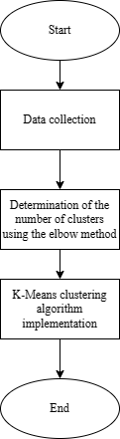

Figure 1. Research Flow Chart

Figure 1 explains the stages of the research carried out:

* 1. Data Collection

The data used in this research was obtained from student assessments taking part in the Information Systems Study Program at the Telkom Purwokerto Institute of Technology. The student score data is secondary data obtained from the score recording system from 2019 to 2022. The dataset used for this research contains the results of student score data from the Information Systems Study Program at the Telkom Purwokerto Institute of Technology as many as 550 students with the attributes of Credits Taken, GPA , Total D Grades, Total E Grades, and Credits Not Yet Taken. The data will be grouped into clusters using the K-Means algorithm using the Elbow method as a cluster optimization approach, to determine the most appropriate number of clusters to use.

* 1. Determining The Number of Clusters Using Elbow

The elbow method is used to determine the most appropriate or optimal number of clusters in the k-means algorithm. This method is used to find the elbow point on the clustering results curve, where increasing the number of clusters no longer provides a significant increase in clustering quality. The elbow method allows identifying the most suitable number of clusters for the k-means algorithm. In research involving assessment data from students from the Information Systems Study Program at the Telkom Purwokerto Institute of Technology, the elbow method approach was used as the optimal way to determine the most appropriate number of clusters.

* 1. Implementation of the K-Means Clustering Algorithm

Application of the K-Means clustering algorithm in this research aims to group the assessment data of students taking part in the Information Systems Study Program at the Telkom Purwokerto Institute of Technology into several groups based on existing attributes. The implementation of K-Means aims to help data analysis and further understanding of student group patterns based on value data. Clustering results can provide valuable insight for academic decision making or the implementation of more appropriate educational strategies.

# RESULT AND DISCUSSION

The data used in this research comes from the scores of students from the Information Systems Study Program at the Telkom Purwokerto Institute of Technology. The student score data is secondary data obtained from the score recording system from 2019 to 2022. The dataset used for this research contains the results of student score data from the Information Systems Study Program at the Telkom Purwokerto Institute of Technology as many as 550 students with the attributes of Credits Taken, GPA , Total D Grades, Total E Grades, and Credits Not Yet Taken. The following example of student data used can be seen in table 1.

TABLE 1. STUDENT VALUE DATASET

|  |  |  |  |  |
| --- | --- | --- | --- | --- |
| **SKS Taken** | **IPK** | **Number of values D** | **Number of values E** | **SKS Not Taken** |
| 151 | 2,46 | 3 | 4 | 21 |
| 136 | 2,92 | 3 | 0 | 8 |
| 138 | 3,77 | 0 | 0 | 6 |
| 140 | 3,56 | 0 | 0 | 4 |
| 132 | 1,69 | 6 | 21 | 67 |
| 140 | 3 | 0 | 0 | 4 |
| 141 | 2,68 | 3 | 6 | 14 |
| 140 | 2,97 | 1 | 0 | 4 |
| 85 | 1,46 | 6 | 17 | 32 |
| 120 | 1,72 | 1 | 17 | 57 |

The results of determining the number of clusters using elbows are displayed in the form of SSE (Sum of Squares Error) value data and also in the form of a graph that has an x-axis and a y-axis. On the x-axis, there are variations in the number of clusters from 2 to 10 clusters, while on the y-axis, there are SSE values resulting from each cluster. The test results show that two clusters are the best number of clusters suitable for dividing student data into the "Lazy", "Not bad" and "Diligent" groups.

After analyzing the test results using the elbow method, you will see a graph showing the location of the "elbow" which is an indication of the optimum number of clusters. The location of the "elbow" will determine the best number of clusters that will be used in the process of grouping student grade data using the K-Means algorithm.

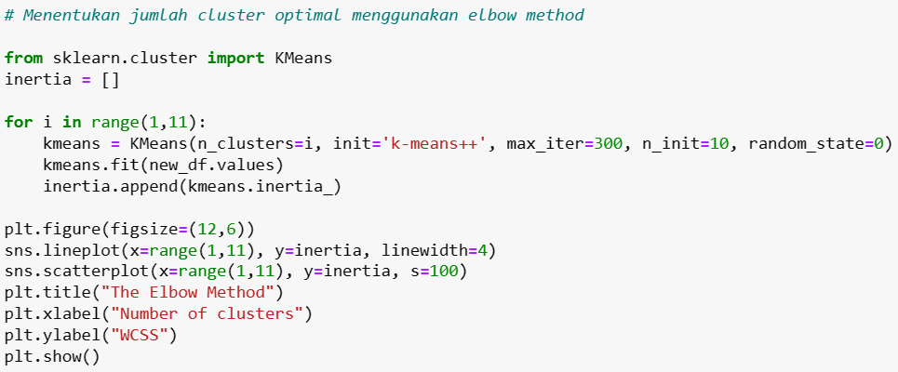

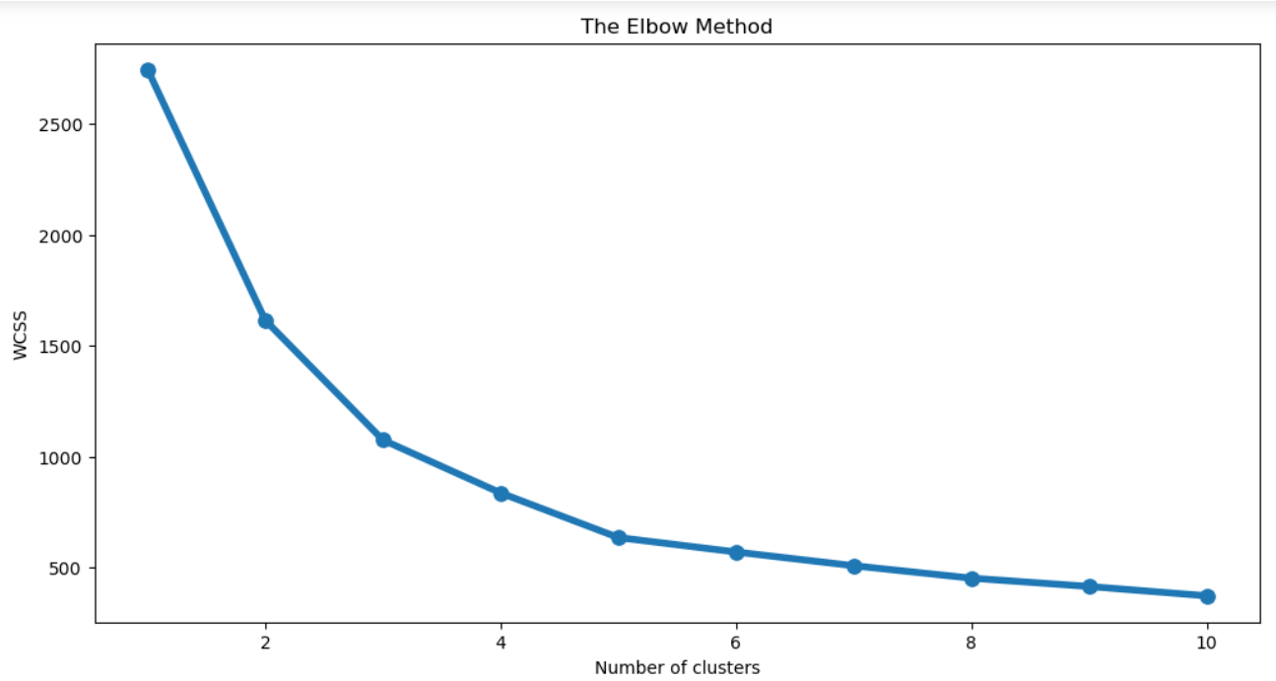

Figure 2. Results of Determining the Number of Clusters

Langkah selanjutnya dalam adalah melakukan standarisasi data. Standarisasi merupakan proses untuk mengubah skala data sehingga memiliki mean (rerata) 0 dan standar deviasi 1. Proses ini dilakukan agar semua atribut memiliki bobot yang seimbang dalam proses clustering dan mencegah atribut dengan skala yang besar mendominasi dalam perhitungan jarak, untuk melakukan standarisasi pada atribut SKS Terambil, IPK, Jumlah Nilai D, Jumlah Nilai E, dan SKS Belum Terambil dalam dataset nilai mahasiswa tersebut. Setelah dilakukan standarisasi, data akan siap untuk diimplementasikan menggunakan algoritma clustering K-Means untuk mengelompokkan data nilai mahasiswa menjadi beberapa kelompok berdasarkan atribut yang ada.

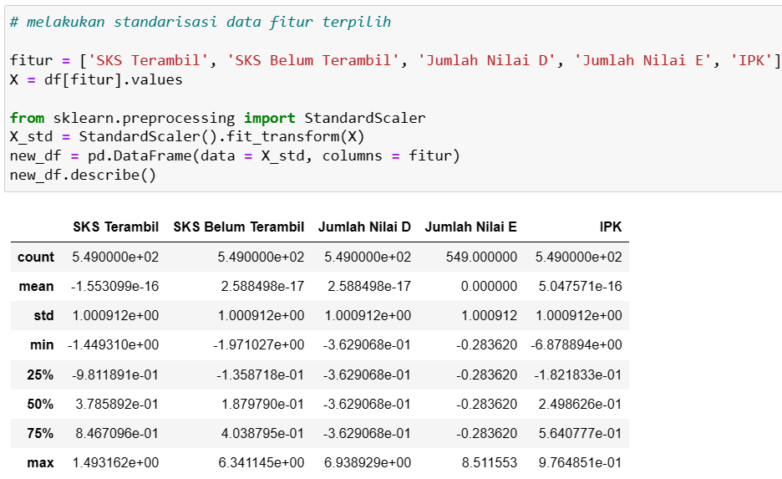

Figure 3. Standardization

The next step is to create segments based on certain criteria from student grade data. Creating segments is done by identifying and grouping student data into segments or groups based on certain characteristics or patterns found from the clustering results. For example, segments can be created based on the range of GPA values, the number of credits taken, or the distribution of D and E grades. The results of creating this segment can be seen in the following table:

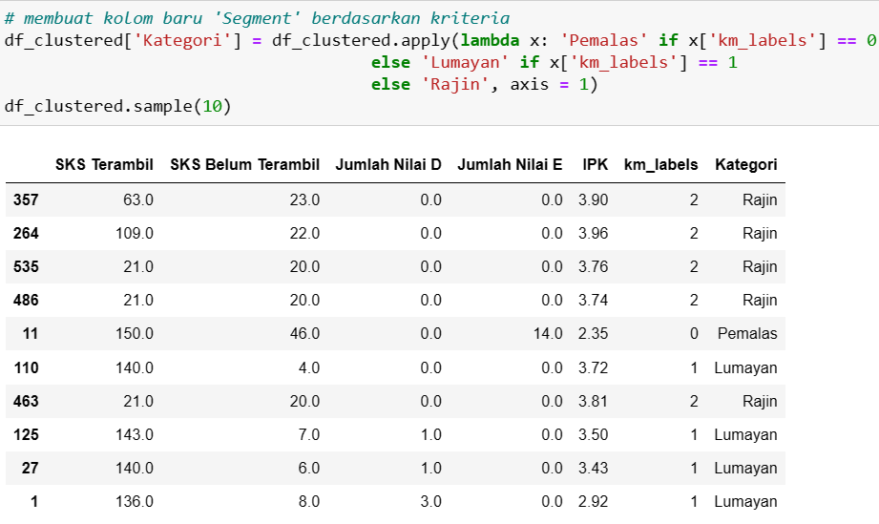

Figure 4. Criteria Segment Results

Based on the table above, student data has been classified into three segments based on certain characteristics resulting from the K-Means clustering method, namely "Lazy", "Not bad", and "Diligent".

As a result of the clustering process using the K-Means method, student data has been divided into three different segments. First, there is the "Diligent" segment consisting of five students. Students in this segment show excellent academic performance with a high number of credits taken, ranging from 63 to 150 credits. They also never got an E, which indicates consistency in completing academic assignments without bad grades. The GPA of students in this segment is also high, ranging from 3.74 to 3.96, indicating extraordinary academic achievement.

Then, there is the "Not bad" segment consisting of four students. Students in this segment have variations in the number of credits taken, but the majority of them have higher credits taken than credits not yet taken. They also show quite good academic performance with GPAs ranging from 2.92 to 3.72. Even though it is not as good as the "Diligent" segment, students in this segment still show dedication in pursuing good academic achievements.

Finally, there is the "Lazy" segment which only consists of one student. Students in this segment show low academic performance with the number of credits taken which is much lower than credits not yet taken. There are also 14 credits with a grade of E, indicating the number of bad grades in courses. This is reflected in the low GPA, namely 2.35. The "Lazy" segment reflects students who have challenges completing academic assignments and need further support to improve their academic performance.

# CONSLUSION

The K-Means Clustering method succeeded in grouping student score data into three segments: "Diligent" with very good academic performance (GPA: 3.74 - 3.96, credits taken: 63 - 150), "Not bad" with fairly good performance (GPA: 2.92 - 3.72, Credits Taken: varies), and "Lazy" with low performance (GPA: 2.35, Credits Taken: 14). Testing using the elbow method confirms that three clusters are the optimum number for dividing student groups. These results provide important insights into students' academic behavior patterns and can help educational institutions improve learning and provide appropriate support for students.

##### REFERENCES

[1] A. R. Taraju, N. Nurdin, and A. Pettalongi, “Tantangan dan Strategi Guru Menghadapi Era Revolusi Industri 4 . 0,” *Pros. Kaji. Islam dan Integr. Ilmu di Era Soc. 5.0 (KIIIES 5.0) Pascasarj. Univ. Islam Negeri Datokarama Palu*, vol. 1, pp. 314–315, 2022.

[2] T. Kurniati and N. A. Wiyani, “Pembelajaran Berbasis Information and Communication Technology pada Era Revolusi Industri 4.0,” *J. Imiah Pendidik. dan Pembelajaran*, vol. 6, no. 1, p. 182, 2022, doi: 10.23887/jipp.v6i1.41411.

[3] A. Yudhistira and R. Andika, “Pengelompokan Data Nilai Siswa Menggunakan Metode K-Means Clustering,” *J. Artif. Intell. Technol. Inf.*, vol. 1, no. 1, pp. 20–28, 2023, doi: 10.58602/jaiti.v1i1.22.

[4] N. B. Putri and A. W. Wijayanto, “Analisis Komparasi Algoritma Klasifikasi Data Mining Dalam Klasifikasi Website Phishing,” *Komputika J. Sist. Komput.*, vol. 11, no. 1, pp. 59–66, 2022, doi: 10.34010/komputika.v11i1.4350.

[5] E. Muningsih, I. Maryani, and V. R. Handayani, “Penerapan Metode K-Means dan Optimasi Jumlah Cluster dengan Index Davies Bouldin untuk Clustering Propinsi Berdasarkan Potensi Desa,” *J. Sains dan Manaj.*, vol. 9, no. 1, pp. 95–100, 2021, [Online]. Available: https://ejournal.bsi.ac.id/ejurnal/index.php/evolusi/article/view/10428/4839

[6] M. I. T. B. N. Sumadi, R. Putra, and A. Firmansyah, “Peran Perkembangan Teknologi Pada Profesi Akuntan Dalam Menghadapi Industri 4.0 Dan Society 5.0,” *J. Law, Adm. Soc. Sci.*, vol. 2, no. 1, pp. 56–68, 2022, doi: 10.54957/jolas.v2i1.162.

[7] Z. Nabila, A. Rahman Isnain, and Z. Abidin, “Analisis Data Mining Untuk Clustering Kasus Covid-19 Di Provinsi Lampung Dengan Algoritma K-Means,” *J. Teknol. dan Sist. Inf.*, vol. 2, no. 2, p. 100, 2021, [Online]. Available: http://jim.teknokrat.ac.id/index.php/JTSI

[8] D. P. Utomo and M. Mesran, “Analisis Komparasi Metode Klasifikasi Data Mining dan Reduksi Atribut Pada Data Set Penyakit Jantung,” *J. Media Inform. Budidarma*, vol. 4, no. 2, p. 437, 2020, doi: 10.30865/mib.v4i2.2080.

[9] F. Hardiyanti, H. S. Tambunan, and I. S. Saragih, “Penerapan Metode K-Medoids Clustering Pada Penanganan Kasus Diare Di Indonesia,” *KOMIK (Konferensi Nas. Teknol. Inf. dan Komputer)*, vol. 3, no. 1, pp. 598–603, 2019, doi: 10.30865/komik.v3i1.1666.

[10] D. A. I. C. Dewi and D. A. K. Pramita, “Analisis Perbandingan Metode Elbow dan Silhouette pada Algoritma Clustering K-Medoids dalam Pengelompokan Produksi Kerajinan Bali,” *Matrix J. Manaj. Teknol. dan Inform.*, vol. 9, no. 3, pp. 102–109, 2019, doi: 10.31940/matrix.v9i3.1662.

[11] A. W. Fuadah, F. N. Arifin, and O. Juwita, “Optimasi K-Klasterisasi Ketahanan Pangan Kabupaten Jember Menggunakan Metode Elbow,” *INFORMAL Informatics J.*, vol. 6, no. 3, p. 136, 2021, doi: 10.19184/isj.v6i3.28363.

[12] R. Yuliana Sari, H. Oktavianto, and H. Wahyu Sulistyo, “Algoritma K-Means Dengan Metode Elbow Untuk Mengelompokkan Kabupaten/Kota Di Jawa Tengah Berdasarkan Komponen Pembentuk Indeks Pembangunan Manusia K-Means Algorithm With Elbow Method To Grouping District/City in Central Java Based on Components of Human D,” *J. Smart Teknol.*, vol. 3, no. 2, pp. 2774–1702, 2022, [Online]. Available: http://jurnal.unmuhjember.ac.id/index.php/JST

[13] A. R. Said, D. Arifianto, and H. A. Al Faruq, “Pengelompokan Kecamatan Di Kabupaten Jember Berdasarkan Tanaman Pangan Dengan Algoritma Fuzzy C-Means Dan Metode Elbow,” *J. Smart Teknol.*, vol. 2, no. 1, pp. 1–12, 2020.

[14] D. Widyadhana, R. B. Hastuti, I. Kharisudin, and F. Fauzi, “Perbandingan Analisis Klaster K-Means dan Average Linkage untuk Pengklasteran Kemiskinan di Provinsi Jawa Tengah,” *Prism. Pros. Semin. Nas. Mat.*, vol. 4, pp. 584–594, 2021, [Online]. Available: https://journal.unnes.ac.id/sju/index.php/prisma/

[15] S. Sonang, A. T. Purba, and F. O. I. Pardede, “Pengelompokan Jumlah Penduduk Berdasarkan Kategori Usia Dengan Metode K-Means,” *J. Tek. Inf. dan Komput.*, vol. 2, no. 2, p. 166, 2019, doi: 10.37600/tekinkom.v2i2.115.

[16] I. Ahmad, S. Samsugi, and Y. Irawan, “Implementasi Data Mining Sebagai Pengolahan Data,” *J. Teknoinfo*, vol. 16, no. 1, p. 46, 2022, [Online]. Available: http://portaldata.org/index.php/portaldata/article/view/107

[17] A. Trisnawan, W. Hariyanto, and S. -, “Klasifikasi Beras Menggunakan Metode K-Means Clustering Berbasis Pengolahan Citra Digital,” *RAINSTEK J. Terap. Sains Teknol.*, vol. 1, no. 1, pp. 16–24, 2019, doi: 10.21067/jtst.v1i1.3013.

[18] K. S. H. Kusuma Al Atros, A. R. Padri, O. Nurdiawan, A. Faqih, and S. Anwar, “Model Klasifikasi Analisis Kepuasan Pengguna Perpustakaan Online Menggunakan K-Means dan Decission Tree,” *JURIKOM (Jurnal Ris. Komputer)*, vol. 8, no. 6, p. 323, 2021, doi: 10.30865/jurikom.v8i6.3680.

[19] R. Ishak and A. Bengnga, “Clustering Tingkat Pemahaman Mahasiswa Pada Perkuliahan Probabilitas Statistika Dengan Metode K-Means,” *Jambura J. Electr. Electron. Eng.*, vol. 4, no. 1, pp. 65–69, 2022, doi: 10.37905/jjeee.v4i1.11997.