DETECTION OF RICE LEAF PESTS BASED ON IMAGES WITH CONVOLUTION NEURAL NETWORK IN YOLLO V8

Ahmad Fauzi[1]*, Kiki Ahmad Baihaqi[2], Anggun Pertiwi[3], Yudo Devianto[4], Saruni Dwiasnati [5],

Fakultas Ilmu Komputer, Universitas Buana Perjuangan Karawang[1], [2], [3]

Karawang, Indonesia

Fakultas Ilmu Komputer, Universitas Mercu Buana [4][5]

Jakarta, Indonesia

[afauzi@ubpkarawang.ac.id](mailto:afauzi@ubpkarawang.ac.id)[1], [kikiahmad@ubpkarawang.ac.id[2](mailto:kikiahmad@ubpkarawang.ac.id[2)], [anggun.pertiwi@ubpkarawang.ac.id](mailto:anggun.pertiwi@ubpkarawang.ac.id)[3], [yudo.devianto@mercubuana.ac.id[4](mailto:yudo.devianto@mercubuana.ac.id[4)], saruni.dwiasnati@mercubuana.ac.id[5]

***Abstract*—** **Detection of rice leaf pests is important in agriculture because it can help farmers determine appropriate preventive measures. One method that can be used to detect rice leaf pests is digital image processing technology. In this research, a comparison was made between the Convolutional Neural Network (CNN) algorithm which was run offline and YOLOv8 for detecting rice leaf pests. At the data preparation stage, images of rice leaves were taken from various sources with a total of 100 images of data. Next, preprocessing and data augmentation are carried out to improve image quality and increase data variation. At the model training stage, a training and evaluation process is carried out using two types of algorithms, namely CNN and YOLOv8. The accuracy of the testing results using the same data obtained accuracy results accuracy 87.0%, loss 0.1208 dan precision 79%, with the data divided into 70 training data, 20 validation data and 10 testing data. Labeling the dataset uses Makesensei which has been completely standardized, with the benchmark parameter being the diameter of the spots on the rice leaves.**

***Keywords—*** ***hama daun padi, pengolahan citra digital, convolution neural network, yolo v8***

***Abstrak*— Deteksi hama daun padi merupakan hal yang penting dalam pertanian karena dapat membantu petani dalam menentukan tindakan pencegahan yang tepat. Salah satu metode yang dapat digunakan dalam deteksi hama daun padi adalah teknologi pengolahan citra digital. Dalam penelitian ini, dilakukan komparasi antara algoritma Convolutional Neural Network (CNN) yang di jalankan offline dan YOLOv8 untuk deteksi hama daun padi. Pada tahap persiapan data, dilakukan pengambilan citra daun padi dari berbagai sumber dengan jumlah data sebanyak 100 citra. Selanjutnya, dilakukan preprocessing dan augmentasi data untuk memperbaiki kualitas citra dan meningkatkan variasi data. Pada tahap pelatihan model, dilakukan proses training dan evaluasi dengan menggunakan dua jenis algoritma yaitu CNN dan YOLOv8. Akurasi dari hasil testing dengan menggunakan data yang sama didapatkan hasil akurasi accuracy 87.0%, loss 0.1208 dan precision 79%, dengan data yang dibagi menjadi 70 data training 20 data validasi dan 10 data testing. Labeling dataset menggunakan makesensei yang sudah di standarkan seluruhnya, dengan tolak ukur parameter adalah diameter bercak pada daun padi.**

***Kata Kunci—hama daun padi, pengolahan citra digital, yolo v8, convolution neural network***

# **Introduction**

# Rice leaf pests are one of the problems often faced by farmers in rice cultivation. Rice leaf pests can cause damage to the leaves so that the growth of rice plants is disrupted and crop yields decrease. Therefore, detecting rice leaf pests is important in efforts to prevent and control these pests.

# In the current digital era, digital image processing technology can be an alternative for detecting rice leaf pests. One of the methods used in digital image processing technology uses Yolo v8. Yolo v8 is a real-time object detection algorithm developed by the developer team from Ultralytics, which can be modified according to the needs of research and object detection. These objects can be even small objects[1].

Research that has been carried out using Yollo V5 for safety helmet detection shows that Yollo V5 has time efficiency in detection and makes it easier to carry out the desired parameters. The research also explains that labeling is easy to use in training data, as well as having a fairly high level of accuracy.  
reaches 90% [2].

Meanwhile, other research discusses the detection of fruit objects, which prioritizes fruit freshness detection with an accuracy of 92% and uses datasets sourced from websites, so it is not data taken directly by researchers [3]. There was other research, namely regarding rice leaf pest detection using CNN in 2018 with an accuracy of 78.2% with 5 convolution layers, with the lowest reaching 58.4% [4].

There is not much research comparing the performance of the CNN and YOLOv8 algorithms in detecting rice leaf pests. Therefore, this research was conducted to compare the performance between the CNN algorithms and YOLOv8 in detecting rice leaf pests. It is hoped that the results of this research will provide useful information for farmers in choosing an effective and efficient rice leaf pest detection method.

# **METHOD**

Data in the form of pest images obtained via the website as a dataset, it cannot be directly processed for detection or can be indirectly detected by Yolo and the convolution neural network algorithm. The first stage carried out was to augment and then label the pest variants using the website of the labeling service provider. Data augmentation is a stage of image data processing, augmentation is the process of changing or modifying an image in such a way that the computer detects that the modified image is a different image, but humans can always know that the edited image is the same [5]. Improvement may occur. increasing the accuracy of the trained CNN model, because with this increase, the model receives additional data, which can help in creating a model that can generalize better [6].

Improvements made in this research include flipping the image horizontally, flipping the image with a tilt every 5 degrees [5], zooming randomly, with a maximum zoom of 50% of the image size, and also rotating the image randomly up to a maximum of 90. One type of enhancement that is commonly done is to rotate the image by a certain amount [6]. So you get a new variant of the same image. And enrich the image database.

1. Preprocessing Data

The pre-processing stage is quite an important stage in image processing. The preprocessing is carried out to optimize image quality, thereby making it easier and increasing the system's ability to identify objects. The preprocessing stages in this system are divided into two stages, namely original data and augmented data. On the original data, preprocessing is only carried out by resizing the image. Meanwhile, pre-processing for data augmentation is carried out by resizing and augmenting the data [7].

1. Convolution Neural Network

The use of the CNN algorithm in this research is based on research conducted by Tsung-Ren Huang et al., who claim that the flow of the CNN process is the best. The concept can be seen in Figure 2.

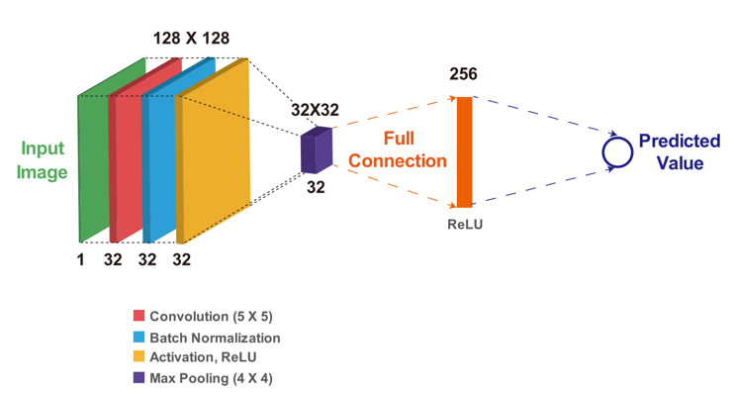

Figure 2. Layers in CNN

The input image is then trained and processed in the CNN algorithm through layers and a convolution process until the prediction results are obtained [8]. Once completed, it will go through the classification stage, which is discussed in the stages in this sub-chapter.

1. Yolo v8

Yolo is an algorithm in digital image processing technology, especially in the sector of deep learning. The stages carried out in Yolo in detecting objects are detecting objects by dividing the image into sxs-sized regions or grids, then detecting with each bounding box having 5 information values, and detection by means of each grid will predict the probability class value if it is predicted that there is an object in it. [ 9].

The architecture of Yolo version eight can be seen in Picture 3.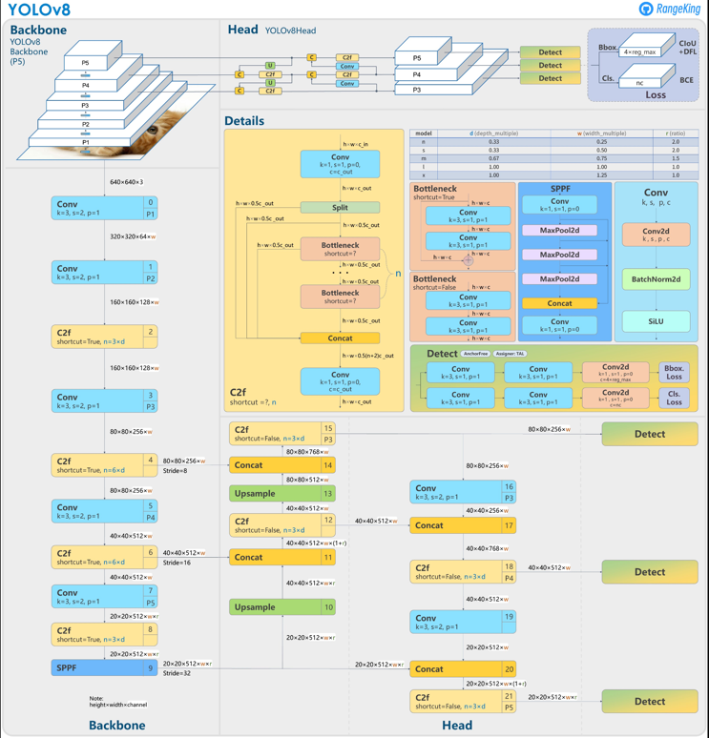

Figure 3. architecture yolo 8

1. Clarification

Image classification is one of the basic concepts in computer vision. It classifies images based on their message, which can be analyzed after translation. Image classification is also key to image detection, image segmentation, visual object tracking, behavior analysis, and many other high-level visual tasks. There are also a large number of image classification applications, such as face recognition, video content analysis, traffic scene recognition, content-based image retrieval, and automatic photo classification. Image classification describes the entire image through handcrafted features, or feature learning, and uses classifiers to categorize objects in the image. Therefore, how to extract features becomes important. Before deep learning was widely used, there was a word classification called “Bag of Words”. This method was introduced in natural language, where word bags function as a feature. For images, this “Bag of Words” method requires creating a dictionary. The simplest model of the Bag of Words framework can be a process of low-level feature extraction, feature coding, and classifier design [10], [11].

In contrast, image classification, based on deep learning, can replace the process of manually designing or selecting image features with hierarchical characterization through supervised or unsupervised learning.

Convolution Neural Networks achieved incredible achievements in recent years. CNN uses image pixels as input, and it retains almost all the information from the original image. Feature extraction and high-level abstraction through convolution make the model output the result of image recognition. This I/O-based learning method has been a great success and is widely used [12].

Before 2012, although the main procedure was categorized into three parts, as mentioned before, usually the complete process of building an image recognition model included low-level feature learning, feature coding, spatial feature restriction, and classifier design. The flow can be seen in Figure 3, and more or less, the depiction of the system is as follows:

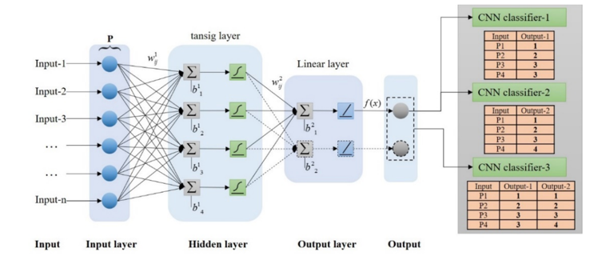

Figure 4. Classification flow illustration

Then the results of the classification will produce accuracy and precision, which will be the resulting parameters of the algorithm's performance in this case of rice leaf pests [13]. The formula for calculating it can be seen in formulas 1, 2, and 3.

$Akurasi= \frac{TP}{TP+TN+FP+F} X 100\%$ (1)

$Presisi=\frac{TP}{TP+FP} x 100\%$ (2)

$Loss=\frac{FP+FN}{TP+TN+FP+F}$ (3)

Explanation :

1. True Positive (TP): Data that is correctly classified by the system as a positive value (true).
2. True Negative (TN): Data that is correctly classified by the system as a negative value (false).
3. False Positive (FP): The data is wrong (negative) but is classified as true data (positive).
4. False Negative (FN): Data is correct (positive) but classified as wrong data (negative).

# **RESULTS AND DISCUSSION**

The results of the training and validation of the images were formed into a dataset, and then the results obtained from the detection of the two types of disease were taken as the theme in this paper.

Table 1. Detection Result

|  |  |
| --- | --- |
| Image | type of plant disease |
|  | leaf bacteria |
|  | Leaf blast |
|  | Leaf bacteria |

After it is known that it is detected with a confidence level of 0.5, you can see a graph of the F1-Score, which shows that blight is easier to detect and classify than leaf blast. This can be seen in Figure 5, namely the curve resulting from the F1 score.

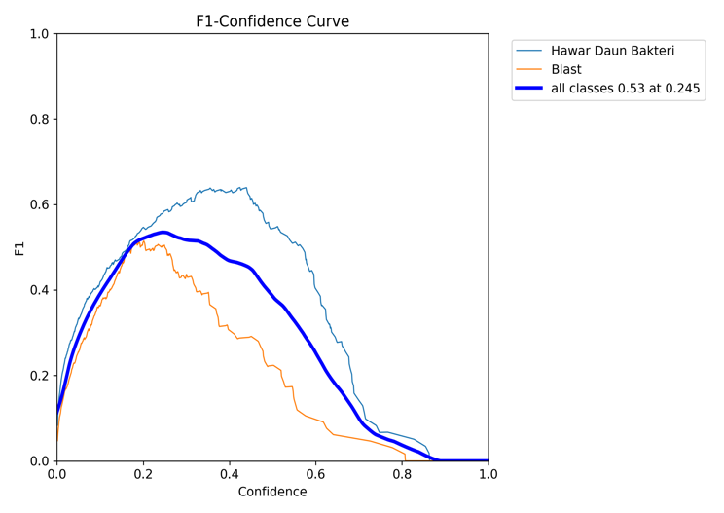

Figure 5. Kurva F1 Score

Meanwhile, the results from Precision Confidence show that all types of disease reached 0.79, with the results can be seen in the curve depicted in Figure 6.

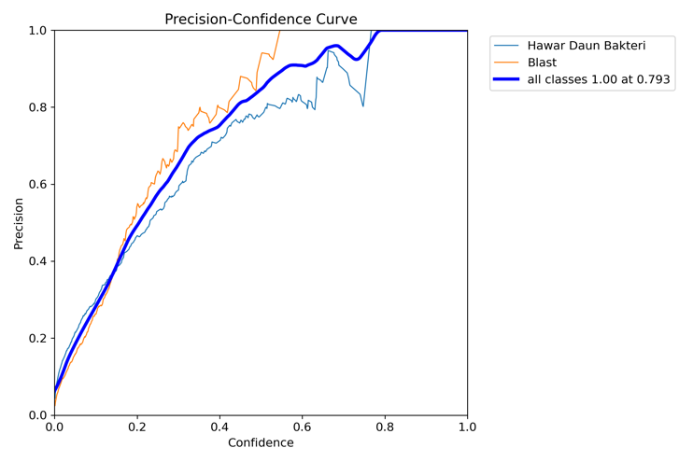

Figure 6. Precision confidance curve

Meanwhile, the precision recall results for bacterial leaf blight were 0.58, and for blast, they reached 0.45, which can be seen in Figure 7.

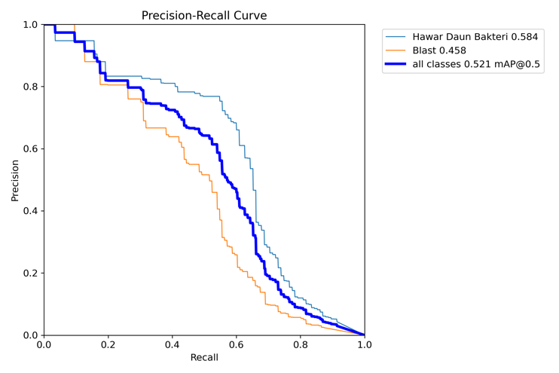

Apart from displaying precision, in this case we also display loss from various training and testing results, starting from train loss to validation loss. Which is depicted in figure 8.

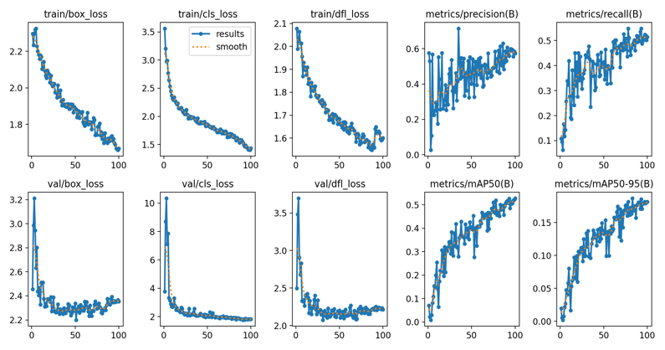

Gambar 8. Loss grafik

# **Conclusion**

The results of this research on the classification of rice leaf diseases have an accuracy of 87.0%, a loss of 0.1208, and a precision of 79%. These results were obtained using augmented data with the best parameters. namely Optimizer RMSprop, learning rate 0.01, batch size32, and epoch 100. The expected accuracy results can occur with a combination of datasets taken from the website and test data taken from the research site. So for further research, it is necessary to compare architectures so that we can find out which one is better than the existing architecture.

# **References**

[1] Q. Wang, J. Tu, Y. Luo, and F. Liu, “Target Detection of Myrica rubra Based on Convolutional Neural Network and Transfer Learning,” in *Proceedings - 2021 International Conference on Electronic Information Technology and Smart Agriculture, ICEITSA 2021*, Institute of Electrical and Electronics Engineers Inc., 2021, pp. 485–490. doi: 10.1109/ICEITSA54226.2021.00098.

[2] Y. Guan, W. Li, T. Hu, and Q. Hou, “Design and Implementation of Safety Helmet Detection System Based on YOLOv5,” in *Proceedings - 2021 2nd Asia Conference on Computers and Communications, ACCC 2021*, Institute of Electrical and Electronics Engineers Inc., 2021, pp. 69–73. doi: 10.1109/ACCC54619.2021.00018.

[3] F. Paraijun *et al.*, “Implementasi Algoritma Convolutional Neural Network Dalam Mengklasifikasi Kesegaran Buah Berdasarkan Citra Buah,” vol. 11, no. 1, 2022, doi: 10.33322/kilat.v11i1.1458.

[4] P. Tejaswini, P. Singh, M. Ramchandani, Y. K. Rathore, and R. R. Janghel, “Rice Leaf Disease Classification Using Cnn,” in *IOP Conference Series: Earth and Environmental Science*, Institute of Physics, 2022. doi: 10.1088/1755-1315/1032/1/012017.

[5] T.-R. Huang, S.-M. Hsu, and L.-C. Fu, “Data Augmentation via Face Morphing for Recognizing Intensities of Facial Emotions,” *IEEE Trans Affect Comput*, vol. 14, no. 2, pp. 1228–1235, Apr. 2023, doi: 10.1109/TAFFC.2021.3096922.

[6] A. Mikolajczyk and M. Grochowski, “Data augmentation for improving deep learning in image classification problem,” in *2018 International Interdisciplinary PhD Workshop (IIPhDW)*, IEEE, May 2018, pp. 117–122. doi: 10.1109/IIPHDW.2018.8388338.

[7] M. F. Naufal, “Analisis Perbandingan Algoritma SVM, KNN, dan CNN untuk Klasifikasi Citra Cuaca,” *Jurnal Teknologi Informasi dan Ilmu Komputer*, vol. 8, no. 2, p. 311, 2021, doi: 10.25126/jtiik.2021824553.

[8] Y. Qin, “A Cancer Cell Image Classification Program : Based on CNN Model,” in *2021 2nd International Seminar on Artificial Intelligence, Networking and Information Technology (AINIT)*, IEEE, Oct. 2021, pp. 140–144. doi: 10.1109/AINIT54228.2021.00037.

[9] K. Patel, V. Patel, V. Prajapati, D. Chauhan, A. Haji, and S. Degadwala, “Safety Helmet Detection Using YOLO V8,” in *2023 3rd International Conference on Pervasive Computing and Social Networking (ICPCSN)*, IEEE, Jun. 2023, pp. 22–26. doi: 10.1109/ICPCSN58827.2023.00012.

[10] C. Ma, S. Xu, X. Yi, L. Li, and C. Yu, “Research on Image Classification Method Based on DCNN,” in *2020 International Conference on Computer Engineering and Application (ICCEA)*, IEEE, Mar. 2020, pp. 873–876. doi: 10.1109/ICCEA50009.2020.00192.

[11] H. Tang, “Image Classification based on CNN: Models and Modules,” in *2022 International Conference on Big Data, Information and Computer Network (BDICN)*, IEEE, Jan. 2022, pp. 693–696. doi: 10.1109/BDICN55575.2022.00134.

[12] Y. Hao, “Convolutional Neural Networks for Image Classification,” in *2021 2nd International Conference on Artificial Intelligence and Computer Engineering (ICAICE)*, IEEE, Nov. 2021, pp. 342–345. doi: 10.1109/ICAICE54393.2021.00073.

[13] A. Andreas, C. X. Mavromoustakis, H. Song, and J. M. Batalla, “CNN-Based Emotional Stress Classification using Smart Learning Dataset,” in *2022 IEEE International Conferences on Internet of Things (iThings) and IEEE Green Computing & Communications (GreenCom) and IEEE Cyber, Physical & Social Computing (CPSCom) and IEEE Smart Data (SmartData) and IEEE Congress on Cybermatics (Cybermatics)*, IEEE, Aug. 2022, pp. 549–554. doi: 10.1109/iThings-GreenCom-CPSCom-SmartData-Cybermatics55523.2022.00107.