Double Exponential Smoothing Forecasting Food Crop Yields Using Geographic Information Systems

Dovel Pirmanto

Islamic Library and Information Science Study Program, Faculty of Adab and Dakwah

Institut Agama Islam Negeri Kerinci

Kerinci, Indonesia

dovelpirmanto16@gmail.com

**Abstract— The need for food for humans is increasing, so food security becomes a challenge for every country. The increasing demand for food in Kota Sungai Penuh has caused several problems related to land use. This is due to a lack of information related to productivity and land use feasibility. The advancement of information technology enables the current forecasting activities to be done easily through computer assistance, the information required is the need for geographic information systems. Forecasts can predict future events mathematically by looking at historical data. One method of forecasting is Double Exponential Smoothing (DSE). Based on the result of forecast error calculation with Double Exponential Smoothing method using combination of value α = 0,1 and 0,5 and value of β = 0,1 and 0,5. From the calculation results obtained the smallest error value is: ME = 80.92, MAD = 5.58, MAPE = 11%, MSE = 52.69 obtained from a combination of values α = 0.1 and value β = 0.1. With value α = 0,1 and value of β = 0,1 this is used to predict corn yield in subdistrict Kumun Debai next year. Using the value of α = 0,1 and value of β = 0,1 can be obtained forecast result of crop of corn in Kumun Debai subdistrict of 2018 is 45 ton, 2019 is 40 ton and 2020 is 35 ton.**

***Keywords—*** ***Double Exponential Smoothing, Forecasting, Crops, Geographic Information Systems.***

# INTRODUCTION

Food needs for humans are increasing, so food security is a challenge for every country, because the human population has reached nine billion people. The agricultural sector, especially food crops, is the main thing needed by the community, especially in Sungai Banyak City. The increasing need for food in Sungai Banyak City has given rise to several problems related to land use. This is caused by a lack of information related to productivity and feasibility of land use. Advances in information technology allow forecasting activities to now be carried out easily with the help of computers. Traditional forecasts traditionally do not pay attention to previous data and are more qualitative rather than quantitative [1].

Forecasts can predict future events mathematically by looking at historical data, thus forecasting methods can provide an orderly and directed way of working so that more advanced analytical techniques can be used. The use of these analysis techniques is expected to be able to provide a greater level of accuracy because it can be tested with the deviations that occur [3]. One method for making forecasts is double exponential smoothing (DSE).

Technological developments really help people in obtaining information, one of the information needed is geographic information. The public can use this geographic information for various fields such as agricultural distribution, regional planning, research, mapping and other purposes. Geographic information is able to present data processing results that are integrated with spatial and non-spatial data. Several previous studies have developed Web GIS in a spatial support system which is very suitable for agricultural land mapping, because of the ease of interaction and joint use [9]. Mohammed conducted research using GIS for sustainable use of agricultural land through integrated biophysics, economic feasibility and social acceptance in the northern Sinai region [10].

Based on the problems described above, an agricultural yield forecast is needed to determine the productivity of land use in Sungai Banyak City, especially food crops. The method used in this research is double exponential smoothing, the application of the double exponential smoothing method to predict food crop yields integrated with a geographic information system. So the results of calculations using double exponential smoothing can be mapped using GIS.

# RESEARCH METHODOLOGY

## Forecasting

Forecasting is the activity of predicting future values, on the basis of prepared knowledge or past values. Forecasting includes the use of historical data, by projecting it for the future using a type of mathematical model [4]. Forecasting is a statement regarding the future value of a variable such as demand. This means that a forecast is a prediction about the future [5]. Forecasting is the art and science of predicting future events. Forecasting would involve taking historical data such as last year's sales and projecting them into the future with a mathematical model [3].

## Forecast Model

Forecast models provide a more orderly and focused way of working, so that better analysis techniques are obtained, which can be expected to be able to provide greater trust or confidence, because they can be tested and scientifically proven deviations or deviations that occur. Based on their nature, forecasts are divided into two, namely:

1. *Quantitative Approach*

Quantitative approach is a prediction that is based on a party's opinion and the data cannot be represented strictly as a number or value. The results of the forecasts made depend greatly on the person who prepared them.

1. *Qualitative approach*

Qualitative approach is a forecast that is based on past quantitative data and can be made in the form of numbers which can be called time series data which has a relationship with one or more variables that influence it.

To make a forecast, first determine the forecast period that will be carried out. Based on the forecast time, it can be grouped into three categories [3] namely:

* + 1. *Short Term Forecast*

Short term forecasts can be classified as forecasts for a period of less than three months. These forecasts are usually used to plan purchases, work scheduling, sales, number of workers, and production levels.

* + 1. *Medium Term Forecast*

Medium term forecasts can be classified into forecasts for a period of three months to three years. Medium-term forecasts are used for sales planning, production planning and budgeting, cash budgets and analyzing various operating plans.

* + 1. *Long Term Forecast*

Long term forecasts can be classified as forecasts for a period of more than three years. Medium-term forecasts are used to plan new products, capital expenditures, location, or facility development and research and development.

## Exponential Smoothing

Exponential Smoothing is a procedure for continuous improvement in forecasting the latest observation objects. He emphasizes the exponential decrease in priority for older observation objects. In other words, recent observations will be given higher priority for forecasting than older observations. There are several methods that are grouped into the Exponential Smoothing method, namely:

* + 1. *Single Exponential Smoothing*

Single exponential smoothing is also known as simple exponential smoothing which is used in short-term forecasting, usually only 1 month into the future. The model assumes that the data fluctuates around a fixed mean value, with no trend or consistent growth pattern. Rumus untuk mencari forecast pada metode *Single Exponential Smoothing* :

Ft + 1 = α Xt + (1-α) Ft  (1)

Theory the value of α = 0.1 or 0.5 or 0.9 (depending on the problem and achieving the desired results)

Contoh : Ft (feb + 1)=0,1 . 9265 + (1-0,1) 9325 Ft Maret = 9319

Ft = Forecast value for the t-th time period

Ft-1 = Forecast value for the past time period, t-1 Xt + (1-α) = Actual time series value

* + 1. *Double Exponential Smoothing*

This method is used when the data shows a trend. Exponential smoothing with a trend is like simple smoothing except that two components must be updated every period – the level and the trend. Levels are smoothed estimates of the data values at the end of each period. Trend is a smoothed estimate of the average growth at the end of each period. This method is a development of Single Exponential which adds a trend element to the calculation weights, so that in Double Exponential Smoothing (Holt Method) we give two types of weights to the calculation, namely level (α) and trend (β). The formula used:

At = αYt + (1- α) (At-1 +Tt-1) (2)

Tt = β (At – At-1) + (1 – β) Tt-1 (3)

Ft+m = At + Ttm (4)

At = exponential smoothing value

 = smoothing constant for data (0 <  <1)

 = smoothing constant for trend estimation (0 <  < 1)

Yt = actual value in period t

Tt = trend estimation

F(t+m) = Forecast value

* + 1. *Triple Exponential Smoothing*

This method is used when the data shows a trend. Exponential smoothing with a trend is like simple smoothing except that two components must be updated every period – the level and the trend. Levels are smoothed estimates of the data values at the end of each period. Trend is a smoothed estimate of the average growth at the end of each period. is a development of Double Exponential where forecasting is carried out using three parameters with different weights, namely level (α), trend (β) and seasonal (γ). Based on the seasonal type (Triple Exponential Smoothing) it is divided into two, namely:

* Multiplicative Seasonal Model
* Additive Seasonal Model

The difference between the Multiplication Seasonal Model and Additive Seasonal is as follows:

The Multiplicative Seasonal Model is multiplying the results of level and trend calculations with Seasonal calculations. Meanwhile, the Additive Seasonal Model is adding the results of level and trend calculations with Seasonal calculations. But what will be discussed here is only Triple Exponential Smoothing with the Multiplicative Seasonal Model.

At = α $\frac{Yt}{St-L}$ + (1- α)(At-1 +Tt-1) (5)

Tt = β (At- At-1) + (1- β) Tt-1 (6)

St = γ $\frac{Yt}{At}$ + (1- γ) St-l (7)

Yt+p = (At + Ttp) St-L-p (8)

At = exponential smoothing value

a = smoothing constant for data (0 < a < 1)

b = smoothing constant for trend estimation (0 < b < 1)

m = smoothing constant for seasonal estimation (0 < m < 1)

Yt = actual value in period t

Tt = trend estimation

St = seasonal estimates

L = the length of the season

p = the number of future periods that will be forecast

## Measurement Error

These measures can be used to compare different forecasting models, along with monitoring forecasts to ensure that they are working properly. The three most well-known measures are mean absolute deviation (MAD), mean squared error (MSE), and mean absolute percent error (MAPE). But here the average error (ME) will be added as the first reference for finding the error value.

1. ME (Mean error) or Average Error Value

ME = $\frac{∑ Actual-Forecasting}{n}$ (9)

1. MAD (Mean Absolute Deviation) or Absolute Error Average Deviation Value

ME = $\frac{∑|Actual-Forecasting}{n}$ (10)

1. MSE (Mean Square Error) or Mean Squared Error Value

MSE = $\frac{∑|Actual-Forecasting|2}{n}$ (11)

1. MAPE (Mean Absolute Percent Error or Average Value of Percentage Error )

MAPE = $\frac{\sum_{i-1}^{n}{\left|Actual-Actual\right|/Actual}}{n}$ (12)

## Geographic Information System

Geographic information system (GIS) is a tool that can be used to manage (input, process and output) spatial data or data with geographic differences. Any data that refers to a location on the earth's surface can be called spatial data, for example population density data in an area, road network data in a city, data on the distribution of sampling locations, and so on [6]. GIS consists of a combination of database management in collecting and storing large amounts of geospatial data, to determine the relationship between the entities of each data used, plus map layers which function to describe geospatial data relationships in two and three dimensions in the form of maps. [8].

Geographic information system is a computer-based system or technology built with the aim of collecting, storing, processing and analyzing and presenting data and information from an object or phenomenon related to the location or existence of an object on the surface of the earth. Basically, GIS can be broken down into several interrelated sub-systems which include data input, data management, data processing or analysis, reporting and analysis results [15].

The reason GIS is needed is because it is very difficult to handle spatial data, especially because maps and statistical data quickly become outdated so that there is no service to provide more effective data and information. Thus, GIS is expected to be able to provide the desired conveniences such as better handling of geospatial data in standard formats. The Equator System (Universal Transverse Mercator/UTM) is a projection system in GIS to change a curved plane (earth's surface) to a flat plane (map) by taking into account several conditions, including maintaining the shape (conformal), maintaining the right scale (equivalent), maintaining distance (equidistant), maintaining direction (true direction) [6].

Input text data and Global Positioning System (GPS) coordinates, this sub-system is used to collect, prepare spatial data and attributes from various sources, and is responsible for converting the original data format into a format that can be used by GIS analysis tools. Database Management System (DBMS) is a sub-system used to organize spatial and attribute data into a database so that it is easy to call, update and delete for data processing needs [7].

In general, a Geographic Information System consists of four main components, namely [10]:

1. Data, basic materials that can be processed or processed into information that has meaning so that it is useful to use. The data used in GIS is divided into two, namely spatial data and non-spatial data.
2. Hardware, is a physical device in the form of a computer and its supporting instruments.
3. Software is a module system that functions to operate GIS.
4. Use includes human resources or human intelligence (brainware).

# RESULTS AND DISCUSSION

## Design

At the application design stage there are several processes that will be carried out starting from the system workflow to the system database, namely as follows:

1. Flowchart

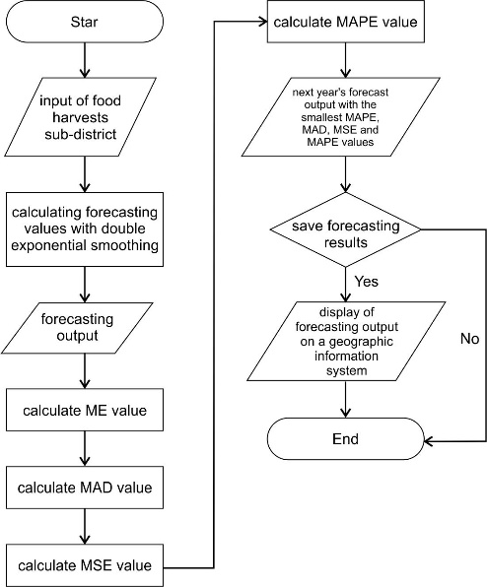

Figure 1. Flowchart of the Double Exponential Smoothing Forecast System

Based on the flowchart above it can be explained as follows:

* Enter harvest data to look for the alpha value
* Calculate forecasting values
* Displays forecasting results
* Calculating the Mean Error (ME) value
* Calculate the Mean Absolute Deviation (ME) value
* Calculate the Mean Percentage Error (MAPE) value
* Calculate the Mean Square Error (MSE) value
* Displays the output of estimated harvest results for the following year. Next save the forecast, otherwise it's done.
* geografis untuk setiap kecamatan. Kemudian selesai Displays the estimated harvest results in the geographic information system for each sub-district. Then it's done.

1. Use Case

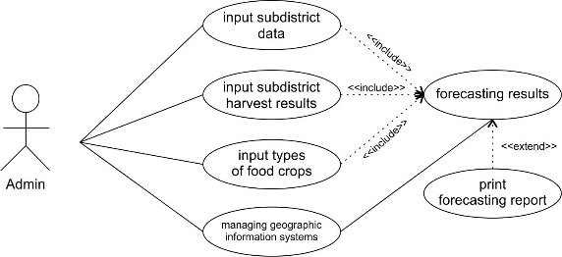

Figure 2. *Use Case* Diagram

The use case diagram describes the activities that admins can carry out in a forecasting system with a geographic information system, namely:

* Admin can add data for each sub-district in Sungai Full City, as well as edit data and delete data.
* Admin can input, delete and edit plant type data.
* Admin can input, delete and edit harvest data for each sub-district.
* Admin can manage geographic information systems.
* Admin can see forecast results that have been processed using the double exponential smoothing method and can print forecast results reports. Admin can see forecast results on the geographic information system.

## Double Exponential Smoothing Calculation

This research was conducted in Sungai Banyak City, Jambi Province with secondary data from 2018 to 2023.

1. RICE FIELD PRODUCTS /(TON)

|  |  |  |  |  |  |  |
| --- | --- | --- | --- | --- | --- | --- |
| **Subdistrict** | **2018** | **2019** | **2020** | **2021** | **2022** | **2023** |
| Tanah Kampung | 13823 | 14211 | 10082 | 12432 | 16790 | 16299 |
| Kumun Debai | 4905 | 4548 | 7400 | 5524 | 10197 | 9874 |
| Sungai Penuh | 17842 | 12270 | 10727 | 13205 | 4272 | 4953 |
| Pondok Tinggi | 0 | 6140 | 9181 | 7780 | 10863 | 8958 |
| Sungai Bungkal | 0 | 5821 | 8372 | 7949 | 5494 | 9889 |
| Hamparan Rawang | 1952 | 0 | 0 | 0 | 1584 | 11866 |
| Pesisir Bukit | 4767 | 0 | 0 | 0 | 6208 | 7669 |
| Koto Baru | 0 | 0 | 0 | 0 | 2871 | 5984 |

Source : BPS Kota Sungai Penuh

TABLE II. CORN HARVEST RESULTS /(TON)

|  |  |  |  |  |  |  |
| --- | --- | --- | --- | --- | --- | --- |
| **Subdistrict** | **2012** | **2013** | **2014** | **2015** | **2016** | **2017** |
| Tanah Kampung | 11 | 15 | 76 | 108 | 83 | 0 |
| Kumun Debai | 43 | 47 | 58 | 44 | 41 | 49 |
| Sungai Penuh | 76 | 144 | 108 | 105 | 8 | 11 |
| Pondok Tinggi | 0 | 19 | 25 | 0 | 11 | 103 |
| Sungai Bungkal | 0 | 0 | 40 | 0 | 0 | 92 |
| Hamparan Rawang | 3 | 0 | 0 | 0 | 124 | 22 |
| Pesisir Bukit | 84 | 0 | 0 | 0 | 8 | 22 |
| Koto Baru | 0 | 0 | 0 | 0 | 0 | 0 |

Source : BPS Kota Sungai Penuh

The initial step of this forecasting system is to input data on harvest results each year based on plant code, plant name and number of harvests (actual value). The next process is calculating the forecast value using the forecast method (double exponential smoothing). The following are the results of the forecasting calculations.

1. *Estimated Rice Harvest Results for Tanah Kampung District*

TABLE III. RESULTS OF CALCULATION OF DOUBLE EXPONENTIAL SMOOTHING RICE DISTRICT TANAH KAMPUNG

|  |  |  |
| --- | --- | --- |
| Year | Actual/ton | Forecast /ton |
| 2018 | 13823 | - |
| 2019 | 14211 | 13823 |
| 2020 | 10082 | 14075 |
| 2021 | 12432 | 11537 |
| 2022 | 16790 | 11578 |
| 2023 | 16299 | 14559 |

TABLE IV. CALCULATION RESULTS OF THE FORECAST ERROR VALUE OF RICE HARVEST IN TANAH KAMPUNG DISTRICT

|  |  |  |  |  |
| --- | --- | --- | --- | --- |
| Error Value | α =0,1 | α =0,1 | α =0,5 | α =0,5 |
| β =0,1 | β =0,5 | β =0,1 | β =0,5 |
| ME | 25288,68 | 25178,64 | 24978,21 | 24794,32 |
| MAD | 2265,80 | 2355,00 | 2298,11 | 2549,81 |
| MAPE | 0,17% | 0,18% | 0,17% | 0,19% |
| MSE | 6935856,07 | 7623425,19 | 8453445,91 | 10271647,02 |

Based on Table IV, the results of calculating forecast errors using the double exponential smoothing method use a combination of α = 0.1 and 0.5 and β = 0.1 and 0.5. From the calculation results, the smallest error value was obtained, namely: ME = 25288.68, MAD = 2265.80, MAPE = 17%, MSE = 6935856.07 which was obtained from a combination of the value α = 0.1 and the value β = 0.1. With a value of α= 0.1 and a value of β = 0.1, this is used to predict the next year's harvest, namely:

TABLE V. FORECAST RESULTS OF RICE HARVEST IN TANAH KAMPUNG DISTRICT

|  |  |  |
| --- | --- | --- |
| Year | Actual/ton | Forecast/ton |
| 2018 | 13823 | - |
| 2019 | 14211 | 13823 |
| 2020 | 10082 | 14075 |
| 2021 | 12432 | 11537 |
| 2022 | 16790 | 11578 |
| 2023 | 16299 | 14559 |
| 2024 |  | 16065 |

Figure 3. Comparison of Actual and Estimated Paddy Rice Harvest

So by using the value α = 0.1 and the value β = 0.1, it can be estimated that the yield of lowland rice in Tanah Kampung District in 2018 will be 16065 tons.

1. *Forecast of Corn Harvest Results for Kumun Debai District*

TABLE VI. RESULTS OF CALCULATION OF DOUBLE EXPONENTIAL SMOOTHING CORN HARVEST IN KUMUN DEBAI DISTRICT

|  |  |  |
| --- | --- | --- |
| Year | Actual/ton | Forecast/ton |
| 2018 | 43 | - |
| 2019 | 47 | 43 |
| 2020 | 58 | 43 |
| 2021 | 44 | 45 |
| 2022 | 41 | 45 |
| 2023 | 49 | 44 |

TABLE VII. CALCULATION RESULTS OF CORN HARVEST FORECAST ERROR VALUE FOR KUMUN DEBAI DISTRICT

|  |  |  |  |  |
| --- | --- | --- | --- | --- |
| Error Value | α =0,1 | α =0,1 | α =0,5 | α =0,5 |
| β =0,1 | β =0,5 | β =0,1 | β =0,5 |
| ME | 80,92 | 81,99 | 84,96 | 86,58 |
| MAD | 5,58 | 5,68 | 7,40 | 8,50 |
| MAPE | 0,11% | 0,11% | 0,15% | 0,18% |
| MSE | 52,69 | 52,86 | 65,32 | 84,85 |

Based on Table VII, the results of calculating forecast errors using the double exponential smoothing method use a combination of α = 0.1 and 0.5 and β = 0.1 and 0.5. From the calculation results, the smallest error values were obtained, namely: ME = 80.92, MAD = 5.58, MAPE = 11%, MSE = 52.69 which was obtained from a combination of the value α = 0.1 and the value β = 0.1. With a value of α= 0.1 and a value of β = 0.1, this is used to predict the next year's harvest, namely:

TABLE VIII. FORECAST RESULTS OF CORN HARVEST IN KUMUN DEBAI DISTRICT

|  |  |  |
| --- | --- | --- |
| Year | Actual/ton | Forecast/ton |
| 2018 | 43 | - |
| 2019 | 47 | 43 |
| 2020 | 58 | 43 |
| 2021 | 44 | 45 |
| 2022 | 41 | 45 |
| 2023 | 49 | 44 |
| 2024 |  | 45 |
| 2025 |  | 40 |
| 2026 |  | 35 |

Figure 4. Comparison of Actual and Forecast Corn Harvest

1. *Forecast of Sweet Potato Harvest Results for Pesisir Bukit District*

TABLE IX. RESULTS OF CALCULATION OF DOUBLE EXPONENTIAL SMOOTHING SWEET POTATOES, PESIR BUKIT DISTRICT

|  |  |  |
| --- | --- | --- |
| Year | Actual/ton | Forecast/ton |
| 2018 | 0 | - |
| 2019 | 51 | - |
| 2020 | 129 | 28,05 |
| 2021 | 203 | 86,12 |
| 2022 | 136 | 158 |
| 2023 | 120 | 159,34 |

TABLE X. RESULTS OF CALCULATION OF THE ERROR VALUE OF THE FORECAST OF SWEET POTATO HARVEST IN PESIR BUKIT DISTRICT

|  |  |  |  |  |
| --- | --- | --- | --- | --- |
| Error Value | α =0,1 | α =0,1 | α =0,5 | α =0,5 |
| β =0,1 | β =0,5 | β =0,1 | β =0,5 |
| ME | 39,09 | 55,32 | 137,85 | 172,40 |
| MAD | 103,31 | 89,65 | 66,03 | 79,99 |
| MAPE | 0,82% | 0,71% | 0,57% | 0,70% |
| MSE | 12898,23 | 10784,64 | 5696,84 | 6625,15 |

Based on Table From the calculation results, the smallest error value is obtained, namely: ME = 137.85, MAD = 66.03, MAPE = 0.57%, MSE = 5696.84 which is obtained from a combination of the value α = 0.5 and the value β = 0.1 . With a value of α= 0.5 and a value of β = 0.1, this is used to predict the next year's harvest, namely:

TABLE XI. FORECAST RESULTS OF SWEET POTATO HARVEST IN PESIR BUKIT DISTRICT

|  |  |  |
| --- | --- | --- |
| Year | Actual/ton | Forecast/ton |
| 2018 | 0 | - |
| 2019 | 51 | - |
| 2020 | 129 | 28,05 |
| 2021 | 203 | 86,12 |
| 2022 | 136 | 158 |
| 2023 | 120 | 159,34 |
| 2024 |  | 150,05 |
| 2025 |  | 77,89 |

Figure 5. Comparison of Actual and Forecasts of Sweet Potato Harvest

So by using the value α = 0.1 and the value β = 0.1, it can be estimated that the yield of sweet potatoes in Pesisir Bukit District in 2018 was 150.05 tons and in 2019 it was 77.89 tons.

## Screen Display

In the initial display, the admin can see a graph of land area based on sub-district. There are several menu bars, namely master data consisting of sub-district data, plant types, annual harvest results. In the analysis results menu there are forecast results for food crop harvests in each sub-district according to the double exponential smoothing calculation. The geographic information system menu will display harvest results based on the analysis results and you can see the distribution of plants in the geographic information system.

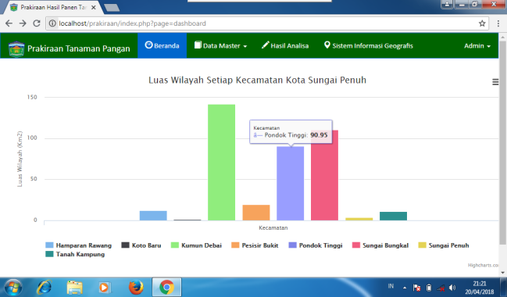

Figure 7. Harvest Forecast Results Graph

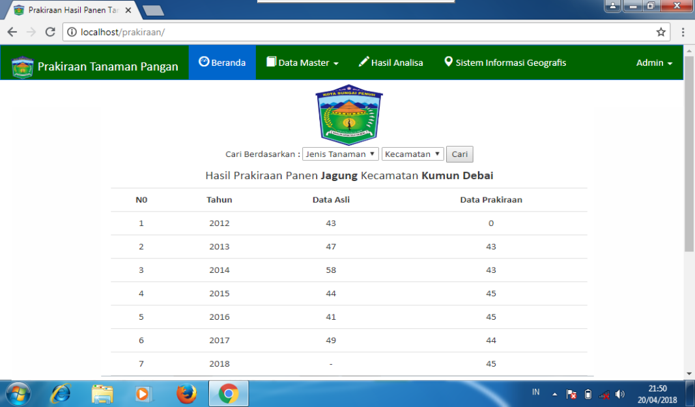

Figure 8. Forecast Results Menu Display

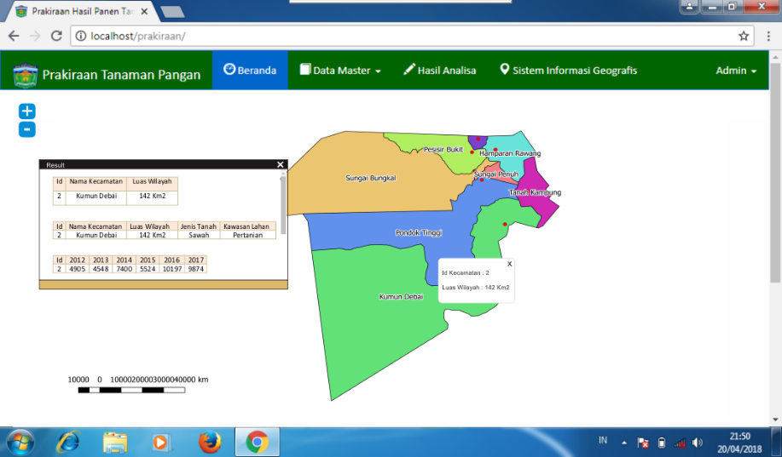

Figure 9. Geographic Information System Menu Display

# CONCLUSION

Based on the results of this research, it can be concluded that the double exponential smoothing method can be applied to predict food crop yields. In this study, to estimate corn harvest yields in Kumun Debai District using the value α = 0.1 and the value β = 0.1, the values obtained were ME = 80.92, MAD = 5.58, MAPE = 11%, MSE = 52.69 . So it can be predicted that the corn harvest in Kumun Debai District in 2024 will be 45 tons, 2025 will be 40 tons and 2026 will be 35 tons. The Double Exponential Smoothing method has good performance in forecasting annual data.

##### References

1. Anggodo, Yusuf Ptiyo dan Wayan Firdaus Mahmudy. Peramalan Butuhan Hidup Minimum Menggunakan Automatic Clustering Dan Fuzzy Logical Relationship. *Jurnal Teknologi Informasi Dan Komputer* (JTIIK), 3(2), p.94-120.
2. CC, Holt. 2004 Forecasting Seasonals And Trends By Exponentially Weighted Moving Averages. *Int. J. Forecast*. 20. P.5-13.
3. Heizer, Jay dan Barry, Render. 2015. *Manajemen Operasi, Edisi 11,* Jakarta: Salemba Empat.
4. Assauri, Sofjan. 2016. *Manajemen Operasi Produksi Edisi 3*. Jakarta : Raja Grafindo Persada.
5. Stevenson, William J Dan Sum Chee Choung. 2014. *Operation Menagement: An Asian Prespective*. Jakarta : Salemba Empat.
6. Budiyanto, E., 2016. *Sistem Informasi Geografis dengan Quatum GIS*. Yogyakarta : Andi Offset.
7. Nyerges, T., 2009*. GIS and Society*, University of Washington, Seatle, WA, USA.
8. Vatsavai, R., S. Shekhar, T. E. Burk, Lime, S., 2014. Mapserver : A high performance, interoperable, and open source web mapping and geo-spatial analysis system, *Geographic Information Science*, pp.400-4017.
9. Chen Tian-En, L.P., Chen, Yunbin, G.Y., WANG.2009. Spasial Decision Support System For Percision Farming Based On GIS Web Service, *Information Technology And Application*. 2 p.372-376.
10. Mohammed, E.S. Saleh, A.M., Belal, A.A. 2014. Sustainability Indicators For Agriculture Land Use Based GIS Spacial Modeling In Notrth On Sinai-Engypt, *The Engyptian Journal Of Remote Sensing And Space Science*. 17 p.1-15.
11. E. Vercher, A. Corberan-Vallet, J.V. Segura, Et Al. 2012. Initial Conditions Estima-Tion For Improving Forecast Accuracy In Exponential Smoothing, 20. p. 517–533.
12. R.R. Yager. 2013. Exponential smoothing with credibility weighted observations, *Inf.Sci*. 252. p. 96–105.
13. A.L. Santiago Maia, F.D.A.T. De Carvalho, Et Al. 2011. Holt’s Exponential Smoothingand Neural Network Models For Forecasting Interval-Valued Time Series, *Int. J.Forecast*. 27. p.740–759.
14. A.B. Koehler, R.D. Snyder, J.K. Ord, Et Al. 2016, A Study Of Outliers In The Expo-Nential Smoothing Approach To Forecasting, *Int. J. Forecast*. 47(28). P.7–484.
15. Nyerges, T., 2009. Gis And Society. University of washinton, staatle, WA,USA.