Application of Data Mining for Tuberculosis Disease Classification Using K-Nearest Neighbor

Lamria Simangunsong [1] , Geertruida Frederika Sundah [2] , Rani Hutahaean [3] , Indren[4] , Delima Sitanggang [*]

Information Systems Study Program, Faculty of Science and Technology [1], [2], [3], [3],[4],[5]

Universitas Prima Indonesia

Medan, Indonesia,

[Lamriasimangunsong2@gmail.com[1] geertruidafrederika26@gmail.com[2]ranihutahaean059@gmail.com[3] indrenjaya2@gmail.com](http://unknown?id=rId10)[4] delimasitanggang@unprimdn.ac.id[5]

***Abstract*— Tuberculosis (TB) is a chronic airborne disease caused by Mycobacterium tuberculosis bacteria that can attack the body's organs, especially the lungs. This disease has consequences on public health, because it is the leading cause of death. according to WHO data, the number of tuberculosis in Indonesia in 2020 is in third position with the highest number of cases. Until now, TB disease is one of the diseases that is a problem in the world of health, because this disease attacks all age groups with a very high incidence of disease. So it is necessary to do a method to find out how many people have TB disease for the past 5 years, especially in one of the nearest health centres. The purpose of this research is to calculate the level of accuracy in classifying tuberculosis disease using the K-Nearest Neighbor method and this research can also help improve public health and the development of science, so that people can prevent and overcome Tuberculosis disease. Based on this research, the processing of tuberculosis disease data resulted in an accuracy value of 80%. Thus this study concluded that the K-Nearest Neighbor algorithm is best in classifying disease data.**

***Keywords— Tuberculosis, K-Nearest Neighbor, disease, Classification***

# Introduction

Tuberculosis (TB) is a chronic disease that is transmitted through the air caused by the bacterium Mycobacterium tuberculosis which can attack the organs of the body, especially in the lungs. This disease has consequences for public health, because it is the main cause of death. According to WHO data, the number of TB in Indonesia in 2020 is in third place with the highest number of cases. One of the important vital organs in the human body is the lungs. The lungs are respiratory (breathing) organs that are affiliated with the respiratory system as well as flow (blood circulation) [1]. The main function of this organ is to exchange oxygen from the air with carbon dioxide from the blood. In the global world of health, lung disease is a challenge that cannot be ignored because it can result in death [2]. The triggering factors for lung disease are increasing air pollution, lifestyle changes, and other environmental factors [3]. Several types of diseases in the lungs are pneumonia, tuberculosis, bronchitis, and asthma. This study focuses on Tuberculosis disease in the lungs.

This disease has an impact on public health, because it is the main cause of death [4]. According to WHO data, the number of TB in Indonesia in 2020 is in third position with the burden of the highest number of cases[5]. Tuberculosis cases in Indonesia are estimated at 969,000 TB cases. In Indonesia, tuberculosis is a chronic disease that has become the No. 1 health problem in 2022, the Ministry of Health detected patients *Tuberculosis* (TB) more than 700,000 cases. In general, Tuberculosis is transmitted through the air that contains bacteria when TB patients actively cough and sputum, the bacteria will automatically be carried into the air and enter the body of other people who

Inhale [6]. There are many symptoms of tuberculosis, including chronic cough, fatigue, fever, to weight loss. Tuberculosis patients expel about 3000 sputum splashes when coughing and can last for hours in a dark or humid room. In most cases, people who breathe such air will develop Tuberculosis.

Tuberculosis is still a *problem* especially in the world of health, especially in countries that use high levels of poverty [7]. This disease affects all age groups with a very high incidence of the disease, an innovative approach is needed to analyze and handle this disease. Tuberculosis (TB) as a challenge focuses on the health sector of citizens around the world, including in Indonesia. Despite many prevention efforts, the spread of TB is still quite difficult to predict accurately. Therefore, a productive process is needed that can predict the spread of tuberculosis more accurately. One of the methods that can be used in this study is the K-NN (K-Nearest Neighbor) method.

The K-NN method is a simple algorithm used to classify data and regression in machine learning [8]. The K-NN method is one of the methods in the field of machine learning that can be used to classify data according to similarity using the nearest neighbor [9]. In the context of this study, K-NN will be applied to analyze and classify data of tuberculosis patients based on various clinical and laboratory parameters related to using this disease. Testing and validation of the K-NN model will be carried out using independent test data to evaluate the effectiveness and reliability of the method in classifying tuberculosis status in patients. This method is needed to make a significant contribution to improving the accuracy of assessment and helping early identification of tuberculosis problems, as a result of which it can support more effective prevention and treatment efforts [10].

# LITERATURE REVIEW

## Algoritma K-Nearest Neighbor

The K-Nearest Neighbor algorithm is used as a dataset classification method based on previously classified training data. This involves supervised learning where the results of a new sample query are classified based on the proximity of the K-NN class [11]. KNN is the most basic and simplest classification technique, especially if there is little or no prior knowledge of the distribution of data. According to the KNN principle, each sample is classified similarly to the surrounding samples[12]. How close or distant the neighbors are usually calculated based on Eucledian distance. KNN is a widely used algorithm for text classification, relying on learning with training data to identify K groups of objects [13]. The K-Nearest Neighbor formula for data classification is:

d(x,y) = $\sqrt{\sum_{i}^{n}{(xi-}}{yi)}^{ 2}$ (1)

information:

d(x,y) : the distance of data x and y

xi : sample data

yi : test data or data testing

i : variable data

n : data dimension

*d*(p,q) = $\sqrt{(q1-{p1)}^{2}+(q2-{p2)}^{2}}+…+(qn-{pn)}^{2}$ (2)

Parts of the K-Nearest Neighbor algorithm are as follows [14] :

1. Determining the value of K, i.e. counting the number of nearest neighbors
2. Calculate the distance between the new data and the entire training data
3. Determination of the nearest neighbor class
4. It uses a simple majority class of the nearest neighbor to calculate the classification of the data.

## Tuberculosis

Tuberculosis (TB) is a chronic disease that is transmitted through the air caused by the bacterium *Mycobacterium* tuberculosis which can attack the organs of the body, especially in the lungs [4]. This disease has consequences for public health, because it is the main cause of death [5].

# RESEARCH METHODS

Start

Dataset Collection

Literature Studies

Problem Formulation Identification

Data Acquistion

Data Prepocessing

Accuracy Results of the K-Nearest Neighbors Method

Finish

**Figure 1. Flowchart Working procedure**

## Collection of Data Sets

Information data on the types of diseases in the lungs consisting of 6 types of diseases consisting of Pneumonia, Bronchitis, Asthma, Other diseases in the lower respiratory tract, Pulmonary tuberculosis, Tuberculosis other than the lungs and other diseases in the upper respiratory tract but the researchers focused more on tuberculosis diseases obtained from the Darussalam Health Center. From 2019 to 2023, the author conducted research at the Darusallam Health Center and obtained the results of more than 1000 data.

## Literature Studies

In literary research, theoretical sources related to research are collected in the form of magazines, books, articles and others, which support the research. Observation is an observation made to identify the material used for the research object, namely tuberculosis [15].

## Data Acquistion

The TB dataset was obtained using primary data directly from the Darussalam Health Center. The data was processed through a data processing process and used to identify the cause of lung disease, namely tuberculosis.

|  |  |  |  |  |  |  |
| --- | --- | --- | --- | --- | --- | --- |
| **Pneumonia** | **Bronkhitis** | **TBC** | **OTHER DISEASES OF THE UPPER AND LOWER RESPIRATORY TRACT** | **PULMONARY TUBERCULOSIS - TUBERCULOSIS OTHER THAN PULMONARY TUBERCULOSIS** | **ASTHMA** | **YEAR** |
| 10 | 10 | 9 | 11 | 11 | 34 | 2019 |
| 30 | 20 | 18 | 23 | 26 | 17 | 2019 |
| 11 | 6 | 7 | 5 | 9 | 10 | 2019 |
| 13 | 13 | 8 | 12 | 9 | 10 | 2019 |
| 13 | 13 | 18 | 10 | 10 | 10 | 2019 |
| 13 | 13 | 8 | 12 | 30 | 20 | 2019 |
| 15 | 13 | 11 | 22 | 11 | 6 | 2019 |
| 36 | 20 | 10 | 8 | 13 | 13 | 2019 |
| 24 | 10 | 13 | 13 | 13 | 13 | 2019 |
| 24 | 10 | 13 | 11 | 13 | 13 | 2019 |
| 24 | 10 | 13 | 11 | 15 | 13 | 2019 |
| 13 | 23 | 13 | 17 | 36 | 20 | 2019 |
| 22 | 32 | 12 | 4 | 24 | 10 | 2019 |
| 9 | 13 | 12 | 4 | 24 | 10 | 2019 |
| 9 | 13 | 12 | 4 | 24 | 10 | 2019 |
| 9 | 1 | 12 | 4 | 13 | 23 | 2019 |
| 14 | 19 | 39 | 27 | 22 | 32 | 2019 |
| 16 | 18 | 2 | 3 | 9 | 13 | 2019 |
| 10 | 8 | 6 | 7 | 9 | 13 | 2019 |
| 10 | 8 | 6 | 7 | 9 | 1 | 2019 |
| 10 | 8 | 6 | 7 | 14 | 19 | 2019 |
| 13 | 27 | 11 | 15 | 16 | 18 | 2019 |
| 26 | 21 | 7 | 9 | 10 | 8 | 2019 |
| 17 | 7 | 13 | 8 | 10 | 8 | 2019 |

## Data Processing

The process of transforming raw data into an easy-to-understand and easy-to-understand form. This process is carried out because raw data often has an irregular format. The goal is to collect data, process data and overcome the problems faced by the health center in providing appropriate and accurate information. This study uses the object of tuberculosis disease which includes various approaches to aspects, namely the prevention, diagnosis, and management of this disease.

# Results and discussion

## Problem Analysis

In this study, Tuberculosis (TB) is a serious disease that spreads through the air when people cough or sneeze, secrete droplets containing the bacteria *Mycobacterium* tuberculosis Indonesia, with more than 700,000 cases in 2022, becoming the country with the third highest number of cases in the world, influenced by socioeconomic factors such as poverty and limited access to health. TB is often difficult to diagnose because its symptoms are similar to those of other respiratory diseases, leading to delays in treatment. Long-term adherence to medication is necessary, but many patients stop treatment early, increasing the risk of drug resistance. Vaccination and health education programs are still ineffective, so technological approaches such as the K-Nearest Neighbor (K-NN) machine learning method are needed to analyze patient data, improve prediction accuracy, and support more effective TB prevention and treatment efforts.

## Data Acquistion

Data acquistion is a process carried out by researchers to obtain data that will be used in research. The TB dataset was collected directly from the Darussalam Health Center. The data is processed through several stages such as collecting raw data from the source, changing the data format, filtering the data to obtain relevant data and can be seen in figure 1.

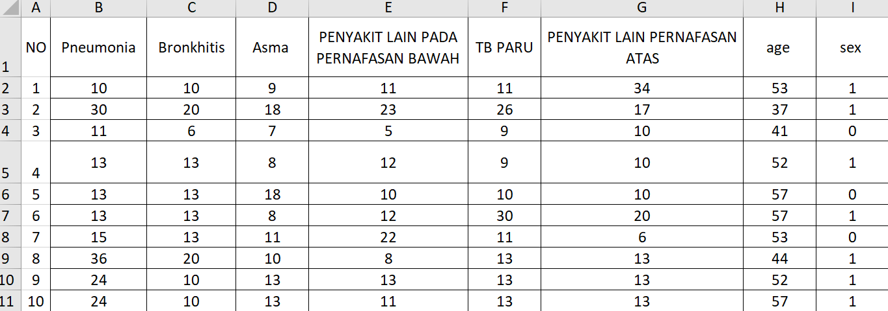

Picture 1 Disease Image Set Data

## Uzi meaning

During the test, the first step was to process the TB data in Excel. After the data was processed and applied the K-Nearest Neighbor (K-NN) formula, the data was further processed using Matlab. The analysis included 143 data collected from 2019 to 2023. The analysis process using the K-NN method in Matlab aims to classify TB disease data. The results of the analysis show that the K-NN method achieves an accuracy level of 80% in the classification of TB data. These findings show that the K-NN method is effective in supporting the prevention and treatment of tuberculosis in the community.

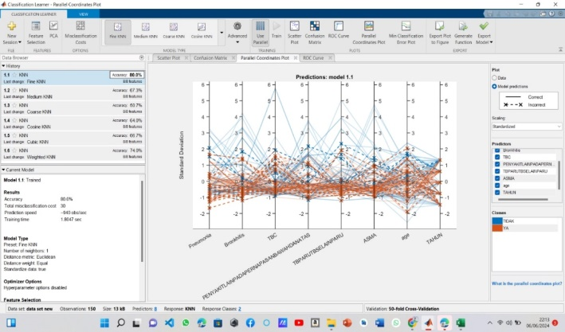

Picture 2. Disease Multidimensional Data Visualization

The figure above shows a visualization of the relationship between several variables in the disease dataset. The model used to predict this dataset has an accuracy of 80% and a total *misclasification cost* 30, meaning that the model can correctly classify data on 80% of all observations. The orange line color on the chart shows accurate accuracy while the blue color of the chart is the opposite of the orange color with inaccurate accuracy.

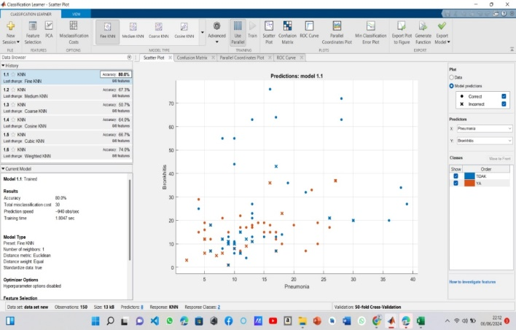

Picture 3. Relationship between two variables in a dataset

The figure above illustrates the relationship between two variables in the dataset. The model used to classify the relationship between these two variables has a data accuracy rate of 80%, which means that it is able to correctly classify data as much as 80% of all observations. The color of the dots on the plot image is used to indicate the predicted value of the model.

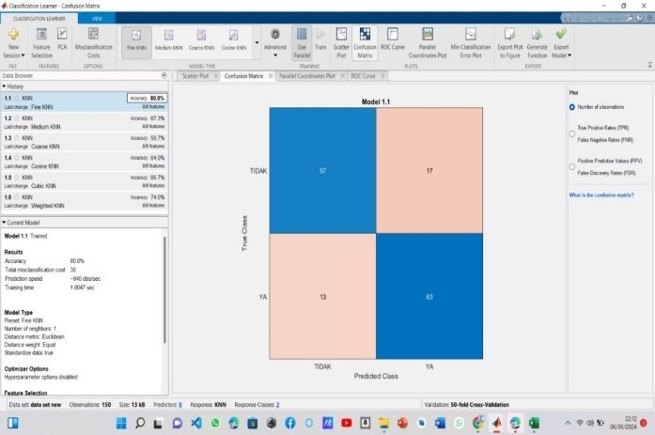

Picture 4. Model Classification *Number of Observations*

Based on Figure 4, it can be seen that the model *classification number of observations* shows the number of true and false classifications of the model, where the Y axis (*True Class*) and the X axis (*Pradicted Class*) are known. On the Y axis 57 is true and 17 is false, while on the X axis 63 is true and 13 is false. Before modeling the training data in Matlab, the researcher first determined the average value of the dataset using excel to determine which one experienced the most tuberculosis in the past 5 years

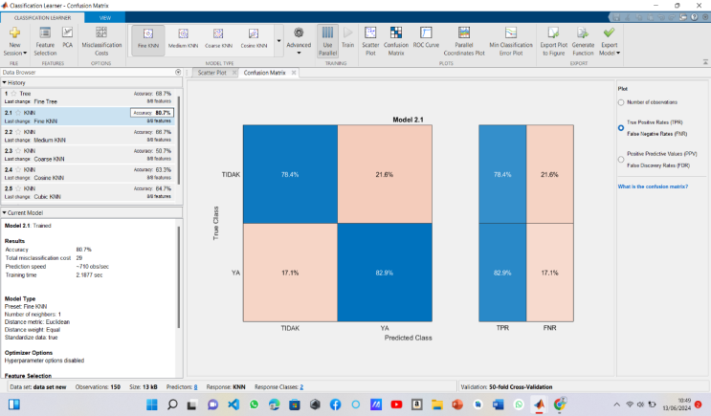

Picture 5. Model Classification *True Positive & False Negative*

Based on the figure, the matlab classification modeling has the results of the overall TB disease data for the past 5 years with 6 attributes or types of TB disease with an accuracy result of 80%. And each type of disease data has different data accuracy. In the data, there are True Positive Rates or called TPR 78.4% and 82.9%, while for False Negative Rates or FNR, they are 21.6% and 17.1%. From the results of the above data, it can be seen that the data included in the K-Nearest Neighbor method by tuberculosis disease is more than the data that is categorized as not included in the K-Nearest Neighbor method.

# CONCLUSION

*Tuberculosis* (TB) is a chronic disease that is transmitted through the air caused by the bacterium *Mycobacterium* tuberculosis which can attack the organs of the body, especially in the lungs. This disease has consequences for public health, because it is the main cause of death. Based on the research conducted and the process of applying data mining for the classification of tuberculosis disease using the K-Nearest Neighbor method, the final result of accuracy was 80%. Thus, it can be concluded that the K-Nearest Neighbor algorithm is good.

In this study, the number of datasets used is still very small. Therefore, for the next research, it is necessary to add more datasets and use other algorithms such as Naive Bayes, Random Forest, Support Vector Machine, and others. By adding a larger dataset, it is hoped that the results of the study will be more accurate and representative. In addition, the application of additional algorithms will allow for a comparison of the performance of various methods, so that the most suitable algorithm for the case under study can be selected. Naive Bayes, Random Forest, and Support Vector Machine are some of the machine learning algorithms that have proven to be effective in various types of data analysis and classification, so the use of these algorithms can improve the quality and reliability of research results.

##### Reference

[1] A. M. Argina, "Application of K-Nearest Neigbor Classification Method on Datasets of Diabetic Patients," *Indones. J. Data Sci.*, vol. 1, no. 2, pp. 29–33, 2020, doi: 10.33096/ijodas.v1i2.11.

[2] E. T. Atok, D. R. Sina, and D. M. Sihotang, "Implementation of Case-Based Reasoning to Diagnose Tuberculosis Disease Using the K-Nearest Neighbor Algorithm," *J. Komput. and Inform.*, vol. 7, no. 2, pp. 124–128, 2019, doi: 10.35508/jicon.v7i2.1656.

[3] M. A. Brillianto, H. T. Fauzi, and T. S. Siadari, "Classification of tuberculosis and pneumonia in child x-ray images using statistical first order extraction method," vol. 8, no. 6, pp. 3271–3277, 2022.

[4] D. Cahyanti, A. Rahmayani, and S. A. Husniar, "Performance Analysis of Knn Method on Dataset of Patients with Breast Cancer," *Indones. J. Data Sci.*, vol. 1, no. 2, pp. 39–43, 2020, doi: 10.33096/ijodas.v1i2.13.

[5] T. N. Halim, R. Martin, and ..., "Classification of Customer Satisfaction Towards E-Commerce Platforms with the K–Nearest Neighbor (K-NN) Method," *Jurassic (Jurnal Ris. ...*, vol. 8, pp. 512–523, 2023, [Online]. Available: http://ejurnal.tunasbangsa.ac.id/index.php/jurasik/article/view/636%0Ahttps://ejurnal.tunasbangsa.ac.id/index.php/jurasik/article/download/636/609

[6] Q. A. A'yuniyah and M. Reza, "Application of K-Nearest Neighbor Algorithm for Classification of Student Majors at SMA Negeri 15 Pekanbaru," *Indones. J. Inform. Res. Softw. Eng.*, vol. 3, no. 1, pp. 39–45, 2023, doi: 10.57152/ijirse.v3i1.484.

[7] H. Saleh, M. Faisal, and R. I. Musa, "Classification of Nutritional Status of Toddlers Using the K-Nearest Neighbor Method," *Simtek J. Sist. Inf. and Tek. Comput.*, vol. 4, no. 2, pp. 120–126, 2019, doi:10.51876/simtek.v4i2.60.

[8] I. S. Muallif, H. Budiman, and R. Natalis, "Application of Data Mining to Predict Stock Price Movements Using the K-Nearest Neighbor Algorithm," *J. Media Inform. Budidarma*, vol. 8, no. 1, pp. 497–507, 2024.

[9] L. Nur Aziza, R. Yuli Astuti, B. Akbar Maulana, and N. Hidayati, “Application of the K-Nearest Neighbor Algorithm for Food Security Classification in Central Java Province,” *MALCOM Indones. J. Mach. Learn. Comput. Sci. J.*, vol. 4, no. 2, pp. 404–412, 2024.

[10] R. S. A, Y. Faturrahman, and A. Setiyono, "ANALYSIS OF RISK FACTORS FOR TUBERCULOSIS INCIDENCE IN THE WORKING AREA OF THE HEALTH CENTER OF NORTH CIPINANG BESAR VILLAGE, EAST JAKARTA ADMINISTRATIVE CITY," vol. 2, no. 4, pp. 346–354, 2021.

[11] H. A. Dwi Fasnuari, H. Yuana, and M. T. Chulkamdi, "Application of K-Nearest Neighbor Algorithm for Classification of Diabetes Mellitus," *Antivirus J. Ilm. Tech. Inform.*, vol. 16, no. 2, pp. 133–142, 2022, doi: 10.35457/antivirus.v16i2.2445.

[12] D. Sitanggang, N. Nicholas, V. Wilson, A. R. A. Sinaga, and A. D. Simanjuntak, "Implementation of Data Mining to Predict Heart Disease Using K-Nearest Neighbor and Logistic Regression Methods," *J. Tek. Inf. and Komput.*, vol. 5, no. 2, p. 493, 2022, doi: 10.37600/tekinkom.v5i2.698.

[13] W. Syahfira *et al.*, "Application of Case Based Reasoning Method for Disease Diagnosis in Cows," vol. 18, no. x, pp. 211–219, 1978.

[14] Y. Pratama, A. Prayitno, D. Azrian, N. Aini, Y. Rizki, and E. Rasywir, "Classification of Heart Failure Using the K-Nearest Neighbor Algorithm," *Bull. Comput. Sci. Res.*, vol. 3, no. 1, pp. 52–56, 2022, doi: 10.47065/bulletincsr.v3i1.203.

[15] I. D. Damayanti and A. Michael, “Determination of Coffee Fruit Maturity Level Using Image Histogram and K-Nearest Neighbor,” *BAREKENG J. Science Mat. and Terap.*, vol. 18, no. 2, pp. 0785–0796, 2024, doi: 10.30598/barekengvol18iss2pp0785-0796.